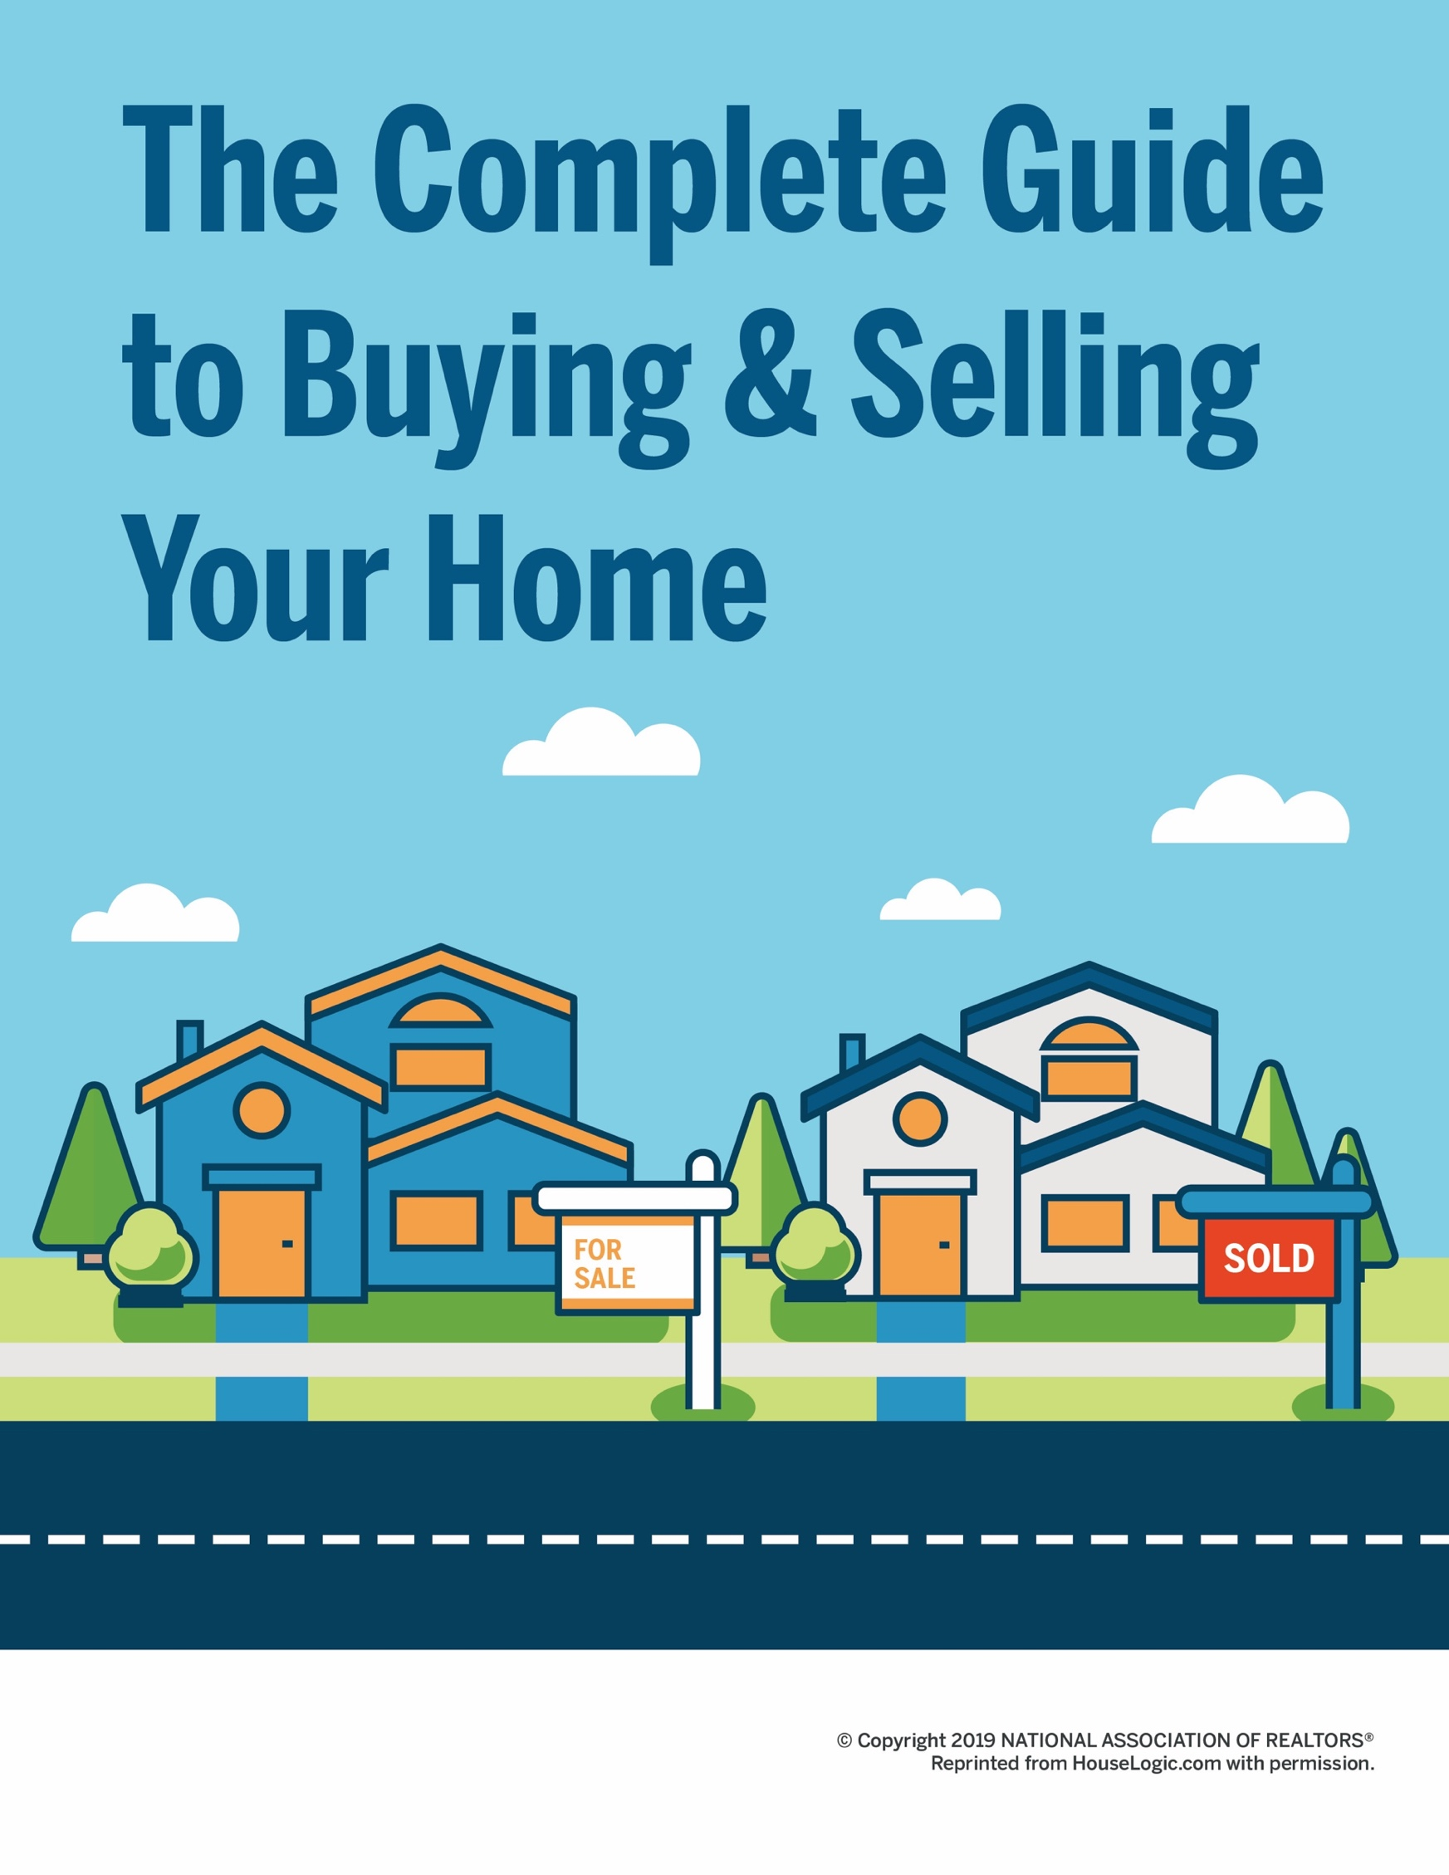

TABLE OF CONTENTS
A Step-by-Step Guide to Home Buying

5 The Everything Guide to Buying Your First Home

8 Buy a Home: Step-By-Step

11 The Ultimate "I Wanna Buy a House" Checklist

16 What You Should Really Know About Browsing for Homes Online

18 Here’s How You’ll Know You’ve Found the Right Agent

23 How to Be a Savvy Open House Guest

26 Your Stress-Free Guide to Shopping for Home Loans

31 Before You Choose a Mortgage Lender, Read These Tips

35 Make an Offer Like a Boss

40 8 Simple Rules for Negotiating Your Offer and Getting That House

44 What to Expect During A Home Inspection

49 Hey, Buyers: These Home Appraisal Tips Are for You

52 In Closing: How to Seal the Home-Buying Deal

TABLE OF CONTENTS
A Step-by-Step Guide to Selling Your Home

58 | The Everything Guide to Selling Your First Home
60 | Sell Your Home: Step-by-Step
63 | The Ultimate "Let's Sell This House!" Checklist
66 | What You Need to Know About Researching Home Prices
70 | How to Find the Right Person to Sell Your House
75 | The Ins and Outs of Setting a Price for Your Home
79 | Staging Your Home: How to Make Buyers Fall in Love
83 | 10 Tricks for Hosting an Open House That Make Buyers Say “OMG, Wow!”
88 | What You Need to Know Before Accepting — or Rejecting — an Offer
93 | Your Guide to Negotiating an Offer
97 | A Seller’s Guide to Navigating the Home Inspection

102 | What Every Seller Needs to Know About Closing

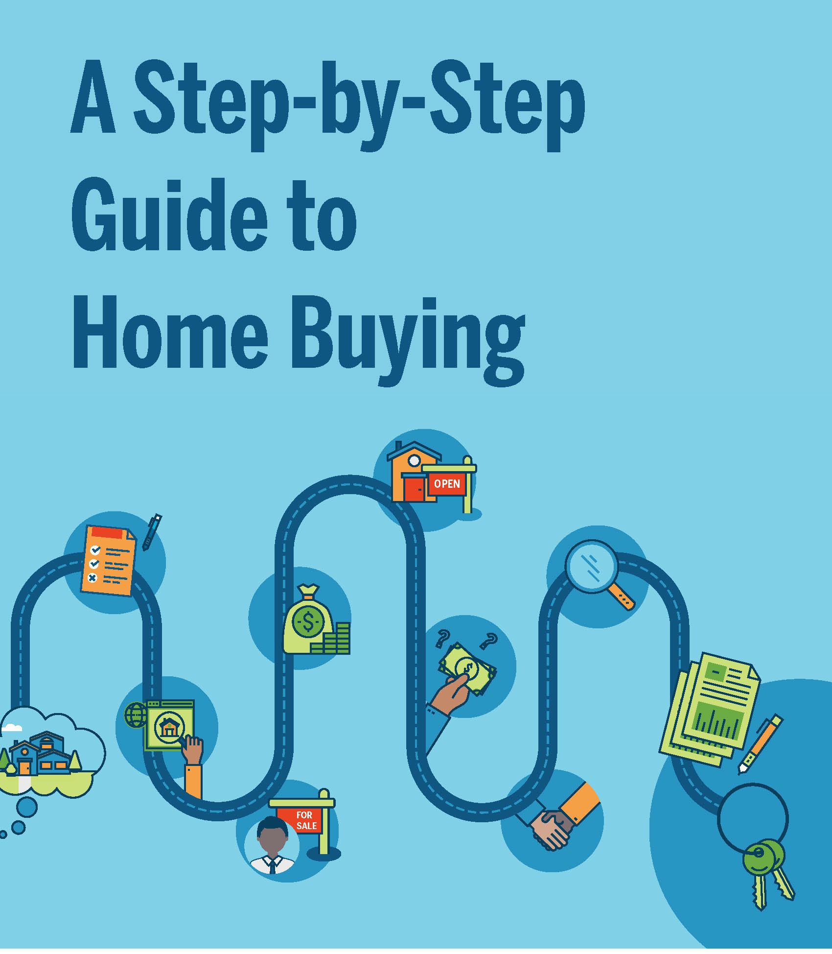

THE EVERYTHING GUIDE TO
Buying Your First Home
How to find exactly what you want, and how to work with the experts who’ll help you get it.
So you’re thinking about buying your first
home. Your very own house (and mortgage).
A place to call — and make — your own.
It’s a big move, literally and figuratively. Buying a house requires a serious amount of money and time. The journey isn’t always easy. It isn’t always intuitive. But when you get the keys to your new home — that, friend, can be one of the most rewarding feelings pretty much ever.

The key to getting there? Knowing the home-buying journey. Knowing what tools are at your disposal. And most importantly? Creating relationships with experts who can help you get the job done.

That’s where this guide comes in. We’ll show you not only the major steps you’ll take during the home-buying process, but also explain the relationships and experts you’ll need along the way.

You ready to live the dream? Here we go.

Do Your Homework
Oh sure, everybody wants to jump right into open houses. But before you even set foot into a foyer, you should identify your list of “musts” and “wants.” This list is an inventory of priorities for your search. And there’s so much to decide: Price, housing type, neighborhood, and school district — just to name a few.

To get yourself grounded, we recommend filling out the worksheet on page 11.

If you’re planning to buy a home with a partner (in life or in real estate), fill the worksheet out with them. You want to be on the same page while buying a house. If you’re not, you’ll be less able to give agents or lenders the information they need to help you. And you risk wasting time viewing homes you can’t afford — or don’t even want in the first place.

Start Shopping
Once you know what you’re looking for, the next step is to start looking at listings and housing information online. (This part? You’re going to crush it.)

Find a Great Agent
Your relationship with your real estate agent is the foundation of the home-buying process. (And your agent
= your rock.) He or she is the first expert you’ll meet on your journey, and the one you’ll rely on most. That’s why it’s important to interview agents and find the agent who’s right for your specific needs.

Choose a Lender
Once you’ve found your agent (AKA, your new best friend), ask him or her to recommend at least three mortgage lenders that meet your financial needs. This is another big step, as you’ll be working with your lender closely throughout the home-buying process.

Pick a Loan (It’s Not So Bad)
Once you’ve decided on a lender (or mortgage broker), you’ll work with your loan agent to determine which mortgage is right for you. You’ll consider the percentage of your income you want to spend on your new house, and you’ll provide the lender with paperwork showing proof of income, employment status, and other important financials. If all goes well (fingers crossed) you’ll be pre-approved for a loan at a certain amount. (Sweet.)

Visit Open Houses, and Look Around
Now that you have both an agent who knows your housing preferences and a budget — and a lender to finance a house within that budget — it’s time to get serious about viewing homes. Your agent will provide listings you may like based on your parameters (price range, ZIP codes, features), and will also help
you determine the quality of listings you find online. Then comes the fun part: Open houses and private showings, which give you the unique opportunity to evaluate properties in a way you can’t online.

Make an Offer
Once you find the home you want to buy, you’ll work with your agent to craft an offer that not only specifies the price you’re willing to pay but also the proposed settlement date and contingencies — other conditions that must be agreed upon by both parties, such as giving you the ability to do a home inspection and request repairs.

Negotiate, Negotiate, Negotiate
Making an offer can feel like an emotional precipice, almost like asking someone out on a date. Do they like me? Am I good enough? Will they say yes? It’s stressful! Some home sellers simply accept the best offer they receive, but many sellers make a counteroffer. If that happens, it’s up to you to decide whether you want your agent to negotiate with the seller or walk away. This is an area where your agent can provide real value by using their expert negotiating skills to haggle on your behalf and nab you the best deal.

Get the Place Inspected
If your offer is accepted, then you’ll sign a contract. Most sales contracts include a home inspection contingency, which means you’ll hire a licensed or certified home inspector to inspect the home for needed repairs, and then ask the seller to have those repairs made. This mitigates your risk of buying a house that has major issues lurking beneath the surface, like mold or cracks in the foundation. (No one wants that.)

Ace the Appraisal
When you offer to buy a home, your lender will need to have the home appraised to make sure the property value is enough to cover the mortgage. If the home appraises close to the agreed-upon purchase price, you’re one step closer to settlement — but a low appraisal can add a wrinkle. Not one you can’t deal with.

Close the Deal
The last stage of the home-buying process is settlement, or closing. This is when you sign the final ownership and insurance paperwork and make this whole thing official.

When it’s all said and done — break out the rosé. You’ll have the keys to your new home!

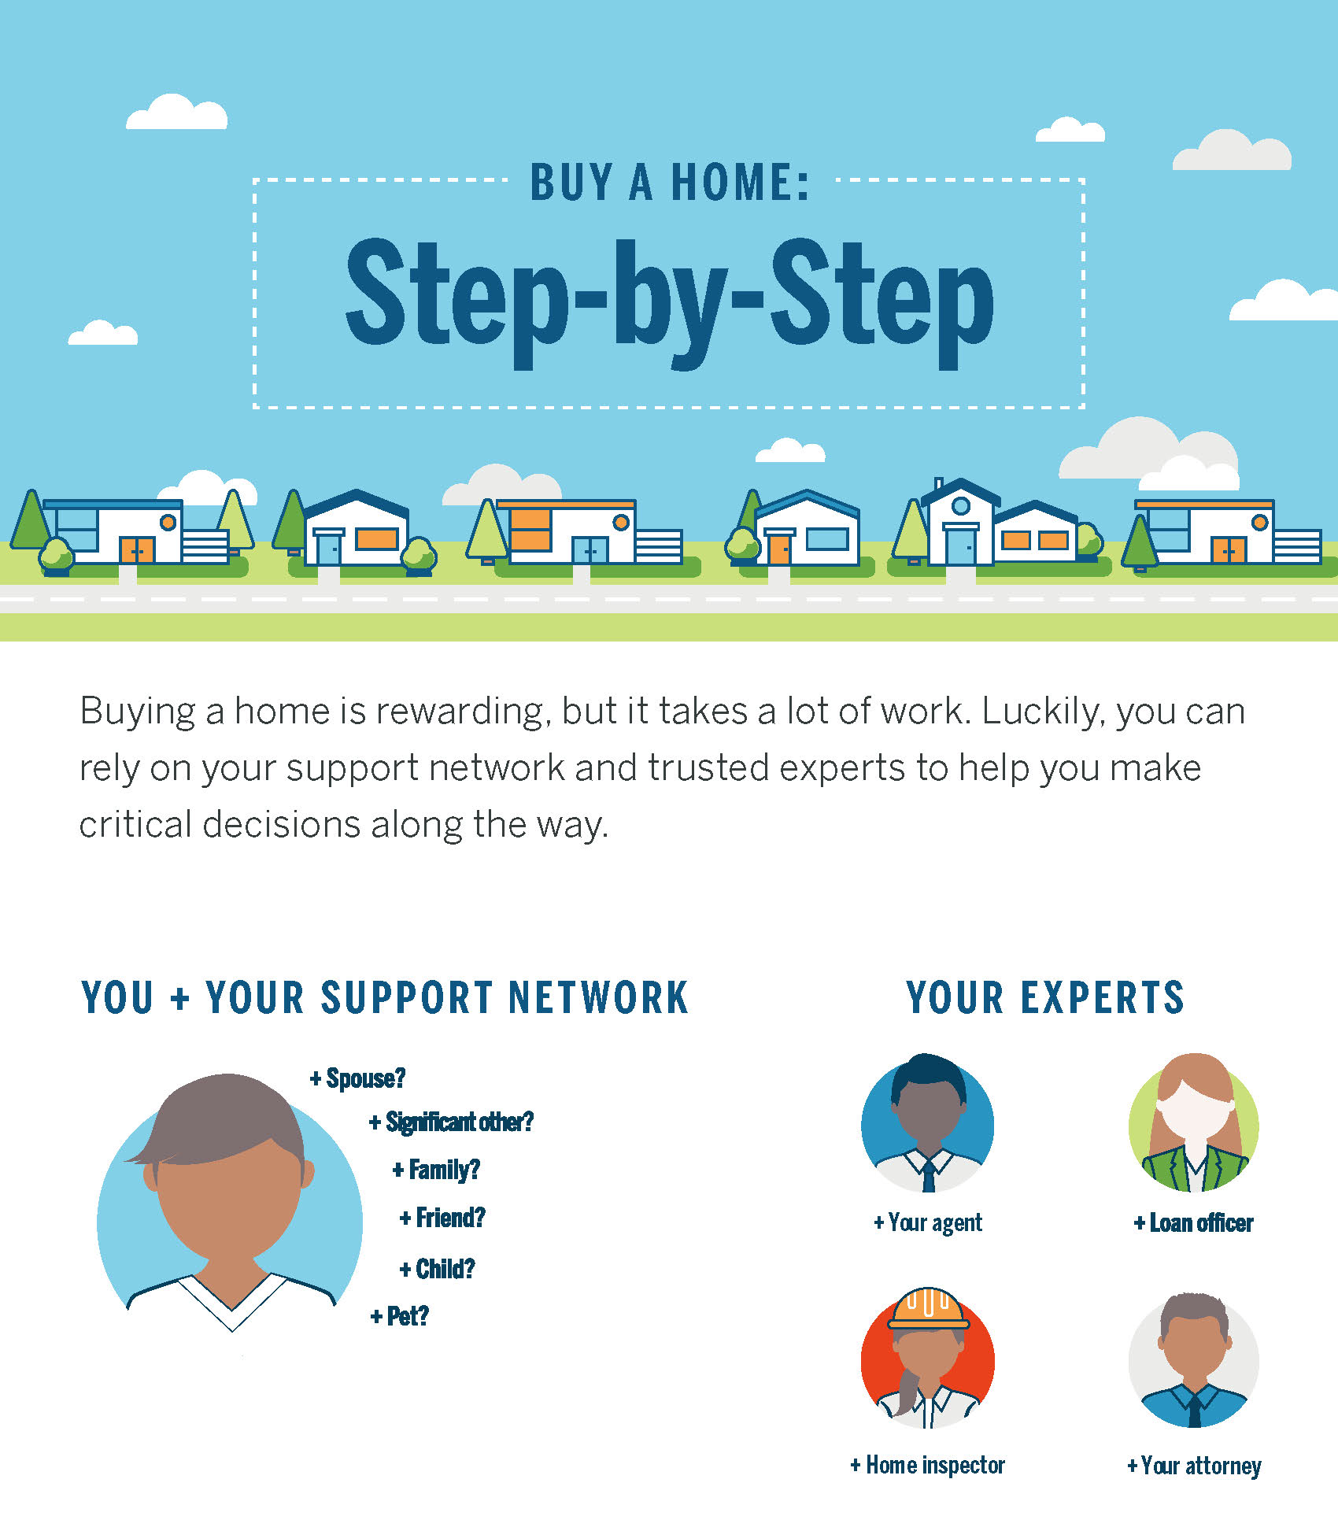

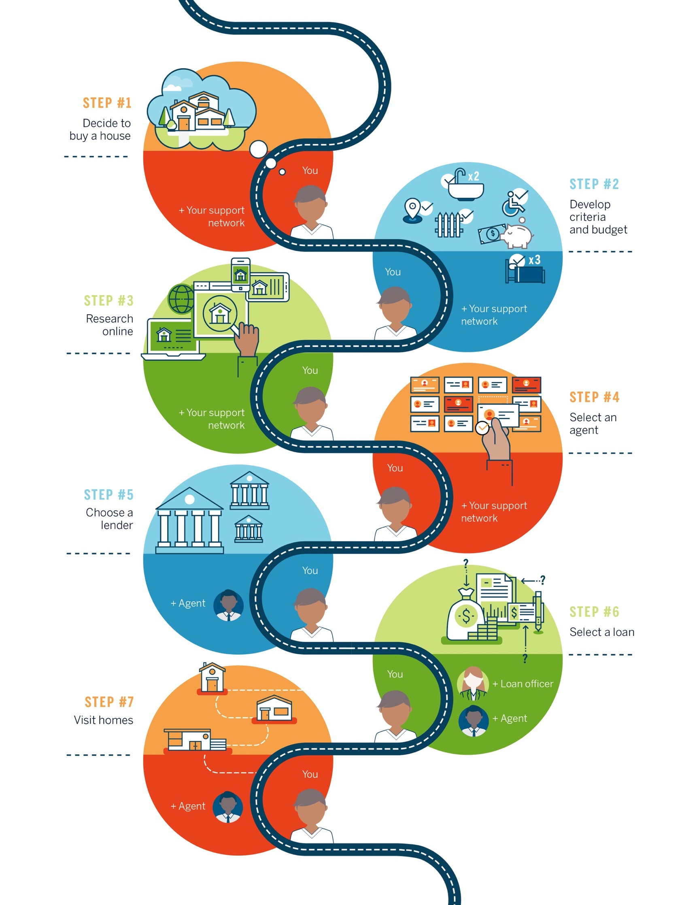

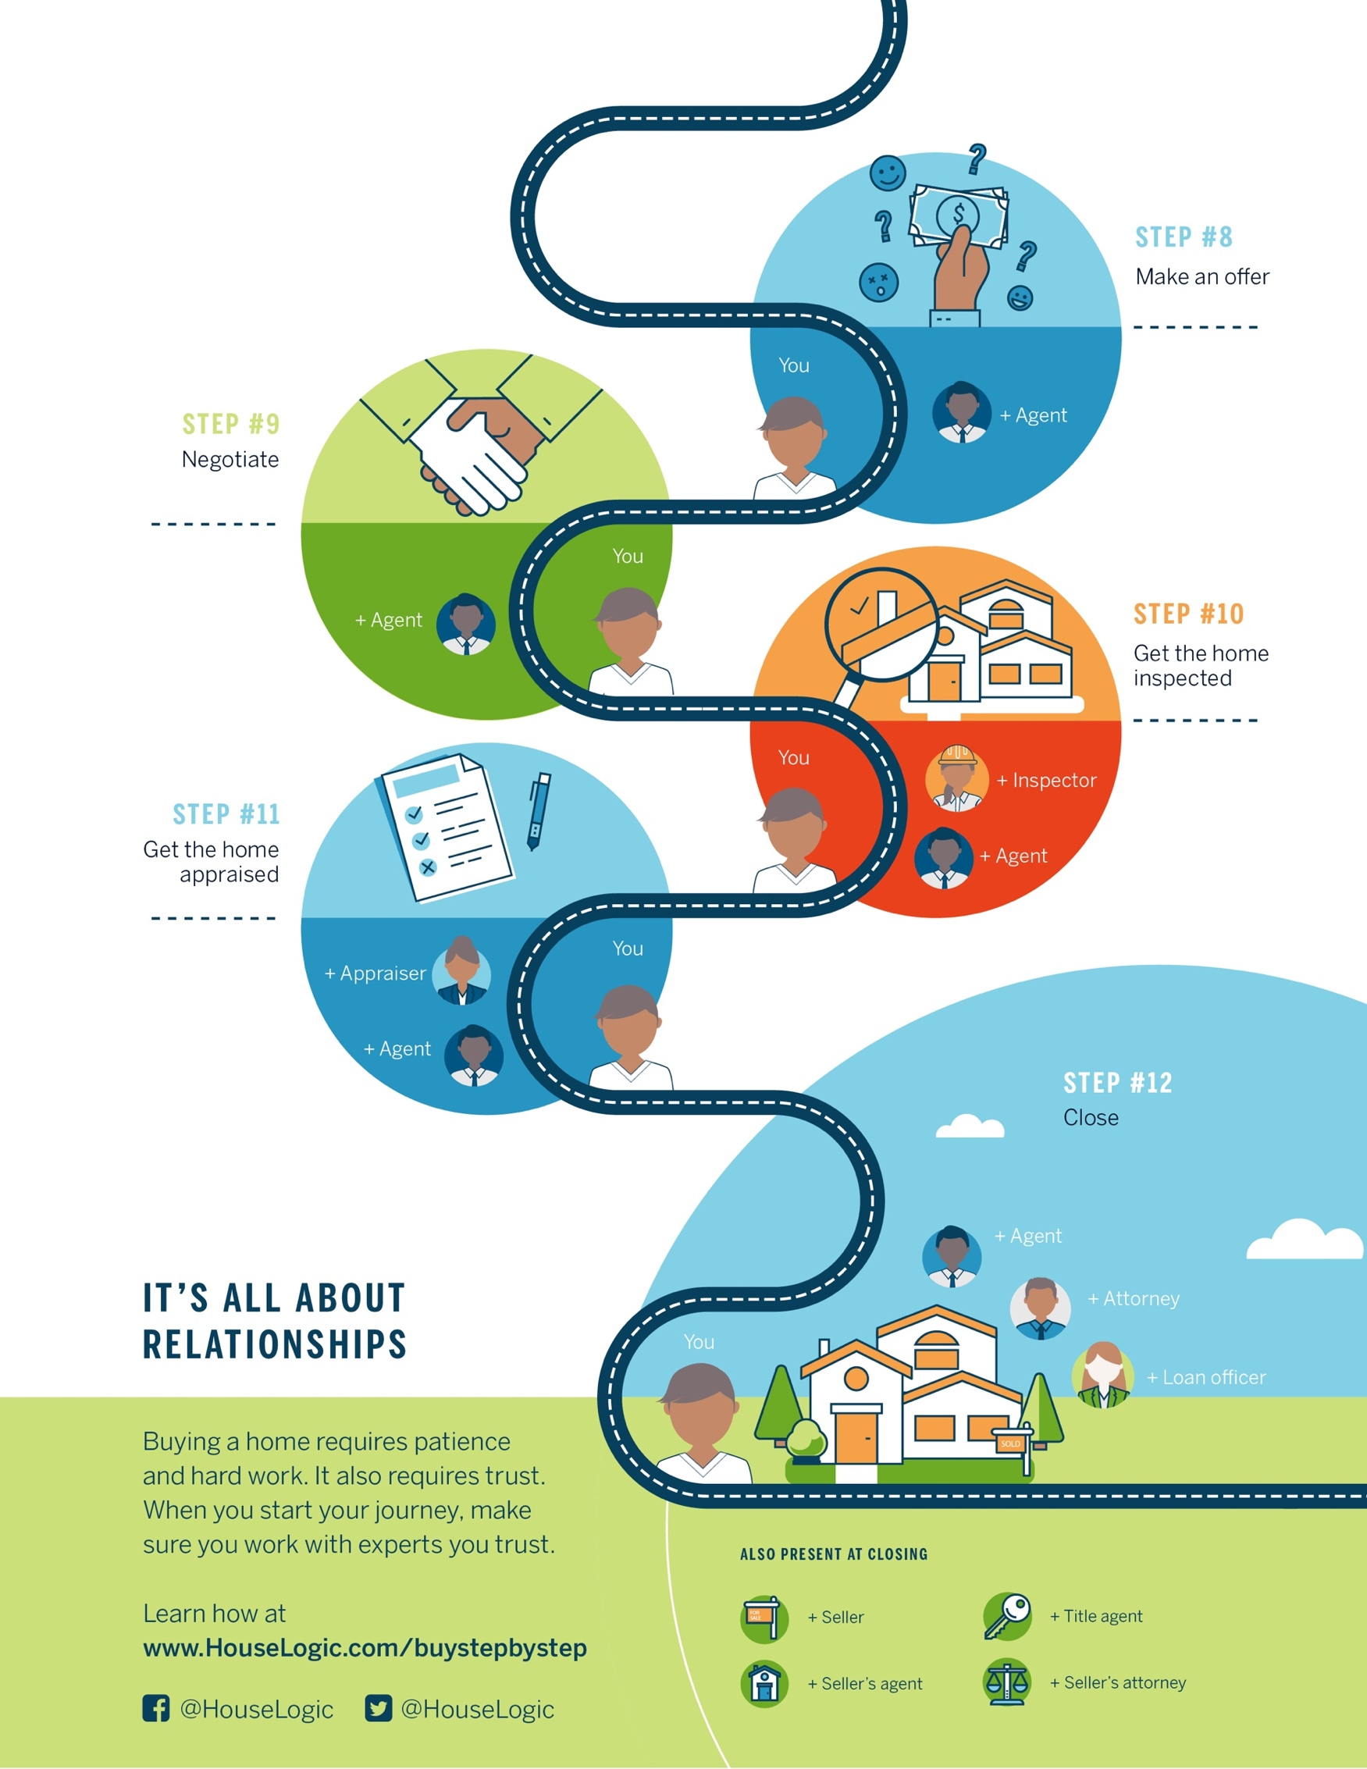

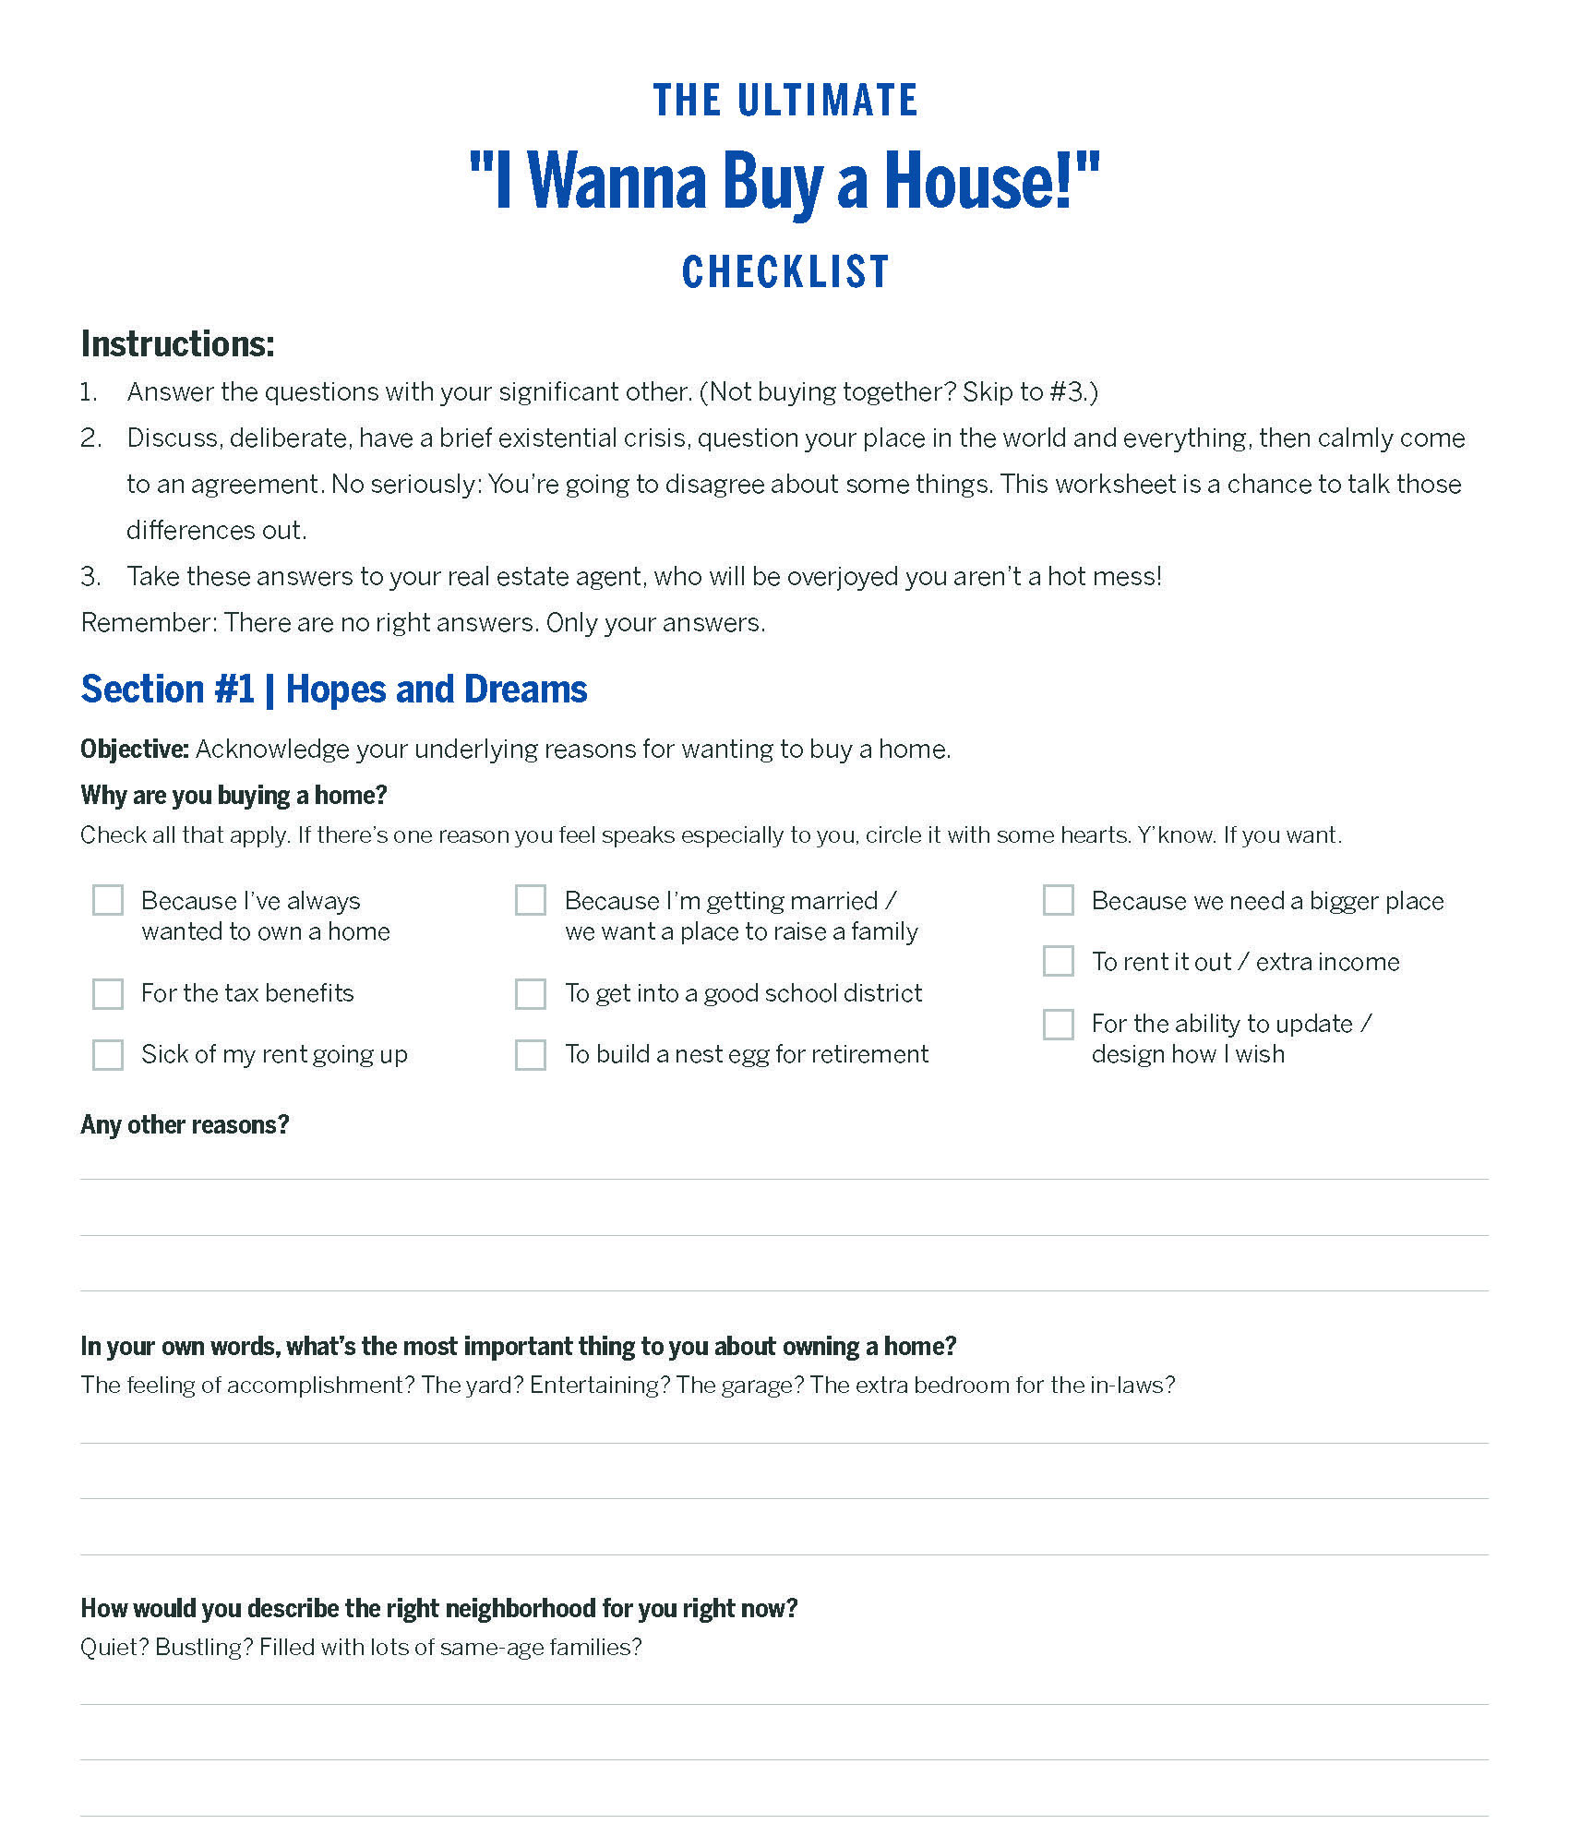

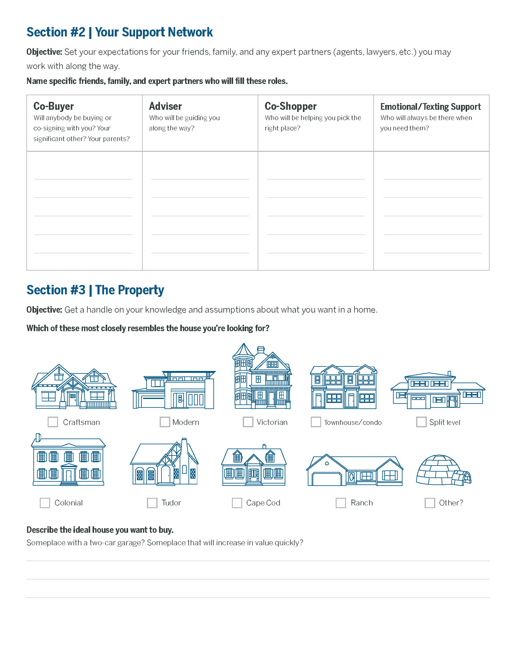

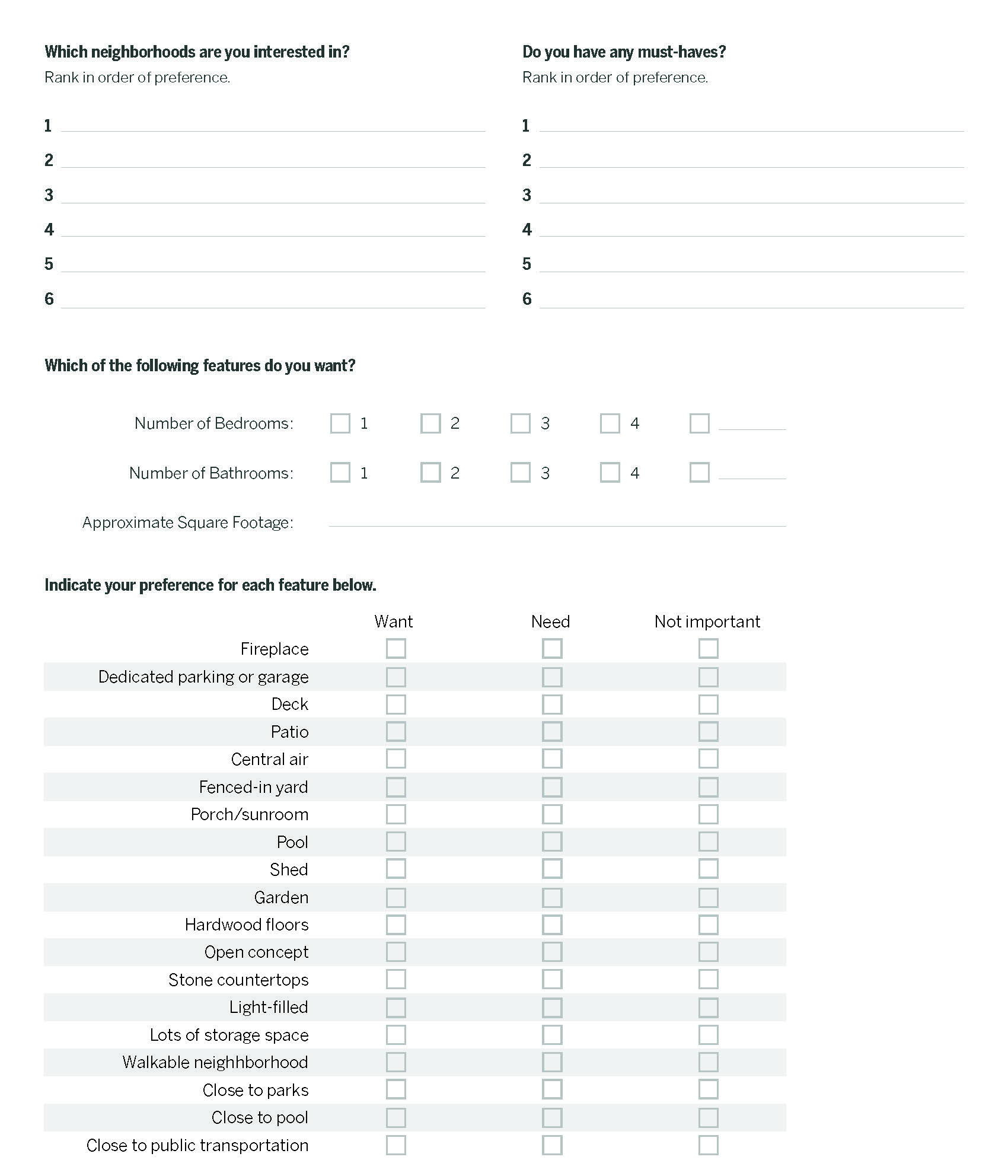

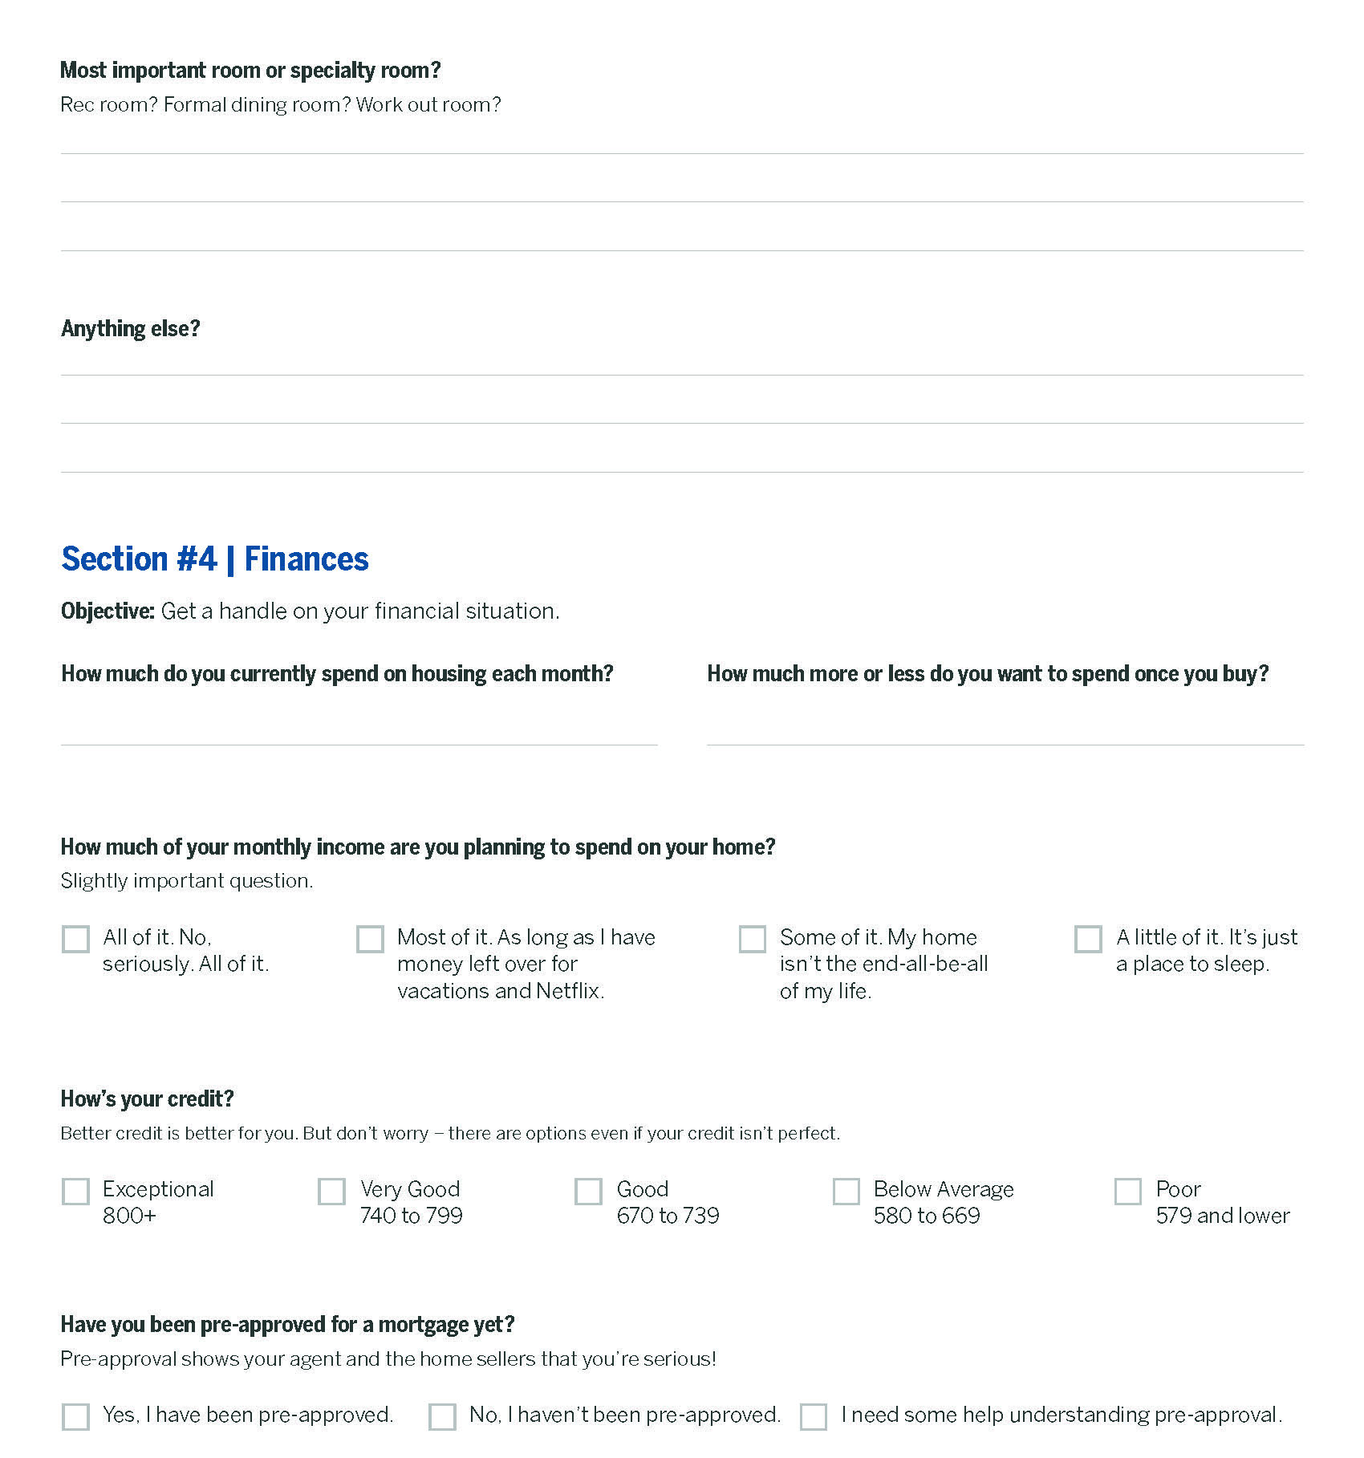

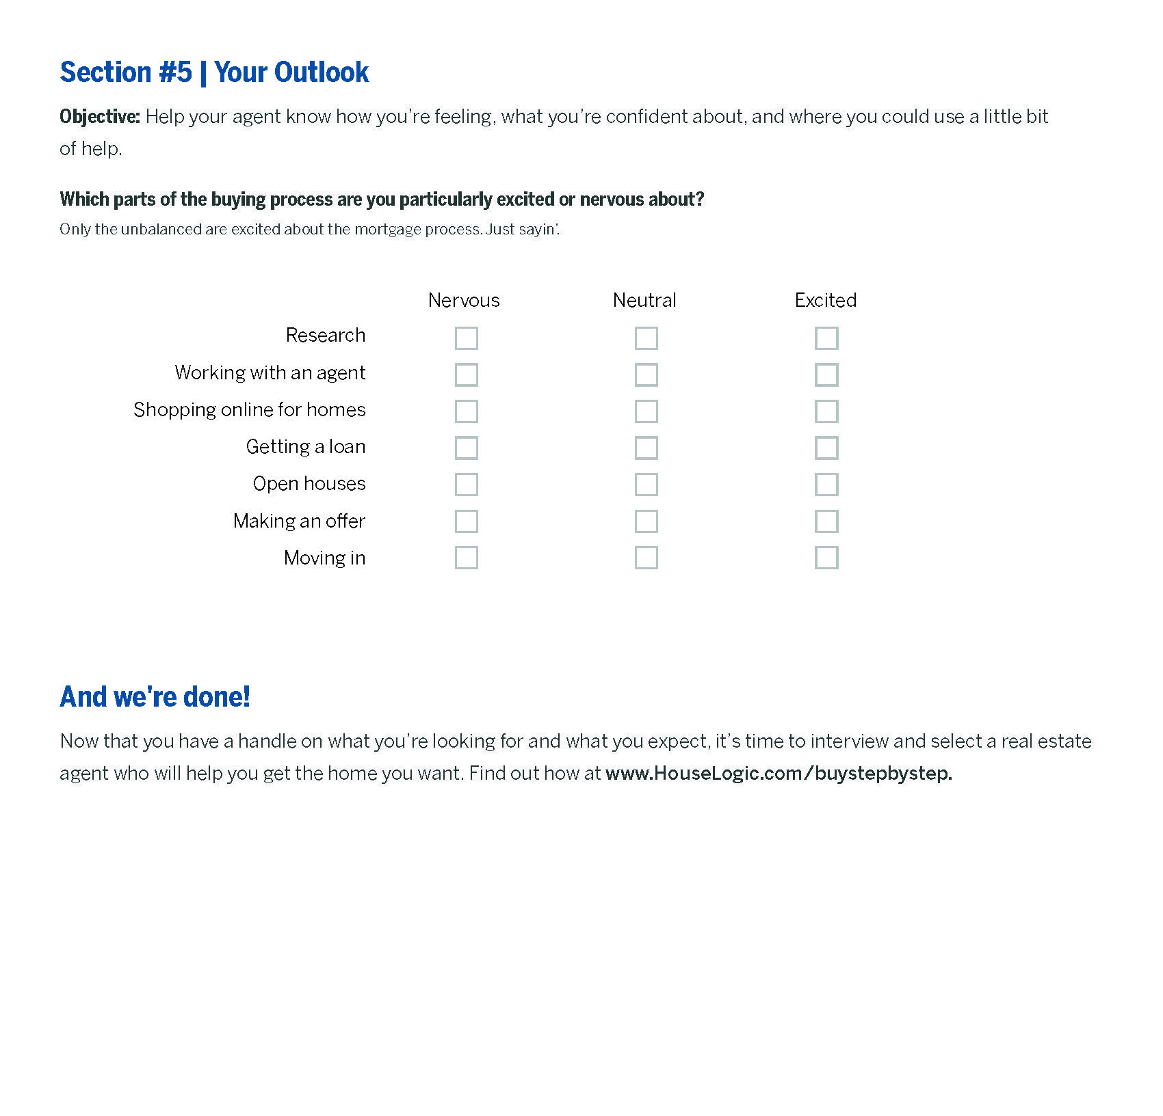

WHAT YOU SHOULD REALLY KNOW ABOUT
Browsing for Homes Online
It’s fun! It’s exciting! It’s important to take everything with a grain of salt!

Oh, let’s just admit it, shall we?
Browsing for homes online is a window shopper’s Shangri-La.
The elegantly decorated rooms, the sculpted gardens, the colorful front doors that just pop with those “come hither” hues. Browser beware, though: Those listings may be seductive, but they might not be giving you the complete picture.

That perfect split-level ranch? Might be too close to a loud, traffic-choked street. That handsome colonial with the light-filled photos? Might be hiding some super icky plumbing problems. That attractively priced condo? Miiiight not actually be for sale. Imagine your despair when, after driving across town to see your dream home, you realize it was sold.

So let’s practice some self-care, shall we, and set our expectations appropriately.

Step one, fill out our home buyer’s worksheet on page 11 of this buying guide. The worksheet helps you understand what you’re looking for. Step two, with that worksheet and knowledge in hand, start browsing for homes. As you do, keep in mind exactly what that tool can, and can’t, do. Here’s how.

You Keep Current. Your Property Site Should, Too
First things first: You wouldn’t read last month’s Vanity Fair for the latest cafe society gossip, right? So you shouldn’t browse property sites that show old listings.

Get the latest listings from realtor.com®, which pulls its information every 15 minutes from the Multiple Listing Service regional databases where real estate agents post listings for sale. That means that realtor.com®’s listings are more accurate than some others, like Zillow and Trulia, which may update less often. You wouldn’t want to get your heart a flutter for a house that’s already off the market.

BTW, there are other property listing sites as well, including Redfin, which is a brokerage and therefore also relies on relationships with brokers and MLSs for listings.

The Best Properties Aren’t Always the Best Looking
A picture, they say, is worth a thousand words. But what they don’t say is a picture can also hide a thousand cracked floorboards, busted boilers, and leaky pipes. So while it’s natural to focus on photos while browsing, make sure to also consider the property description and other key features.

Each realtor.com® listing, for example, has a “property details” section that may specify important information such as the year the home was built, price per square foot, and how many days the property has been on the market.

Ultimately though, ask your real estate agent to help you interpret what you find. The best agents have hyper-local knowledge of the market and may even know details and histories of some properties. If a listing seems too good to be true, your agent will likely know why.

Treat Your Agent Like Your Bestie
At the end of the day, property sites are like CliffsNotes for a neighborhood: They show you active listings, sold properties, home prices, and sales histories. All that data will give you a working knowledge, but it won’t be exhaustive.

To assess all of this information — and gather facts about any home you’re eyeing, like how far the local elementary school is from the house or where the closest Soul Cycle is — talk to your real estate agent. An agent who can paint a picture of the neighborhood is an asset.

An agent who can go beyond that and deliver the dish on specific properties is a true friend indeed, more likely to guide you away from homes with hidden problems, and more likely to save you the time of visiting a random listing (when you could otherwise be in the park playing with your canine bestie).

Want to go deeper? Consider these sites and sources:
- School ratings: GreatSchools.org, National Center for Education Statistics (https://nces.ed.gov), and the school district’s website
- Crime rates and statistics: CrimeReports.com, NeighborhoodScout.com, SpotCrime.com, and the local police station
- Walkability and public transportation: WalkScore.com and APTA.com
- Hospital ratings: HealthInsight.org, LeapfrogGroup.org, and U.S. News and World Report rankings

Just remember: You’re probably not going to find that “perfect home” while browsing listings on your smartphone. Instead, consider the online shopping experience to be an amuse bouche to the home-buying entree — a good way for you to get a taste of the different types of homes that are available and a general idea of what else is out there.

Once you’ve spent that time online, you’ll be ready to share what you’ve learned with an agent.

HERE’S HOW YOU’LL KNOW
You’ve Found the Right Agent
A great real estate agent is like an Oprah for living your best real estate life.
For every journey, there is a guide.
To explore the West, Lewis and Clark had Sacagawea. To navigate his magical powers, Harry Potter had Dumbledore. And to discover our best lives, America has Oprah.
Then there’s the all-too-real journey of buying a home. For that, you have an Oprah of your own: your real estate agent — a licensed professional who’s familiar with local home values and neighborhood perks, understands real estate trends, can write an offer on your behalf, and who negotiates with home sellers so you don’t have to.

Think of your agent as a therapist/consultant for your home search. A collaborator. A co-conspirator. A mentor. Someone who amps up your confidence and counsels you through big decisions (teamwork makes the dream work, after all). And, someone who wants you to find a house you can be happy in because they’re invested in your happiness.

If the housing market doesn’t line up with your needs and budget, your agent will go back to the drawing board with you. They interpret raw housing data through the filter of your unique search, then tell you what’s important and why. They help you map the path to your goal, and connect you with trusted experts who can
get you into your dream home. (Cue selfie of you drinking wine in your new living room. First like on Instagram? Probably your agent.)

That’s a lot of responsibility. And a lot of pressure. There’s obviously a lot at stake: money and time, of course, but also your happiness. So reach out to an agent sooner in the process rather than later, and you’ll be on the fast track to picking out paint swatches for your new kitchen.

Agents, Brokers, and REALTORS®: What’s the Difference?
“Agent” is a catchall phrase that is used, in casual conversation, to describe the three types of professionals who buy and sell real estate: agents, brokers, and REALTORS®. No, they’re not really the same. Yes, you should care about what makes them different.

Here’s a breakdown:
A real estate agent is a licensed professional who helps people buy, sell, rent, or invest in homes. To become an agent, a person must take pre-licensing training from a certified institution (these vary from state to state) and pass their state’s real estate licensing exam. Once they have their license, an agent must affiliate themselves with a real estate brokerage.

Some agents specialize in representing buyers, some specialize in representing sellers. Some do both.
An agent who represents both the buyer and the seller in the same real estate transaction is called a dual agent. By law, a dual agent must disclose dual agency to both parties. (If an agent is seeing other people, you obviously need to know.)

A real estate broker is a professional who has additional education beyond the agent level, as required by state law, and who has passed a broker’s exam. In some cases, brokers also have more years of experience than agents. The biggest difference between a broker and an agent is that a broker may work independently. An agent must be overseen by a broker.

A REALTOR® is a broker or agent who belongs to the National Association of REALTORS® (NAR), the largest trade group in the country. (Full disclosure: NAR publishes HouseLogic.com). A REALTOR® commits to following a strict Code of Ethics intended to protect buyers and sellers; for example, REALTORS® pledge themselves to protect and promote the interests of their client. Agents and brokers who are not NAR members can’t call themselves REALTORS®. There are more than 1 million REALTORS® in the United States. You can use realtor.com®’s Find a REALTOR® tool to connect with one in your area.

In most cases, using an agent, broker, or REALTOR® won’t cost you a penny because the seller typically pays both the listing agent and buyer’s agent’s commissions. However, some buyers’ agents request a representation fee from the buyer. That’s rare.

The Best Agent for You Depends on ... You
Before you seriously partner with anyone, you’ll probably survey family, friends, and trusted acquaintances for at least some input. Finding a real estate agent is no different: A great starting point is to ask your inner circle and neighbors for recommendations. According to recent NAR research, 52% of buyers 36 and younger found their real estate agent through a referral.

Then there’s the internet.

Each of the major property listing websites — realtor.com®, Zillow, Redfin, and Trulia — has an agent-finder tool that lets you search for agents in your area. These property sites also collect reviews and ratings from an agent’s past clients, which gives you insight into an agent’s reputation. Keep in mind, though, that the sites vary in their policies about whether agents can edit or remove reviews. (Like with Yelp, use your own discretion.)

The sites also show an agent’s sales history, so you can see how many homes a person has sold. In general, it’s best to choose an agent who has a large number of sales under his or her belt (a sign they’re committed to real estate work). Perhaps even more important: an agent who has sold homes at the price point and in the neighborhood where you’re looking to buy — a sign they understand the local market.

Whatever you do, don’t rely on online listings alone. Always interview prospective agents — at least three — in person. A meet-and-greet will give you the perspective you need on the agent’s personality and style. Is this someone you’ll like working with? Who has a sense of humor? Who has your back? Who communicates in the ways you want to be communicated with? Best to find out in person.

How to Know If An Agent Is Knowledgeable
Once you’ve gathered all the information, listen to your gut: It won’t steer you wrong about who’s the best agent for you.

But, that said, there are a few qualities you’ll want to look for in any agent (your gut would agree):
- Local expertise. Does this person know their stuff about neighborhood home value trends, shops and restaurants, schools, commute times, and geographic factors such as floodplains? These things are important, especially if you’re looking for a home in a new city or town. If the agent seems lost or like they’re winging it, keep looking.
- Responsiveness. You’ll have a lot of questions, and will be asked to produce documents at certain steps during the buying process. Think about how available you want your agent to be, and how quickly you want him or her to respond. One way to figure that out? Contact a prospective agent online or by phone and see how long it takes them to reply. If you don’t hear back within a timeframe that works for you, it’s probably best to move on.
- Reputation. This is when to consult your inner circle again. The agent-finder tool mentioned above can also help. In addition, you’ll want to verify the agent’s license; search “[state] real estate license lookup” in your browser to find a resource for your state. If you want to confirm whether an agent is a REALTOR®, you can call NAR at 1-800-874-6500.

There are a number of professional designations that indicate an agent has obtained additional education beyond their licensing work. An accredited buyer’s representative (ABR®), for instance, is someone who specializes in working with home buyers and has taken a course on buyer-client relationships.

Don’t Be Afraid to Ask a Lot of Questions
Congratulations! You now have a list of agents you like based on their stats, and you’re ready to get to know the finalists. Binge a few episodes of “The Bachelor” for pointers — just kidding, don’t do that.

What to really do: Schedule interviews with the top three agents, at least. During each conversation, your goal is to understand the agent’s experience, personality, and working style.

Here are 13 questions that will help the vetting:

- How many years have you been in the business? Having more experience doesn’t guarantee that someone is a great real estate agent, but a lot of the business is learned on the job.

- How many homes have you sold in the last year? Volume isn’t the most important factor when choosing an agent, but you want someone who is active in the industry. Also, the more transactions an agent has under their belt, the more adept the person should be at solving complicated problems that can crop up during a home sale. Remember: Your transaction is unique.

- How will you help me determine my needs and priorities? The agent’s first task is to help you identify your list of “musts” and “wants” — the home features that you need, versus the features that you’d like to have but can live without.

- Is your real estate license in good standing? You can also check with your state’s Real Estate Commission to confirm the agent has no disciplinary actions.

- How will you stay in touch with me? Your agent’s communication style should align with yours. If you prefer to be contacted via text when new listings crop up, make sure your agent is able to do that.

- What neighborhoods do you specialize in? You want an agent who’s intimately familiar with the neighborhood(s) you’re interested in. Another way of framing this question is to ask, “How many homes have you sold in this neighborhood in the last year?”

- What price range do you typically work in? In addition to being a neighborhood expert, your agent should do a large portion of their business with home buyers in your price range. It’s important because challenges and negotiation strategies can vary based on what type of home you’re buying.

- How many other clients are you working with? You want someone who can give you quality, one-on-one customer service when you buy your first home. If the agent seems spread thin, it’s probably because they are.

- How are you a good agent for first-time buyers? First-time home buyers face specific challenges. Every buyer has a unique transaction. Good agents can explain what you should expect and how they’re going to help you navigate your special circumstances.

- How will you find homes that match my criteria? Seasoned real estate agents don’t just use the local Multiple Listing Service (MLS) — a regional database of registered property listings — to help home buyers find homes. They also keep track of listings through colleagues, door-knocking, and canvassing neighborhoods to find the right properties for their buyers. They’ll also work their industry connections.

- Have you ever recommended that a buyer not buy a property? Why? An agent should work in your best interest, which means being honest with you about when to pass on a house that will not meet your needs
— even if you’re starry-eyed about it. It’s your choice, obvs, but they should empower you to make a sound
decision.

- Do you have a list of recommended vendors who can help me get a mortgage, inspect a home, and so on? To buy a home, you’re going to need other important players on your team — specifically a mortgage lender, home inspector, settlement/title company, and attorney. An experienced agent has already developed relationships with reputable pros, and should provide you with several references for each; though it’s ultimately your decision to choose who you want to work with.

- Can you provide contact information for your three most recent buyers? Past clients can offer valuable insight into an agent’s skills. Don’t just ask an agent for references, or you’ll get three pre-vetted clients who are guaranteed to sing their praises. Instead, ask for phone numbers and email addresses of the agent’s three most recent buyers. Contact those people directly to learn about their experiences.

Whew, you made it through the interviews. (Are you thirsty? We could use a glass of water.) By now, there’s likely one agent left standing. Someone you can trust. Someone who listens. Someone who knows more about real estate than you, but who also really cares about finding your house.

Now that you’ve got a partner in buying a home, it won’t be long before you own it.

How to Be a Savvy Open House Guest
Getting smart — about what to do, ask, and avoid — can move you ahead of the crowd.

Ah, the open house.
A chance to wander through other people’s homes and imagine yourself knocking out walls and gut rehabbing their kitchens. This is what dreams are made of (or at least episodes of HGTV).
In all seriousness, going to open houses (and scheduled private showings) is one of the most exciting parts of the home-buying experience. Beyond the voyeuristic thrill, visiting houses allows you to assess things that you just can’t see online.

Anyone who has taken a super-posed selfie knows that a picture doesn’t always tell the whole truth. Professional listing photos can make small rooms look spacious, make dim rooms bright, and mask other flaws of a home — but you don’t know any of that until you actually see the house yourself.

You can tour houses at any point, but it can be helpful to first discuss your needs and wants with your partner (if you have one), do some online research, and talk with your agent and your lender. That way, you — and your agent
— can take a targeted approach, which saves you time and can give you an edge over your buying competition. So, before you start viewing, follow these tips to get prepared.

Make It Your Job to Know Which Houses Are “Open”
There are four ways to know when a house is available for viewing:

- Ask your agent. He or she will have details on specific properties and can keep you informed of open houses that fit your criteria.

- Use listing websites. A number of property sites let you search active listings for upcoming open houses. On realtor.com®, for instance, when searching for properties, scroll over the “Buy” tab and click the “Open Houses” link to see upcoming ones in your area.

- Scroll social media. On Instagram, for example, you can search the hashtag #openhouse, or similar tags for your city (#openhousedallas, for example), to discover open houses. Many real estate agents and brokerages also post open house announcements on Instagram, Facebook, and Twitter; find ones from your area and start following.

- Drive around. Cruise through the neighborhoods you’re interested in — it’s a good way to get a sense of the area amenities — and look for open house signs.

And while you’re searching, be sure to jot down the location, time, and date for any open house that strikes your fancy. It will make it that much easier to plan times and routes for hitting as many homes as possible. Drive around.

Get There Early (and Say Hi to the Neighbors)
If you’re seriously interested in a home, show up to the open house early. That way you’ll beat the rush, and the agent showing the house (AKA the host) will have time to focus on you and your questions.

And don’t be shy! Many home buyers hop from one open house to the next without talking to the listing agent. But chatting up the host can help you learn information that you wouldn’t get by only touring the premises.

If a house seems like a match, take a walk around the neighborhood. Strike up conversations with the neighbors to get an insider’s perspective on what life in that community is really like — families, singles, what the vibe on the block is like, and whether the homeowner’s or condo association (if there is one) is easy to work with.

Ask Lots of Questions, But Avoid TMI
To make the most of your open house visits, have a list of questions in mind for the host — and take notes while you’re there, so you can keep track of what you learned.

At the same time, remember this: Your interaction with the host could be the beginning of negotiations with them. If you end up making an offer, you’ll use the information you’ve gathered to inform your bid. (They’ll also remember that you were an engaged yet courteous person, which can’t hurt your cause.)

Equally important: Oversharing could hurt your negotiating power.

Be careful about what information you share with the agent hosting the event. This person works for the seller
- not you. The host can and will use stats they’ve gleaned about you to counter, reject, or accept an offer.

Keeping that in mind, here are eight questions you can ask a host to help determine whether a house is a good fit for you:

- Have you received any offers? If there are already bids on the table, you’ll have to move quickly if you want to make an offer. Keep in mind: Listing agents can’t disclose the amount of any other offers, though — only whether they exist.

- When does the seller want to move? Find out the seller’s timeline. If the seller is in a hurry (say, for a new job), they may be willing to accept an offer that’s below list price.

- When is the seller looking to close? Price isn’t the only factor for many home sellers. One way to strengthen your offer is to propose a settlement date that’s ideal for them. For example, a 30- to 45-day closing is standard in many markets, but the seller may want more time if they haven’t purchased their next home yet.

- Is the seller flexible on price? Most listing agents won’t tip their hand when you ask this question, but there’s always a chance the agent says “yes.” And, in some instances, the seller has authorized their agent to tell interested buyers that the price is negotiable. In any case, you might as well ask. (It’s kind of like googling for a coupon code when you buy something online.)

- How many days has the home been on the market? You can find this information on the internet, but the seller’s agent can give you context, especially if the house has been sitting on the market for a while. Maybe the home was under contract but the buyer’s financing fell through, or the seller overshot the listing price and had to make a price reduction? Knowing the backstory can only help you.

- Has the price changed? You can see if there’s been a price reduction online, but talking to the listing agent is the only way to find out why the seller dropped the price.

- Are there any issues? Have there been any renovations or recent repairs made to the home? Some upgrades, like new kitchen appliances, are easy to spot, but some are harder to identify. Specifically ask about the roof, appliances, and HVAC system because they can be expensive to repair or replace. BTW, repairs like a leaky faucet, aren’t things that need to be disclosed.

- What are the average utility costs? Many buyers don’t factor utility bills into their monthly housing expenses, and these costs can add up — particularly in drafty older homes. Ask the listing agent what a typical monthly utility bill is during the summer and during the winter, since heating and cooling costs can fluctuate seasonally. Be prepared for higher utility bills if you’re moving from an apartment to a single-family home.

Now that you’ve got your answers, there’s one last thing to do: Thank the host before you go. You never know — you could be seeing them again at the negotiating table soon.

YOUR STRESS-FREE GUIDE TO
Shopping for Home Loans
With this super-simple breakdown of loan types, you won’t get overwhelmed — you’ll find the right mortgage.

When it comes to buying a house, most people know what they prefer: a bungalow or a condo, a hot neighborhood or a sleepy street.
Mortgages, too, come in many styles — and recognizing which type you should choose is just slightly more involved than, say, knowing that you prefer hardwood floors over wall-to-wall carpeting.

First things first: To pick the best loan for your situation, you need to know what your situation is, exactly. Will you be staying in this home for years? Decades? Are you feeling financially comfortable? Are you anxious about changing loan rates? Fill in the checklist on page 11, and read “Before You Choose a Mortgage Lender” on page 31 of this guide.

Next: You’ll want to have an understanding of the different loans that are out there. There are lots of options, and it can get a little complicated — but you got this. Here we go.

Mortgages Are Fixed-Rate or Adjustable, and One Type Is Better for You
Let’s start with the most common type of mortgage, that workhorse of home loans — the fixed-rate mortgage.

A fixed-rate mortgage: Lets you lock in an interest rate for 15 or 30 years. (You can get 20-year loans, too.) That means your monthly payment will stay the same over the life of the loan. (That said, your property taxes and insurance premiums will likely change over time.)

It’s ideal when: You want long-term stability and plan to stay put.

Here’s what else you need to know about fixed-rate mortgages:

- A 30-year fixed-rate mortgage offers a lower monthly payment for the loan amount (for this reason, it’s more popular than the other option, the 15-year).
- A 15-year fixed-rate mortgage typically offers a lower interest rate but a higher monthly payment because you’re paying off the loan amount faster.

Now let’s get into adjustable-rate, the other type of mortgage you’ll be looking at.

An adjustable-rate mortgage (ARM):

- Offers a lower interest rate than a fixed-rate mortgage for an initial period of time — say, five or seven years — but the rate can fluctuate after the introductory period is over, depending on changes in interest rate conditions. And that can make it difficult to budget.
- Has caps that protect how high the rate can go.

It’s ideal when: You plan to live in a home for a short time or you expect your income to go up to offset potentially higher future rates.

Here’s what else you need to know about adjustable-rate mortgages:

- Different lenders may offer the same initial interest rate but different rate caps. It’s important to compare rate caps when shopping around for an ARM.
- Adjustable-rate mortgages have a reputation for being complicated. As the Consumer Financial Protection Bureau advises, make sure to read the fine print.

A general rule of thumb: When comparing adjustable-rate loans, ask the prospective lender to calculate the highest payment you may ever have to make. You don’t want any surprises.

Conventional Loan or Government Loan? Your Life Answers the Question
Which fixed-rate or adjustable-rate mortgage you qualify for introduces a whole host of other categories, and they fall under two umbrellas: conventional loans and government loans.

Conventional loans:
- Offer some of the most competitive interest rates, which means you’ll likely pay less in interest over the period of the loan.
- Typically you can get one more quickly than a government loan because there’s less paperwork.

Who qualifies? Typically, you need at least a credit score of 620 or above and a 5% down payment to qualify for a conventional loan.

Here’s what else you need to know about conventional loans:

- If you put less than 20% down for a conventional loan, you’ll be required to pay private mortgage insurance (PMI), an extra monthly fee designed to mitigate the risk to the lender that a borrower could default on a loan. (PMI ranges from about 0.3% to 1.15% of your home loan.) The upshot: The lender has to cancel PMI when you reach 22% equity in your home, and you can request to have it canceled once you hit 20% equity.

- Most conventional loans also have a maximum 43% dept-to- income (DTI) ratio, which compares how much money you owe (on student loans, credit cards, car loans, and other debts) to your income — expressed as a percentage.

Fannie Mae and Freddie Mac set limits on how much money you can borrow for a conventional loan. A home loan that conforms to these limits is called a conforming loan:
- In most cities, the maximum amount for a conforming loan is $453,100.
- In high-cost areas, such as New York City and San Francisco, the limit is $679,650.
- Limits are revisited annually and are subject to change based on each area’s average home price.

A home loan that exceeds these limits is called a jumbo loan:
- Jumbo loans typically require a higher down payment (up to 30% for some lenders) and a credit score of at least 720. Some borrowers can qualify while putting down 20%, but their credit score has to be higher.
- They also tend to have stricter debt-to-income requirements, generally allowing for a maximum DTI ratio of 38%.

There are practical considerations to take into account before getting a jumbo loan too, mainly: Are you comfortable carrying that much debt? The answer depends on your current financial situation and long-term financial goals.

Government loans:
- Include loans secured by the Federal Housing Administration (FHA), U.S. Department of Veterans Affairs (VA), and the U.S. Department of Agriculture (USDA) Rural Development.
- Are meant to stimulate the housing market and enable folks who may be unable to qualify for conventional loans to still become homeowners.

Who qualifies? That depends on which government loan you’re looking at.

If you’ve had trouble qualifying for a mortgage because of income limitations or credit:

FHA loans are used by a broad swath of people, including those with lower credit scores and income.
- You can get an FHA loan with a downpayment of 3.5% if you have a minimum credit score of 580. You can still qualify with a credit score below 580 — even with no credit score — but the down payment and other requirements will be much higher.
- FHA loans conform to loan limits set by county; these limits typically range from $294,515 to $679,650 in high-cost areas. You can view the FHA mortgage caps for your county at hud.gov.
- If you get an FHA loan, you must pay an upfront mortgage insurance premium (MIP) and an annual premium of 0.85%. Currently, the MIP is 1.75% of the loan amount — so, $1,750 for a $100,000 loan. This premium can be paid upfront at the mortgage closing, or it can be rolled into the monthly mortgage payment.

Also, a heads-up — the date an FHA loan was issued affects the MIP.
- If you received an FHA loan on or before June 3, 2013: You’re eligible for canceling MIP after five years, but you must have 22% equity in your home and have made all payments on time.
- If you received an FHA loan after June 3, 2013: To stop paying MIP, you’d have to refinance into a conventional loan and have a current loan-to-value of at least 80%.

If you’re in the military, a veteran, or a veteran’s spouse:
- VA loans offer active or retired military (or a veteran’s surviving spouse) a mortgage with a 0% down payment.
- VA loans also can have more lenient credit requirements — typically around a minimum 620 credit score — and lower DTI requirements.
- The VA only allows lenders to charge 1% maximum to cover the costs of originating and underwriting the loan, so you save money at closing. There is, however, an additional upfront, one-time funding fee of 2.15%.
- VA loan eligibility: http://www.benefits.va.gov/homeloans/

VA loans also don’t charge borrowers mortgage insurance — potentially helping you save a significant chunk of cash on your monthly payment.

Given the benefits, a VA loan is often the best mortgage option for people who qualify.

If your income is limited and you live in a small or rural town:

USDA loans are mortgages for limited-income home buyers in towns with populations of 10,000 or less, or that are “rural in character,” meaning that some areas that now have bigger populations are grandfathered in. You can see whether your town is eligible on the USDA’s website (https://eligibility.sc.egov.usda.gov).

- USDA loans typically have lower interest rates than non-USDA loans.
- Down payments can be as low as 0%.
- USDA mortgages also have more lenient credit score requirements than conventional loans.
- Income limits to qualify depend on location and household size.
- USDA loans charge an upfront mortgage insurance fee of 1% of the loan amount and annual mortgage insurance premium of 0.35%.
- And USDA loan borrowers must buy a “modest home” — a property with a market value deemed reasonable for the area, though the USDA does not set specific price limitations.

Only a select number of lenders offer USDA loans.

If your job is to help people:

Niche programs, like the Neighbor Next Door (htttps://www.hudhomestore.com) from HUD, allow teachers, law enforcement officers, first responders, and government workers — as much as 50% off the list price — on eligible homes in revitalization districts.

Note: Downpayment assistance programs offer qualified buyers such things as grants and interest-free loans. Start with your state’s housing finance agency (https://www.ncsha.org/housing-help) to find options.

Now You Know the Basics. It’s Time to Call for Backup
Speaking of your lender: Ultimately, you’ll be working with your loan officer or broker to narrow down these choices, and to find a loan that works for you and your finances. (Just another reason why it’s important to choose a lender you’re comfortable with.)

Your real estate agent should be able to offer some insight, too. And because they don’t earn a paycheck from your loan selection, their advice about mortgages should be impartial.

You know your stuff. And you know whom to ask for help. Who’s overwhelmed?

Not you.

READ THESE TIPS
Before You Choose a Mortgage Lender
Someone out there wants to help save you time, stress, and money. Here’s how you find them.
Everyone in the market for a house has different wants — pre-war charm, a lush backyard, a welcoming front door in Pantone Ultra Violet, perhaps.
But at the end of the day, they all share a need in common: money. Lots of it. That’s where your mortgage lender comes in.

The right lender can save you time, anxiety, and loads of cash. And the right loan officer — the professional who represents the lender — can be a powerful ally when you close on a mortgage. As with any potentially life- altering partnership, it’s important to choose wisely.

Only You Know Which Lender Is Your Type
There are three types of mortgage lenders — retail banks, credit unions, and mortgage banks — as well as mortgage brokers, who compare loan products via a coterie of potential lenders to help you, the client, find the right one. Before you start narrowing down the candidates, you have to know what you’re looking for, and where to find it. Let’s talk about your options.

Retail Banks
What they are: These are your Chases and Banks of America, plus your local banks. They do their own underwriting (in a nutshell, investigating your finances), so retail banks, especially the smaller ones, can sometimes offer lower fees and less-stringent credit requirements. If you like to have your accounts all in one place, you may want to use your own bank or credit union.

Who you’ll work with:
You’ll be assigned a loan officer, who will receive a commission or bonus for writing your loan.

Credit Unions
What they are: They’re not-for-profit and customer-owned, so they’re not beholden to shareholders like a bank. Because of that and their not-for-profit tax status, they typically offer more personal service and lower fees. The flip side is less convenience: They have fewer branches and ATMs.

And to apply for a loan, you must be a member of the credit union’s community, which could be faith-, employment-, interest-, or union-based, among other things. That said, it’s typically not difficult to become a member; the National Credit Union Administration’s Credit Union Locator (https://www.mycreditunion.gov) is a tool for finding credit unions near you.

Who you’ll work with: As with a bank, you’ll be assigned a loan officer, who will receive a commission or bonus for writing your loan.

Mortgage Banks
What they are: These banks, such as AimLoan and PennyMac, only offer home loans. Many online lenders like Rocket Mortgage by Quicken Loans, operate as mortgage banks.

Who you’ll work with: A mortgage bank will assign you a loan officer, who will receive a commission or bonus from the lender’s gross fees for writing your loan. An online lender is going to offer less hand-holding.

Mortgage Brokers
What they are: Mortgage brokers are essentially personal home loan shoppers — they act as liaisons between home buyers and mortgage lenders to help people find the lowest rates and the best mortgage terms. They’re able to get home buyers the best mortgage rates because they leverage their existing relationships with lenders — something individual home buyers can’t do. By doing the heavy lifting for the borrower, the idea is that they make loan shopping more convenient — and perhaps a bit faster.

Who you’ll work with: A mortgage broker can be an individual agent or a group of agents, who act as independent contractors. In exchange for their services, mortgage brokers typically charge a 1% to 2% fee of the loan amount, which is either paid by the borrower or the lender at closing.

Now that you’re armed with the basics, you’ll want to give yourself time to weigh the options about which lender, exactly, to work with.

It Pays to Shop Around Before You Commit
Over the life of the loan, seemingly subtle differences could add up to tens of thousands of dollars. That money belongs to future you and all your dream vacations, renovations, and remodeling #goals.

So before you choose your specific lender …

- Thoroughly research any retail bank, credit union, mortgage bank, mortgage broker, or online option you’re considering. Make sure you’re clear on what they can offer you. About one in five (21%) home buyers said they regret their choice of mortgage lender, according to a recent J.D. Power survey. You’re doing your homework so that won’t be you.

- Interview lenders. You’re aiming for a shortlist of three. (You’ll see why it’s three in a minute.) If you’re thinking about selecting an online lender, make sure to read “Your Stress-Free Guide to Shopping for Home Loans" on page 26.

- Don’t be shy about seeking advice. Survey your family, friends, and coworkers — especially the ones who are nerdy about money.

- Ask your real estate agent for a second opinion. They have experience with reputable lenders, particularly in your city or town.

Now, let’s say you’ve narrowed your list of potential lenders to at least three candidates. The next step? Finding out whether they will give you a loan.

You Should Seek Out a Lender’s (Pre-) Approval, Too
There’s a world of difference between being pre-qualified for a loan and being pre-approved. Pre-approval means you’ve got skin in the game. It means you’re a boss. And it’s proof that you can buy.

Besides being the grown-up thing to do, pre-approval puts you in a better position when you make an offer. Everyone takes you more seriously. Pre-approval provides evidence to your real estate agent and the seller (or seller’s agent) that a trusted financial institution is willing to finance the purchase.

In most housing markets, sellers are going to expect you to be pre-approved when you make your offer. And when you’re pre-approved, you’re more likely to have your offer accepted — or at least, you won’t lose out on a bid because you have to go back to the bank to get approved for a loan.

As for pre-qualification, it’s an approximation and not necessary unless you have no clue about your creditworthiness and just want a snapshot.

By contrast, with a pre-approval, a lender typically goes deeper and tells you more specifically how big a loan you can get. Caution here: Just because the lender says you can take out a loan for an amount, doesn’t mean you should. Consider your lifestyle and monthly budget to decide on the responsible loan amount for you.

To get pre-approved, you must also authorize a lender to pull your credit.

- Borrowers with credit scores of 760 or higher can typically qualify for the lowest interest rates.
- Borrowers with credit scores below 650 may need to apply for a non-conventional mortgage, such as a Federal Housing Administration (FHA) loan — a government-backed loan that requires a minimum credit score of 580 but lets borrowers make as low as a 3.5% down payment.
- Borrowers with credit scores below 580 can still qualify for FHA loans, but they’ll have to make at least a 10% down payment. The lower the score, the tighter the requirements become.

It Makes Good Sense to Get Pre-Approved by at Least Three Lenders
A Loan Estimate spells out a future loan’s terms, including:

- The interest rate
- The length of the loan
- Estimated costs of taxes and insurance
- How interest rates and payments might change over time
- Other important financials

By comparing loan estimates, you can effectively size up your loan options and decide which lender is best for you — and your future. (If you need help navigating the details, the Consumer Financial Protection Bureau (https://www.consumerfinance.gov) offers a sample Loan Estimate with helpful tips and definitions.)

Getting pre-approval early in the process also gives you an edge over other buyers. Here’s why:

- The amount you’re approved for can help you determine your price range, and thus save time and frustration when shopping.
- It sends a signal to your agent and sellers that you’re serious about buying a home.
- It’ll help you move quickly to make an offer when you see a home you like.

And it’s an excuse to celebrate! You now have everything you need to move ahead with that one special lender
- and, at the same time, connect with an officer or broker who can help you select the home loan product that’s best for you.

So have a cocktail. Do a dance. Lay back and relax in one of those fancy sheet masks. You’re a (huge) step closer to getting a new house.

Make an Offer Like a Boss
These 10 money- and time-saving steps can help you craft a winning bid.

Ah, the offer!
Cinematically speaking, this is the iconic moment — we’d forgive you if you imagined, say, putting a hand on your agent’s shoulder and whispering (in your best Vito Corleone) that you’re going to make them an offer they can’t refuse.

In reality, it’s not that simple (or dramatic). Your offer marks the beginning of a back-and-forth between you and the seller, typically with real estate agents advising you both.

The more intentional you are about your offer, the better your chances of making a successful bid. Follow these 10 steps, and you’ll be well prepared — that’s a true story. (“The Godfather” again. We couldn’t resist.)

#1 Know Your Limits
Your agent will help you craft a winning offer. You can trust your agent’s advice on price, contingencies, and other terms of the deal: It’s a mutually beneficial relationship. The more collaborative you are with your agent, the more quickly you’ll be able to move.

But ultimately, it’s you who decides what the offer will be — and you who knows what your financial and lifestyle limits are. Buying a home means mixing strong emotions with business savvy, so now is also a good time to reflect on your “musts.”

- Have a top limit to your offer price because you’re also saving for retirement and love beach vacations? Stick to it.
- Want a vegetable garden or to paint your home’s exterior purple? Make sure your homeowners association rules permit it.
- Besides reading HOA rules, find out how much the HOA has in reserves to cover common area repairs. You don’t want to be slapped unexpectedly with a special assessment.
- Want a dog-friendly community? Make sure there are no pet weight limits preventing you from cohabitating with your (extra-large) canine bestie.

#2 Learn to Speak "Contract"
Essentially, an offer is a contract. The documents and wording vary across the country.

In the spirit of due diligence, take time to review sample offer forms before you’ve found a house (LawDepot.com has purchase agreements for each state). If you’re high-maintenance, a real estate attorney can explain the documents to you so you’re familiar with their vocabulary when you’re ready to pull the trigger on an offer with your agent. Your agent will have offer forms for your state.

#3 Set Your Price
Homes always have a listing price. Think of it as the seller’s opening bid in your negotiation to buy a home.

As the buyer, your offer will include an offer price. This is the first thing home sellers look at when they receive a bid.

Your agent will help you determine whether the seller’s listing price is fair by running comps (or comparables), a process that involves comparing the house you’re bidding on to similar properties that recently sold in the neighborhood.

Several factors can also affect your bargaining position and offer price. For example, if the home has been sitting on the market for a while, or you’re in a buyer’s market where supply exceeds demand, the seller may be willing to accept an offer that’s below the list price. Or if the seller has already received another offer on the home, that may impact the price you’re willing to offer. Your agent will help you understand the context here.

#4 Figure Out Your Down Payment
To get a mortgage, you have to make a down payment on your loan. For conventional loans (as opposed to government loans), making a 20% down payment enables borrowers to avoid having to pay private mortgage insurance (PMI), a monthly premium that protects the lender in case the borrower defaults on the loan.

But 20% isn’t always feasible — or even necessary. In fact, the median down payment was 10% in 2017, according to the National Association of REALTORS®. Your lender will help you determine what the best down payment amount is for your finances. Depending on the type of loan you get, you may even be able to put down as little as 0% on your mortgage.

You might qualify for one of the more than 2,400 down payment assistance programs nationwide. Many of them make funds available to households earning as much as 175% of area median income. In other words, middle-income households.

And the savings can be substantial: Home buyers who use down payment assistance programs save an average of $17,766 over the life of their loan, according to real estate resource RealtyTrac. Find out more about down payment assistance programs (https://downpaymentresource.com) in your state.

You can use an online mortgage calculator to see how different down payments would affect your mortgage premiums and how much you’ll pay in interest.

#5 Show the Seller You’re Serious: Make a Deposit
An EMD — short for earnest money deposit — is the sum of money you put down as evidence to the seller that you’re serious (read: earnest) about buying the house. If the seller accepts your offer, the earnest money will go toward your down payment at closing. However, if you try to back out of the deal, you might have to forfeit the cash to the seller.

A standard EMD is 1% to 3% of the sales price of the home (so, that would be $2,000 to $6,000 on a
$200,000 loan). But depending on how hot the market is where you live, you may want to put down more earnest money to compete with other offers.

In most cases, the title company is responsible for holding the earnest money in an escrow account. In the event the deal falls through, the title company will disperse the funds appropriately based on the terms of the sales contract. Title companies also check for defects or liens on a seller’s title to make sure it can be transferred cleanly to you.

#6 Review the Contingency Plans
Most real estate offers include contingencies — provisions that must be met before the transaction can go through, or the buyer is entitled to walk away from the deal with their EMD.

For example, if an offer says, “This contract is contingent upon a home inspection,” the buyer has a set number of days after the offer is accepted to do an inspection of the property with a licensed or certified home inspector.

If something is wrong with the house, the buyer can request the seller to make repairs. But most repairs are negotiable; the seller may agree to some, but say no to others. Or the seller can offer a price reduction, or a credit at closing, based on the cost of the repairs. This is where your real estate agent can offer real value and counsel on what you should ask the seller to fix.

Just remember to keep your eye on the big picture. If you and the seller are bickering over a $500 repair to the hardwood floors, keep in mind that’s a drop in the bucket in relation to the size of the bid.

In addition to the aforementioned home inspection contingency, other common contingencies include:
- A financing contingency, which gives home buyers a specified amount of time to get a loan that will cover the mortgage.
- An appraisal contingency, where a third-party appraiser hired by the lender evaluates the fair-market value of the home to ensure the home is worth enough money to serve as collateral for the value of the mortgage.
- A clear title contingency, where the buyer’s title company verifies that the seller is the sole owner of the property and can legally convey ownership to the buyer.
- A home sale contingency, where the transaction is dependent on the sale of the buyer’s current home.

Although contingencies can offer protection to buyers, they can also make offers less appealing to the seller because they give buyers legal ways to back out of the sale without any financial repercussions. So, if you’re going up against multiple offers, making an offer with fewer contingencies can potentially give you an edge over the competition.

In other words: A chill offer is an attractive offer. But keep in mind you have to be comfortable with the risks that come with this strategy. If you don’t have a financing contingency, for example, and you can’t get a mortgage, you’d likely lose your earnest money deposit since you’re on the hook. (An outcome that’s decidedly un-chill for you.)

#7 Read the Fine Print About the Property
The sales contract states key information about the property, such as the address, tax ID, and the types of utilities: public water or private well, gas or electric heating, and so on. It also includes a section that specifies what personal property and fixtures the seller agrees to leave behind, like appliances, lighting fixtures, and window shades. The seller provides prospective buyers with a list of these items before they submit an offer. This can be another area of negotiation.

Carefully reviewing the property description also helps you know, for example, if the seller plans to take that unattached kitchen island with them when they move. (Stranger things have happened.)

#8 Make a Date to Settle
The sales contract you submit to the seller must include a proposed settlement date, which confirms when the transaction will be finalized. The clock starts as soon as the purchase agreement is signed. If you don’t close on time, the party that’s responsible for the delay may have to pay the other party compensation in the form of “penalty interest” at a predetermined rate.

A 30- to 60-day settlement period is common because it gives the typical home buyer time to complete a title search and obtain mortgage approval, but settlement periods can vary. Some sellers, for example, prefer a longer period so they have more time to move or look for their next house. Being flexible, with respect to the closing date, could give you more negotiating power in another area of the deal.

One thing that’s the same no matter where you live is that you’ll have a three-day period prior to settlement to review the Closing Disclosure, or CD — a five-page form that states your final loan terms and closing costs.

Once the sales contract is signed, the parties can change the settlement date if they both sign an addendum specifying the new day.

#9 Write a Fan Letter to the Seller
Want to make a truly compelling offer? Pull on the seller’s heartstrings by attaching a personal letter to the bid documents. Tell a compelling story about your family and your connection to the area. Get deep about your roots.

Also, sincere flattery can go a long way. Compliment the seller on how their kitchen renovation looks Apartment Therapy–worthy, for instance, or how the succulents in their landscaping remind you of a resort in Palm Springs.

Your agent can help you gather background on the sellers (e.g., are they crazy about their labradoodle, like you are about yours? Did they run a small business from the home, like you dream of doing?). And you should — of course — refer to information you gleaned during the open house or private showing. Use this intel to write a message that really speaks to the seller, and it may very well seal the deal.

#10 Brace Yourself for a Counteroffer
If you’re making a lowball bid or going up against multiple offers, the seller may decide to make you a counteroffer — a purchase agreement with new terms, such as a higher sales price or fewer contingencies. At that point, it’s up to you to accept the new contract, make your own counteroffer to the sellers, or walk away.

Don’t panic: The next part of our guide walks you through the counteroffer process, and it offers strategies to give you more negotiating power.

8 SIMPLE RULES FOR
Negotiating Your Offer and
Getting That House
You and your agent are going to use everything you’ve learned to seal the deal.

Here's the dream:
Your offer is perfect, you don’t need to negotiate, and you can spend the next few weeks addressing more pressing home-ownership questions, like “Why is it called wainscoting?” and “Do I want a new couch in blush or emerald green?”

And it could happen. Many sellers accept the best offer they receive, and for a variety of reasons.

But sellers are also known to reject offers for a variety of reasons. Or make counteroffers. This is especially likely if you bid low, or when you’re up against multiple competing offers.

If you do receive a counteroffer, it’s up to you to decide whether you want to accept the new contract, negotiate the terms, or walk away.

In cases such as these, look to your agent. He or she is your spirit guide. If you decide you want to negotiate — that is, make a counteroffer to the seller’s counteroffer — your agent will use their negotiating skills to help get you the best deal. This is what agents do every day.

But you’re not just going to sit there. If you understand what negotiating tactics your agent may deploy — they depend on the local market and your position — you can back them up. And cheer them on.

Here are eight rules every buyer should know before they — and their agent — start negotiating:

#1 Act Fast — Like, Now
When you receive a counteroffer, you should respond quickly — ideally within 24 hours. The longer you wait, the more space you leave for another buyer to swoop in and nab the property. Also? If a seller senses hesitation, they may decide to withdraw their counteroffer before you even have a chance to respond.

#2 Raise Your Price (Within Reason)
While you obviously don’t want to overpay for a house, you may have to up the ante — especially if you initially made a lowball offer. Lean on your agent’s expertise to determine how much money you should add to the sales price to make it more enticing to the seller.

Then, through their powers of persuasion, your agent can make the counteroffer look even more attractive by pointing out similarly priced “comps” — recently sold homes in your area that are comparable in terms of square footage and features.

As your agent negotiates, it can feel like things are escalating quickly. It’s stressful. You may feel a sudden urge to do whatever it takes to win.

Before you go overboard, there are two things you must keep in mind:

- You can’t exceed the monetary confines of the pre-approved mortgage you received from your lender.
- You shouldn’t overextend your budget.

Because your counteroffer has to be an amount you’re comfortable spending on a home. You want that new house and to keep living your life. Plus: You’re not out of options yet.

#3 Increase Your Earnest Money Deposit
Increasing your earnest money deposit (EMD) — the sum of money you put down to prove to the seller you’re serious (i.e., “earnest”) about buying the house — is another way to show the seller you have more skin in the game. A standard EMD is typically 1% to 3% of the sales price of the home. Making a counteroffer with a 3% to 4% deposit could be what you need to persuade the seller to side with you.

#4 Demonstrate Patience About Taking Possession
Depending on the seller’s timetable, changing your proposed possession date — the date you take over the property — could butter them up, too. If the seller wants to stay in the home for a few days after closing, try offering a later possession date. You could also draw up a “rent-back” agreement, meaning the seller pays you rent for staying in the home for a set period of time after the closing date.

#5 Let Go of a Few Contingencies — With Care
Want to give your counteroffer an even bigger boost?

Reduce the number of contingencies you’re asking for. It’s your way of saying, “Hey, look, I have fewer ways to back out,” which gives the seller more reassurance that the deal will close.

But be selective: Some contingencies are too important to give up. A home-inspection contingency — the right to have a home inspection and request repairs — gives you an out if you spot major problems with the home (and protects you from buying a total money pit).

You might waive a termite inspection if you’re in a state where the risk is lower.

But ultimately, waiving contingencies depends on your market, your loan program requirements, your risk tolerance, and the circumstances of the house in question. And if you waive contingencies and then you find a problem, the seller isn’t responsible for fixing it.

#6 Ask for Fewer Concessions
At a mortgage settlement, home buyers have to pay closing costs for taxes, lender’s fees, and title company fees. Closing costs vary by location, but you can expect to shell out between 3% and 4% of the home’s sales price. The seller pays an additional 1% to 3%. (SmartAsset.com and Nerdwallet.com have simple calculators you can use to get a rough idea of what your closing costs might be.)

When making an initial offer, you have the option to ask the seller for concessions — a settlement paid in cash to help you offset your share of the closing costs. (This move is less feasible if you’re going up against multiple offers.)

Concessions effectively lower the seller’s net proceeds from the sale. Making a counteroffer that removes the concessions you would have otherwise received at settlement puts cash back in the seller’s pocket — and can improve your bid.

#7 Pick Up the Cost of the Home Warranty
Sometimes sellers offer prospective buyers a home warranty. This is a plan that covers the cost of repairing major home appliances and systems, like the air conditioner or hot water heater, if they break down within a certain period (typically a year after closing).

A basic home warranty costs about $300 to $600 a year, according to Angie’s List. If it seems like waiving the home warranty can sweeten negotiations, but you still want the peace of mind of having one, tell the seller they don’t need to cover it — then buy it yourself.

Just keep in mind, whether you or the seller buy the warranty, you’ll need to pay the service fee (typically between $50 and $100) if something does, indeed, need to be repaired while under warranty.

Also, FYI: A home warranty is entirely separate from homeowners insurance. Homeowners insurance — the security blanket that covers your home’s structure and possessions in the event of a fire, storm, flood, or other accident — is required if you take out a mortgage. It can cost anywhere from $300 to $1,000 per year.

#8 Know When to Walk
When negotiating with a seller, trust your gut — and your agent. If he or she says a deal is bad for you: Listen.

And if you don’t want to make any more trade-offs — and the seller won’t budge — it’s smart to walk. That can be a tough decision to make, and rightfully so! Negotiating is tough. It’s draining.

And losing something you’ve worked hard to get can be disappointing. But don’t worry. There’s a better deal for you out there. And after those strong feelings of frustration pass, you’ll realize:

Now I know how to do this.

WHAT TO EXPECT
During a Home Inspection
From finding an inspector to dealing with surprises — this is your guide to getting a house checked out.

The first thing you need to know about home inspection:
You’ll feel all the feels.
There’s the excitement — the inspection could be the longest time you’re in the house, after the showing. Right behind that comes … anxiety. What if the inspector finds something wrong? So wrong you can’t buy the house?

Then there’s impatience. Seriously, is this whole home-buying process over yet?

Not yet. But you’re close. So take a deep breath. Because the most important thing to know about home inspection: It’s just too good for you, as a buyer, to skip. Here’s why.

A Home Inspector Is Your Protector
An inspector helps you make sure a house isn’t hiding anything before you commit for the long haul. (Think about it this way: You wouldn’t even get coffee with a stranger without checking out their history.)

A home inspector identifies any reasonably discoverable problems with the house (a leaky roof, faulty plumbing, etc.). Hiring an inspector is you doing your due diligence. To find a good one (more on how to do that soon), it helps to have an understanding of what the typical home inspection entails.

An inspection is all about lists.

Before an inspection, the home inspector will review the seller’s property disclosure statement. (Each state has its own requirements for what sellers must disclose on these forms; some have stronger requirements than others.) The statement lists any flaws the seller is aware of that could negatively affect the home’s value.

The disclosure comes in the form of an outline, covering such things as:
- Mold
- Pest infestation
- Roof leaks
- Foundation damage
- Other problems, depending on what your state mandates.

During the inspection, an inspector has three tasks -- to:

- Identify problems that he or she can see
- Suggest fixes
- Prepare a written report, usually with photos, noting observed defects

This report is critical to you and your agent — it’s what you’ll use to request repairs from the seller. (We’ll get into how you’ll do that in a minute, too.)

The Inspector Won’t Check Everything
Generally, inspectors only examine houses for problems that can be seen with the naked eye. They won’t be tearing down walls or using magical X-ray vision, to find hidden faults.

Inspectors also won’t put themselves in danger. If a roof is too high or steep, for example, they won’t climb up to check for missing or damaged shingles. They’ll use binoculars to examine it instead.

They can’t predict the future, either. While an inspector can give you a rough idea of how many more years that roof will hold up, he or she can’t tell you exactly when it will need to be replaced.

Finally, home inspectors are often generalists. A basic inspection doesn’t routinely include a thorough evaluation of:

- Swimming pools
- Wells
- Septic systems
- Structural engineering work
- The ground beneath a home
- Fireplaces and chimneys

When it comes to wood-burning fireplaces, for instance, most inspectors will open and close dampers to make sure they’re working, check chimneys for obstructions like birds’ nests, and note if they believe there’s reason to pursue a more thorough safety inspection.

If you’re concerned about the safety of a fireplace, you can hire a certified chimney inspector for about $125 to
$325 per chimney; find one through the Chimney Safety Institute of America (https://www.csia.org).

It’s Your Job to Check the Inspector
Now you’re ready to connect with someone who’s a pro at doing all of the above. Here’s where — once again — your real estate agent has your back. He or she can recommend reputable home inspectors to you.

In addition to getting recommendations (friends and relatives are handy for those, too), you can rely on online resources such as the American Society of Home Inspectors’ (ASHI) Find a Home Inspector tool (https://www.homeinspector.org/), which lets you search by address, metro area, or neighborhood.

You’ll want to interview at least three inspectors before deciding whom to hire. During each chat, ask questions such as:

- Are you licensed or certified? Inspector certifications vary, based on where you live. Not every state requires home inspectors to be licensed, and licenses can indicate different degrees of expertise.

- How long have you been in the business? Look for someone with at least five years of experience — it indicates more homes inspected.

- How much do you charge? The average home inspection costs about $315. For condos and homes under 1,000 square feet, the average cost is $200. Homes over 2,000 square feet can run $400 or more. (Figures are according to HomeAdvisor.com.)

- What do you check, exactly? Know what you’re getting for your money.

- What don’t you check, specifically? Some home inspectors are more thorough than others.

- How soon after the inspection will I receive my report? Home inspection contingencies require you to complete the inspection within a certain period of time after the offer is accepted — normally five to seven days — so you’re on a set timetable. A good home inspector will provide you with the report within 24 hours after the inspection.

- May I see a sample report? This will help you gauge how detailed the inspector is and how he or she explains problems.

Sometimes you can find online reviews of inspectors on sites like Angie’s List and Yelp, too, if past clients’ feedback is helpful in making your decision.

Show Up for Inspection (and Bring Your Agent)
It’s inspection day, and the honor of your — and your agent’s — presence is not required, but highly recommended. Even though you’ll receive a report summarizing the findings later on, being there gives you a chance to ask questions, and to learn the inner workings of the home.

Block out two to three hours for the inspection. The inspector will survey the property from top to bottom. This includes checking water pressure; leaks in the attic, plumbing, etc.; if door and window frames are straight (if not, it could be a sign of a structural issue);
if electrical wiring is up to code; if smoke and carbon monoxide detectors are working; if appliances work properly. Outside, he or she will look at things like siding, fencing, and drainage.

Get Ready to Negotiate
Once you receive the inspector’s report, review it with your agent.
Legally, sellers are required to make certain repairs. These can vary depending on location. Most sales contracts require the seller to fix:
- Structural defects
- Building code violations
- Safety issues

Most home repairs, however, are negotiable. Be prepared to pick your battles: Minor issues, like a cracked switchplate or loose kitchen faucet, are easy and cheap to fix on your own. You don’t want to start nickel-and- diming the seller.

If there are major issues with the house, your agent can submit a formal request for repairs that includes a copy of the inspection report. Repair requests should be as specific as possible. For instance: Instead of saying “repair broken windows,” a request should say “replace broken window glass in master bathroom.”

If the seller agrees to make all of your repair requests:

He or she must provide you with invoices from a licensed contractor stating that the repairs were made. Then it’s full steam ahead toward the sale.

If the seller responds to your repair requests with a counteroffer:

He or she will state which repairs (or credits at closing) he or she is willing to make. The ball is in your court to either agree, counter the seller’s counteroffer, or void the transaction.

At the end of the day, remember to check in with yourself to see how you’re feeling about all of this. You need to be realistic about how much repair work you’d be taking on. At this point in the sale, there’s a lot of pressure from all parties to move into the close. But if you don’t feel comfortable, speak up.

The most important things to remember during the home inspection? Trust your inspector, trust your gut, and lean on your agent — they likely have a lot of experience to support your decision-making.

That’s something to feel good about.

HEY, BUYERS:
These Home Appraisal Tips Are for You
What to expect, when to negotiate, and how to deal when things don’t go your way.

Most people have deeply personal reasons for wanting to buy a home.
Maybe it’s the bathroom that feels like a dreamy, modern spa. Or that two-tiered deck just made for parties.

Your lender doesn’t care about the freestanding tub. Or the built-in outdoor fire pit. Their only concern is that the house you buy is worth as much as the value of your mortgage.

To them, a house isn’t a home. It’s collateral. (Harsh, but true.) If someday, for some reason, you can’t make your mortgage payments, the lender can foreclose on the home and sell it to recoup all or some of its costs. (Even harsher, but also true.)

For that reason, a home must be valued at, or above, the agreed-upon purchase price, and this has to happen before you can close on a house. That’s where a home appraiser comes in.

A Home Appraiser Is Neutral (Like Switzerland)
After you sign a home purchase agreement (the contract between you and the seller about the terms of the pending sale), and before your lender approves your loan, the home you’re buying must pass an appraisal — an assessment of the property’s value by an unbiased third party: the appraiser.

An appraiser is a state-licensed or -certified professional. Their job is to assess an opinion of value — how much a house is worth. The appraiser is on no one’s side. They don’t represent you or the seller; instead, this person is a contractor chosen by your lender through an appraisal management company (AMC), a separate, neutral entity that maintains a roster of appraisers.

Appraisers survey a house in person, using five main criteria to determine the value of a home:
- Location
- Age
- Condition
- Additions or renovations
- Recent sales of comparable homes

Be Prepared to Pay for the Appraisal — or to Negotiate
Generally speaking, the home buyer is responsible for paying for the appraisal — and the fee is typically wrapped into your closing costs. However, who pays for appraisal is negotiable. It never hurts to see if the seller is willing to cover it.

How much money are we talking about? The average professional home appraisal will run between $287 and $373, according to estimates by the home-professionals resource HomeAdvisor.com. Costs can vary depending on the square footage and quirks of the house, with higher appraisal prices for larger or more unique homes.

Appraisals Take a While, So Be Patient
Typically, a purchase agreement has a “home appraisal contingency” requiring that the appraisal be completed within 14 days of the sales contract being signed. Because it takes appraisers some time to visit your house and write a report — up to a week, or longer in a busy housing market — your lender will order the appraisal immediately after you sign the purchase agreement.

So, You Have a Valuation. Here’s What It Means — and What to Do Next
When the appraisal is finished, the appraiser issues a written report with his or her opinion of the value of the home. To produce the report, they use their analysis of the property and data from comparable homes, as well as review the purchase offer. The report will outline their methodology and also include photographs that they’ve taken of the property, inside and out.

You and your lender will both receive a copy of the report. Three things could happen next:
- If the appraiser’s valuation matches the price you and the seller agreed to for the home: Your lender will proceed to underwrite your loan. Great news: This is the final step in your loan-getting process!
- If the appraiser’s valuation is higher than what you’re paying for the home: Congratulations! You’ve gained immediate equity. How, you ask? Let’s say, for example, you’re paying $200,000 for the house. If the appraiser says it’s worth $250,000 — jackpot. That’s an instant $50,000 in equity. (Keep in mind, this is very rare.)
- If the appraisal is lower than what you’ve agreed to pay for the home: Your lender won’t give you a loan for more than the appraised value. If you and the seller agreed on $200,000, for example, but the appraisal is $190,000, that creates a $10,000 shortfall. So what happens next?

Don’t despair — not yet. If you’re faced with a low appraisal, there are several ways the deal can still go through.

If an Appraisal Is Low, You Can Still Make It Work
Before we talk strategy, some reasons why appraisals come in lower than expected:
- The seller overvalued the price of the home.
- The appraiser isn’t familiar with the neighborhood.
- The appraiser overlooked pending sales data.
- The appraiser had trouble finding comparable homes, or missed comparable homes, so they compared your home with properties outside the neighborhood.
- Home prices in the area are changing so fast that the listing agent’s price no longer reflects the market.
- The appraiser rushed the job.

If the appraisal comes in low, your agent will offer recommendations about how to proceed. In general, your best strategy is to persuade the seller to lower the sales price, or to split the difference between the home’s appraised value and the price with you. This is when you can rely on your agent — and their negotiating skills — to go to bat for you.

You can also appeal the appraisal assessment. You’ll work with your agent to research comparable homes that support the sales price you agreed upon with the seller and present this information to your lender, who will forward it to the appraiser for a re-evaluation of the home’s value. Ultimately, though, it’s up to the appraiser to decide whether to revise their valuation of the property.

Alternately, you can ask your lender for a second appraisal, though there are caveats:

You’ll have to pay for it out of pocket (or persuade the seller to foot the bill). You’re more likely able to challenge an appraisal for a conventional loan than a government loan. And you’d need solid facts to back it up in either case. There’s no guarantee that it will be higher and meet the sales price.

The last option: You can come up with the cash yourself to cover the difference between the home’s price and the appraised value.

If you don’t want to take that route (and who could blame you?), a purchase agreement’s home appraisal contingency gives you the ability to walk away from the deal scot-free, and with your earnest money deposit in hand.

But today, let’s assume it all works out.
With the appraisal behind you, you’ll be one step closer to closing on that house.

IN CLOSING:
How to Seal the Home-Buying Deal
Sign that paperwork. Write those checks. Get those keys!

The closing. It all comes down to this. The grand finale.
Once you have the keys, the house is yours. (Cue: Air horn sound!)
Nice work getting this far. You’re almost a homeowner! Let’s run through some questions you may have as you cross the finish line.

What Does "Closing" Mean?
The close or settlement is when you sign the final ownership and insurance paperwork and get the home’s keys.

The closing process technically begins when you have signed a purchase and sale agreement. That agreement should specify a closing date. Typically — from the signing date to the closing date — closing takes four to
six weeks. During this time, purchasing funds are held in escrow, where your money is safe until the deal is officially done.

What's a Closing Disclosure?
Lenders must provide borrowers with a Closing Disclosure, or CD, at least three days before settlement. This form is a statement of your final loan terms and closing costs.

You have three days to review the CD. Compare it to the Loan Estimate you received shortly after you applied for the loan. For info on Closing Disclosures and Loan Estimates and to find sample forms, visit: (https://www.consumerfinance.gov.)

The point of this formal review process is to ensure there are no surprises at the closing table. If there’s a significant discrepancy between the Loan Estimate and CD, notify your lender and title company immediately. Depending on what the underlying issue is, the closing has to stop and a new closing disclosure must be sent out with a new three-day review period.

There are a couple things on the LE that can’t change by the time you get the CD — namely interest rate and lender fees.

Some items can change by only 10% (fees paid to local government to record the mortgage might be one); and others can change without limit, like prepaid interest, because it can’t be predicted at the start of the loan process.

When Will the Final Walk-Through Happen?
Most real estate sale contracts allow the buyer to walk through the home within 24 hours of settlement to check the property’s condition. During this final inspection, which usually takes about an hour, you and your agent will make sure any repair work that the seller agreed to make has been completed.

During the walk-through, you’ll also double-check that everything in the house is in good working order.

Be sure to:
- Run water in all the faucets and check for leaks under sinks.
- Test appliances.
- Check the garage door opener.
- Flush toilets.
- Open and close all doors.
- Run the garbage disposal and exhaust fans.

If the home is in good shape — woo-hoo! Your next stop is the closing table.

If anything is amiss, your agent will contact the listing agent and, in most cases, negotiate to get the seller to compensate you at closing — typically in the form of a personal check — for the costs of fixing the problems yourself.

Worst-case scenario: You have to delay closing to resolve problems. In the unlikely event that happens, your agent will help you address the issue.

Who’s Invited to The Closing?
Certain people will be there. Who, exactly, depends on your state. Typically, you will be joined by:
- Your agent
- The seller
- The seller’s agent
- A title company representative
- Your loan officer
- Any real estate attorneys involved in the transaction

The closing usually takes place at the title company, attorney’s office, or the buyer’s or seller’s agent’s real estate office. FYI: Some states, like California, don’t require an in-person, sit-down closing because they’ve enacted legislation that allows for electronic closings with remote notaries.

Nonetheless, as the home buyer, you’ll have to sign what might seem like a mountain of paperwork — including the deed of trust, promissory note (promising the lender you’ll pay back the loan), and other documents. That cramp in your wrist will be worth it once everything is done.

How Much Will I Pay for Closing Costs?
If you’ve heard people vent frustration with the process of buying a home, then you’ve likely heard complaints about unexpected costs at closing. Let’s unpack what you should expect so you’re not surprised, too.

Closing costs can vary widely by location and your home’s purchase price. Costs are split between you and the seller, but as the buyer you’ll cover the lion’s share. You can generally expect your closing costs to be 3% to 4% of the home’s sales price. So, on a $300,000 home, you can pay anywhere from $9,000 to $12,000 in closing costs. (Meanwhile, the seller typically pays closing costs of 1% to 3% of the sales price.)

You can try to predict closing costs with calculators like Nerdwallet’s, which lets you plug in your mortgage details to get a rough estimate of what your costs will be.

Closing fees often include (but are not limited to):
- Commission for the buyer’s agent and seller’s agent
- A loan application fee
- An origination fee, which lenders charge for processing your loan
- The appraisal fee
- A fee for pulling your credit report
- An underwriting fee, which covers the lender’s costs of researching whether to approve you for the loan
- A title search fee
- Property taxes, which are due within 60 days of the purchase
- A recording fee for filing a public land record with the courthouse These fees are a bummer.
The bright side: Almost all of them are one-time deals.

What Should I Bring? (Other than Champagne?)
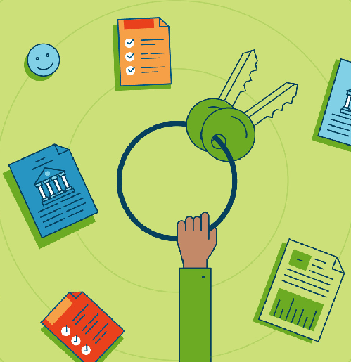
At the closing you should have:
- A government-issued photo ID
- A copy of the ratified sales contract
- A homeowner’s insurance certificate
- Proof of flood insurance, if you’re buying a home in a flood zone
- A cashier’s check, or proof of wire transfer, to cover the remainder of the down payment and your closing costs

Also, talk to your attorney about anything else you might need to bring depending on your state or personal circumstances (such as a separation or divorce decree, should your relationship status affect the closing).

What Is Title Insurance and Why Do I Need It?
Every lender requires borrowers to purchase title insurance — a policy that protects you and the lender from outside claims of ownership of the property. Wait, you may be asking, some random person could show up and claim they own the house? Sounds crazy, but it happens.

Let’s say a previous owner didn’t pay all of their property taxes. Because those taxes remain against the property, the taxing entity could potentially take your home if you don’t have a “clean” title. Title insurance also protects you from ownership claims over liens, fraudulent claims from previous owners, clerical problems in courthouse documents, or forged signatures.

The title company will perform a comprehensive search of deeds, wills, trusts, and public records to trace the property’s history and verify that you’re becoming the rightful sole owner of the property.

Typically, lenders have a preferred title company they work with, but it’s ultimately the buyer’s decision as to which title company to use. Your agent could offer a few referrals.

Title insurance comes in two forms:

- Lender’s title insurance, which (no surprise) protects the lender. It’s required.

- Owner’s title insurance, which protects you. It’s optional but recommended because it covers your interest in the property. If the insurance company loses a battle over the title in the future but you purchased owner’s title insurance, you’re fully protected. Owner’s title insurance will also cover your legal
fees if you have to defend your ownership rights in court.

Unlike most insurance policies, such as homeowner’s insurance, car insurance, and life insurance, title insurance is paid as a one-time fee at closing. The average cost of title insurance is about $544 for the lender’s policy and about $830 for the homeowner’s policy, according to ValuePenguin data. However, costs can vary significantly depending on the home you’re buying, where it’s located, and how much legwork the title company has to perform.

What If There are Last-Minute Issues? Should I Panic?
For your loan to be approved, it has to go through underwriting. The underwriter’s job is to validate all of your financials — confirming that your income, credit, and debt haven’t changed since you were pre-approved for the loan — as well as to review the property’s characteristics and appraisal. If everything checks out, your mortgage will be approved.

If something goes wrong during underwriting though, you’ll have to address the problem before you can close on the home. Let’s say your credit score dropped because you recently purchased a car with an auto loan, or maxed out your credit cards.This isn’t necessarily dire, but you may need to delay closing as you work with your lender to take steps to raise your score. (Also, for that reason, it’s a good idea to hold off on big purchases, avoid overusing a credit line, and doing really anything that could result in a credit inquiry until after the closing.)

OK — Can I Celebrate Now?
If you’ve made it through close … YES! Once you’ve climbed that mountain of paperwork and have those keys in your hands, you now officially, finally own a home.

Congratulations! You put in a lot of hard work — including to build relationships with your agent, your lender, and other experts along the way.

Now it’s time to start investing in other relationships. Like with your new neighbors :)

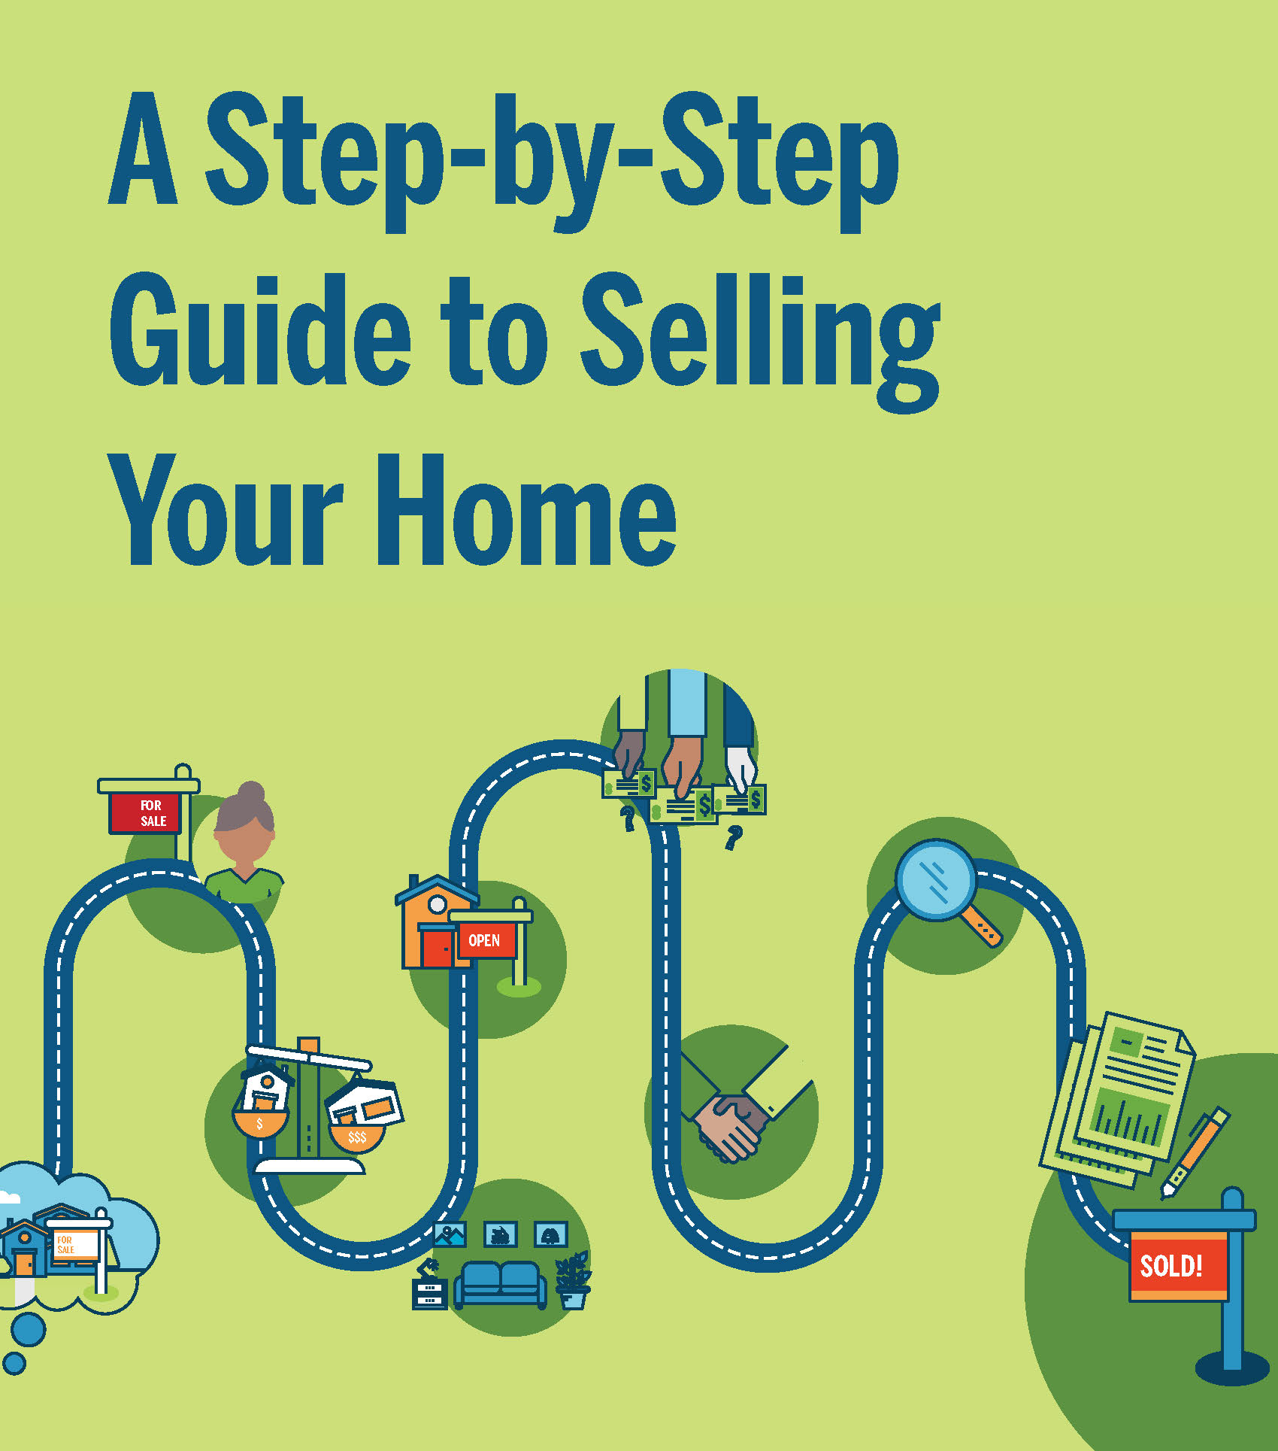

THE EVERYTHING GUIDE TO
Selling Your First Home
How to figure out exactly what you want, and how to work with the experts who’ll help you get it.

Selling, a famous salesman once said, is essentially a transfer of feelings.
You love and cherish your home. You want the next owner to fall in love with it, too — through photos, through words, and through the experience of walking through your front door. But, perhaps most, you want to get the price you want.

This isn’t a small task. Selling a home requires work. It requires time. The journey isn’t always easy. There will be frustrations. But when you seal the deal and move on to your next chapter — wow, what a blissful, boss feeling.

Below, we preview each step in your journey. We’ll discuss how to know what you want (and what your partner wants, if you’re selling together). How to understand the market, and ways to make a plan. And most importantly? How to create relationships with experts and trust them to help you get the job done. Now, let’s talk about selling your house.

Know, Exactly, What You Want
First things first: You need to know what you want (and what your partner wants) in order to sell your home with minimum frustration. Why are you moving? What do you expect from the process? When, exactly, should you put that For Sale sign in the yard? We can help you get your thoughts in order with this home selling worksheet on page 63.

Do Your Research
Unless you bought your home last week, the housing market changed since you became a homeowner. Mortgage rates fluctuate, inventory shifts over time — these are just a few of the factors that affect the state of the market, and every market is unique. Educate yourself on what to expect.

Interview and Select an Agent
This is the most important relationship you’ll form on your home selling journey. Pick the right agent and you’ll likely get a better sales price for your house.

Price Your Home
How much is your home worth? That’s the … $300,000 question. Whatever the number, you need to know it. This is how your agent will help you pinpoint the price.

Prep Your Home for Sale
Today, home buyers have unfettered access to property listings online, so you have to make a great first impression — on the internet and IRL. That means you’ll have to declutter all the stuff you’ve accumulated over the years, make any necessary repairs, and get your home in swoon-worthy condition. Here’s how to stage your home.

Market Your Home
Home buyers look at countless listings online. The best-marketed homes have beautiful photos and compelling property descriptions, so they can get likes — which can amount to buyer interest — on social media. Some agents are even using videos, virtual tours, texts, and audio messages. It’s time to consider how to promote your property.

Showcase Your Home
One of the best ways to get buyers in the door is to have an open house. This is your chance to show off your home’s best assets, and help buyers envision themselves living there. Know how your agent will organize, advertise, and host the event to ensure it’s a success.

Negotiate With the Buyer
To get the best deal for you, you’ll likely have to do some negotiating. Your agent will help you craft a strategic counteroffer to the buyer’s offer, factoring in not only money, but contingencies, etc. Let’s talk about how to ask for what you want.

Negotiate Home Inspection Repairs
Ah, the home inspection. It’s as much a source of anxiety for buyers as it is for sellers. Nonetheless, most purchase agreements are contingent on a home inspection (plus an appraisal, which will be managed by the buyer’s lender). This gives the buyer the ability to inspect the home from top to bottom and request repairs — some even could be required per building codes. The upshot: You have some room to negotiate, including about certain repairs. Once again, your agent will be there to help you effectively communicate with the buyer.

Close the Sale
Settlement, or closing, is the last step in the home selling process. This is where you sign the final paperwork, make this whole thing official, and collect your check. Before that can happen though, you’ll have to prepare your home for the buyer’s final walk-through and troubleshoot any last-minute issues.

We’ve got you covered.

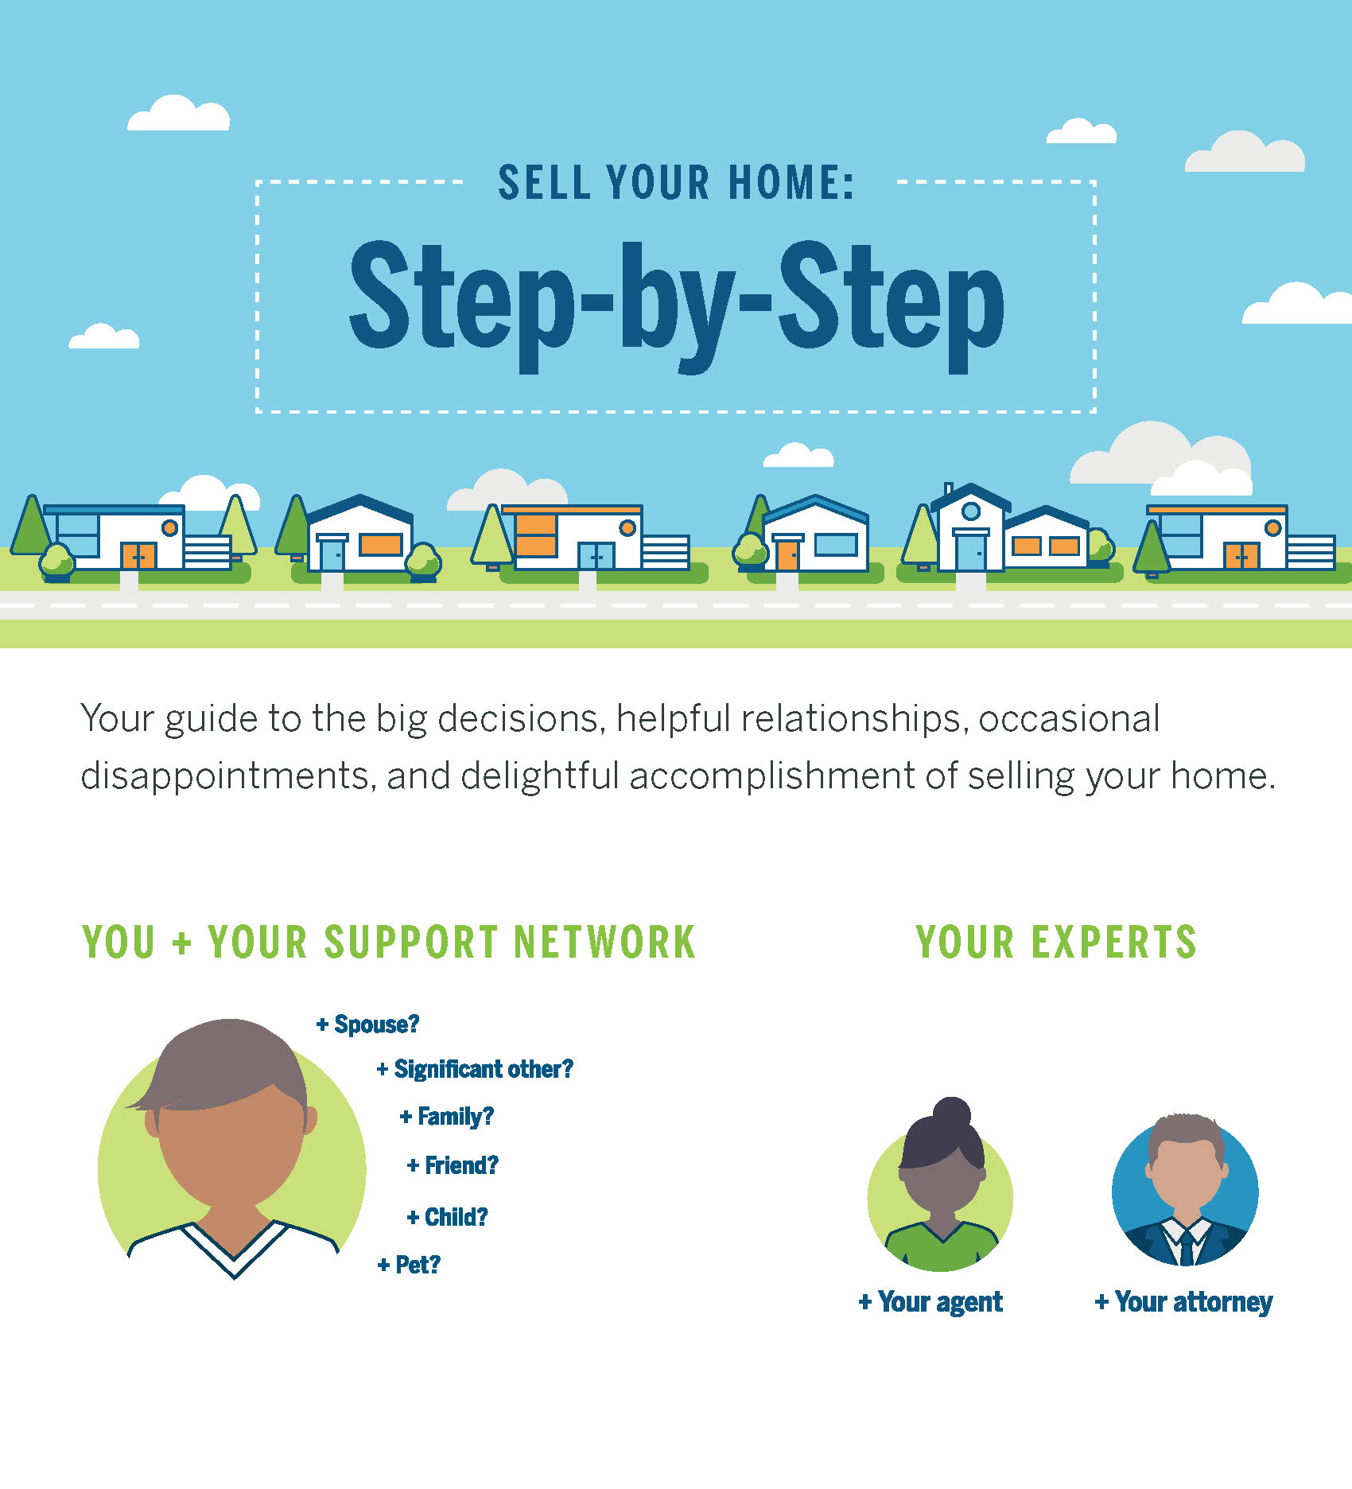

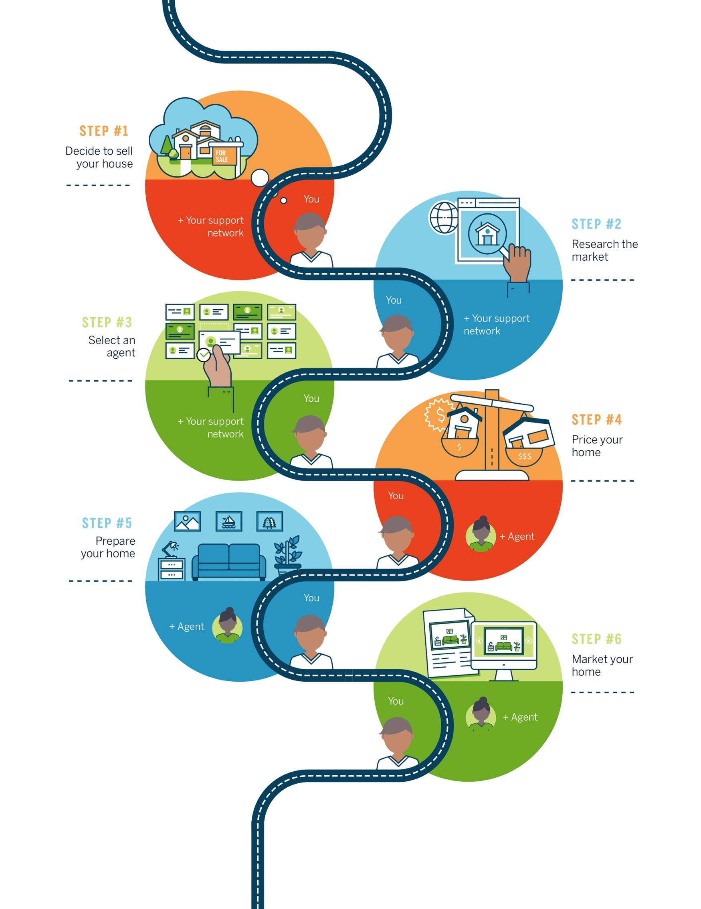
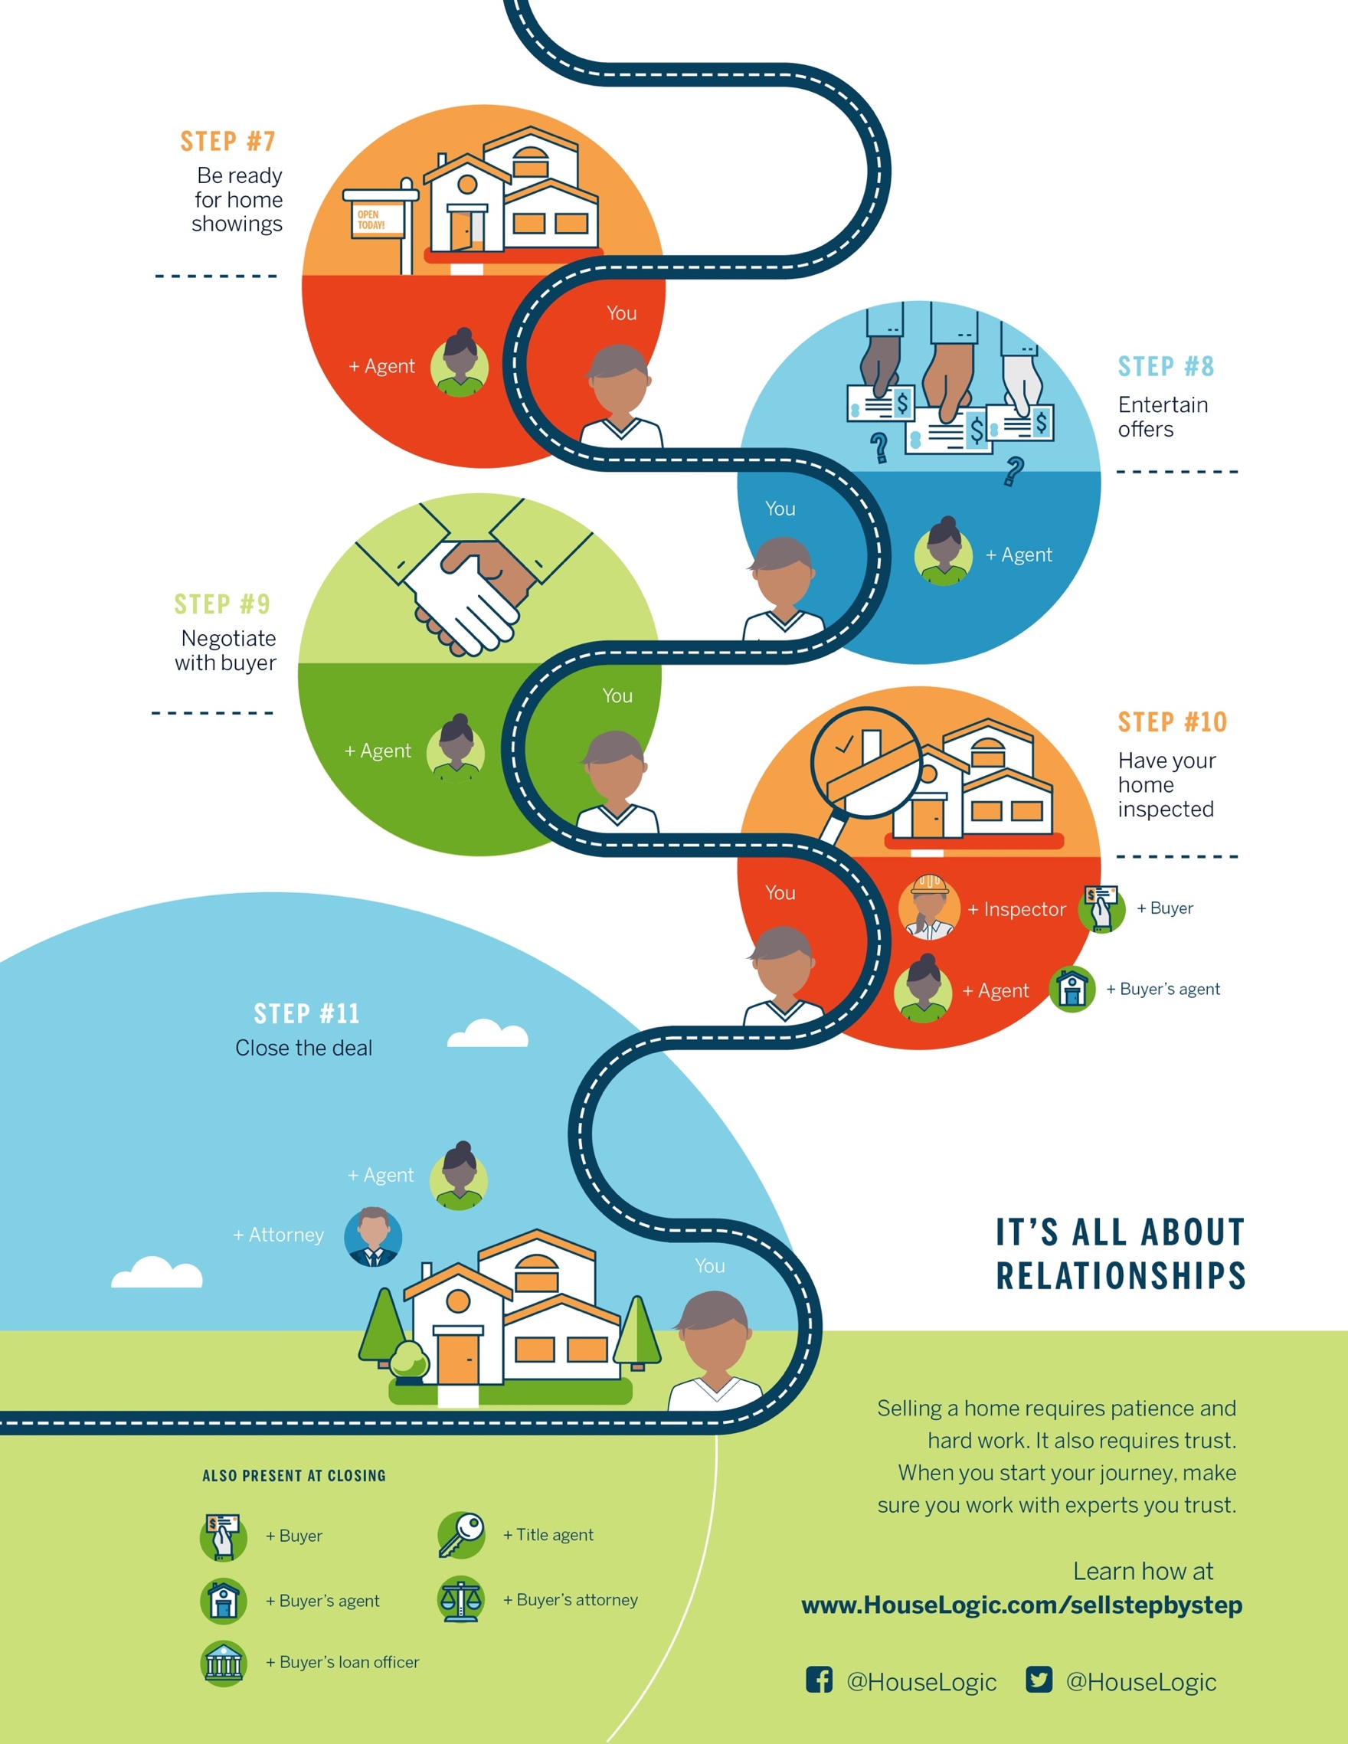
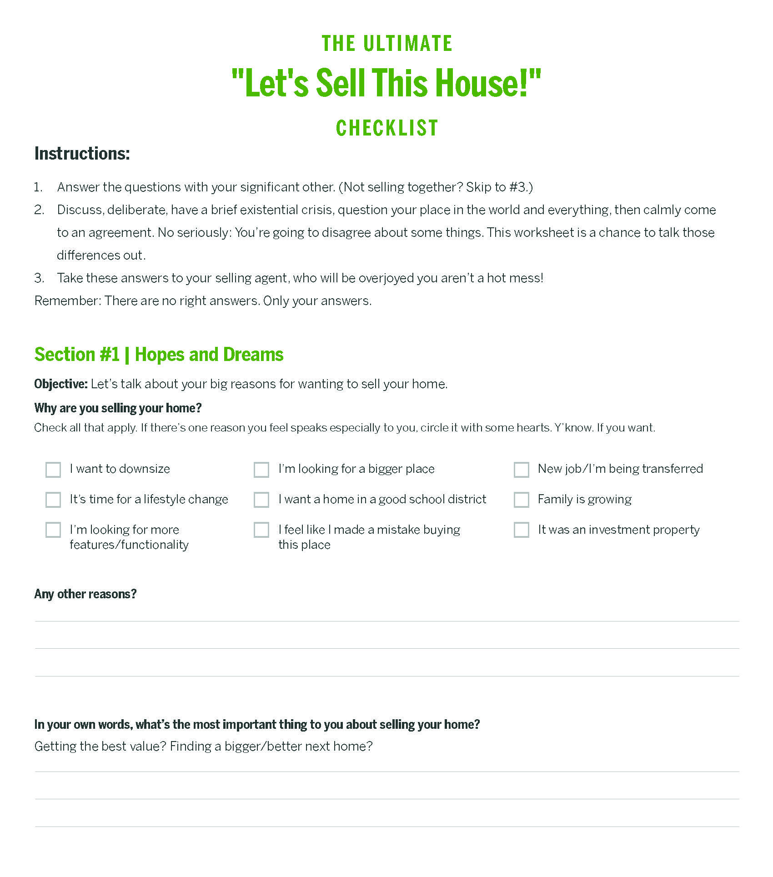
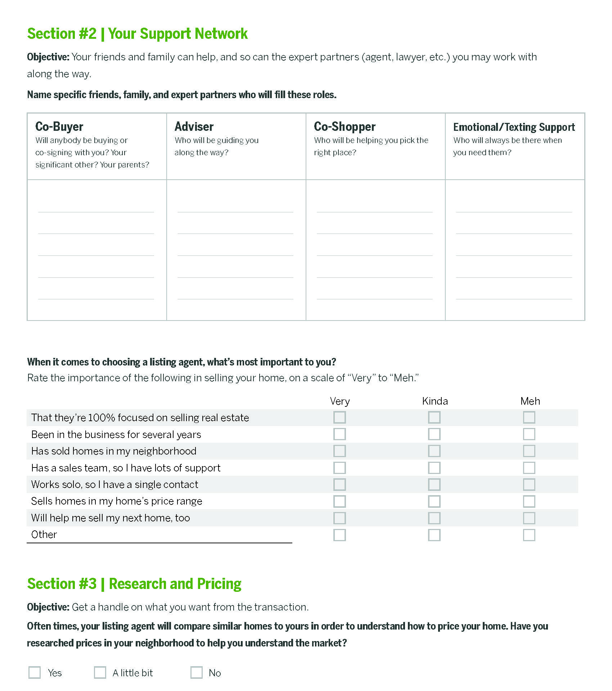

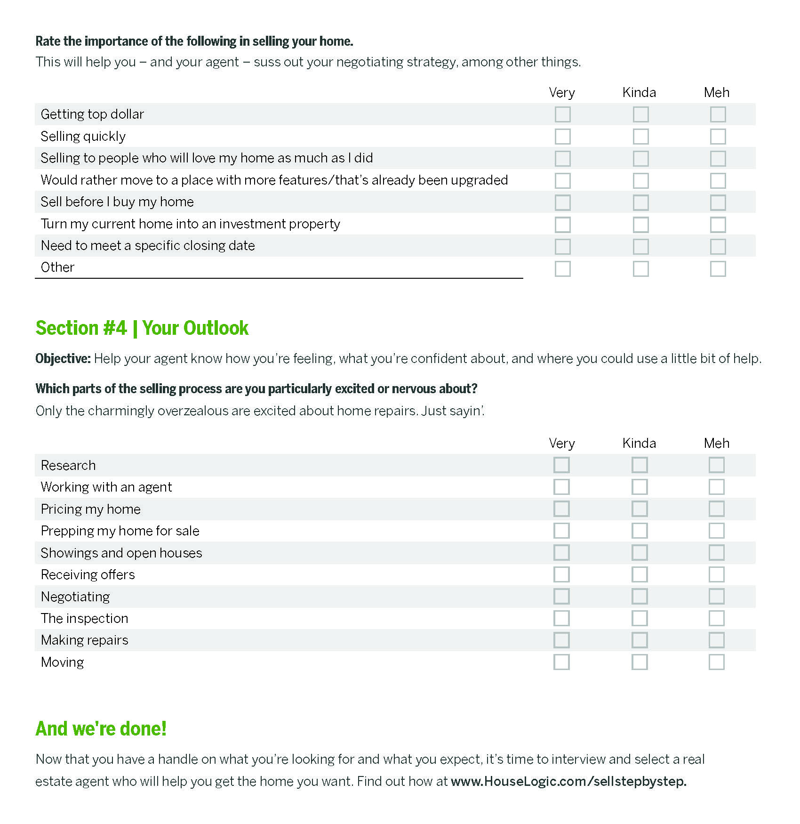

WHAT YOU NEED TO KNOW ABOUT
Researching Home Prices
There are a lot of home pricing resources out there, and some are far better than others.

When it’s time to sell your house, you may be feeling a little anxious.
A chapter of your life is closing. There’s a lot of money on the table. You may be thinking “Is my house priced too high?” “Too low?” “Am I leaving too much money on the table?” These are big questions.

Luckily, you have a few resources at your disposal to figure out where your house stands among the crowd: a listing agent’s expertise and guidance, plus online property sites to get insight into the market.

So take a deep breath. Then do your homework. The more you know, the more confident you’ll be when it’s time to make those big decisions.

Turn to Local Experts — Because They Really Know Their Stuff
The good news: Local market info is freely available online, so you, the seller, can get a sense of what your house is worth.

The bad news: Local market info is freely available online, so most buyers will also have a general idea of what they think your home is worth.

When pricing your house, a listing agent has your back in a way an online property listing site just can’t. An agent:
- Has real world experience in your community.
- Knows the nuances of your neighborhood’s micro-market.
- Can expertly assess how your home compares to similar ones recently sold in your area.
- Can tour your property to determine, inside and out, where your house fits in the real estate landscape.

A website will do none of the above.

An agent will, yes, consider online market data to help you set the price of your home. But he or she will also rely on first-hand knowledge about your home’s unique perks (and quirks), as well as about the neighborhood, to better inform your listing price.

He or she can also recommend ways to market your house (Instagram-able photos, blog-worthy descriptions, etc.), pro stagers who can set your home up to dazzle buyers, and inspectors and contractors who can make any needed repairs.

That being said, you’ll want to have your own sense of what your house is worth too. As invaluable as a listing agent is to your selling journey, being the seller means you’re also the final decision maker.

So keep your laptop out. We’re going to do a little research.

Search Online Property Sites — Because They’ll Give IRL Experience Some Context
Millennials are the largest group of home buyers today, according to a NATIONAL ASSOCIATION OF REALTORS®’ (NAR) report, and they overwhelmingly start their buying journey — where else? — online.

The internet is there for you as well — to an extent — when you’re ready to sell your home.

Online property sites like realtor.com® can give you a sense of local real estate trends, including your city’s median listing price, median closing price, and the average price per square foot. As you search, there are a couple important things to do:

- Pay attention to houses in your area that are similar to your own in terms of size, attributes, and location. When you work with a listing agent to price your home, these houses will provide the main criteria for setting the amount.

- Take notes about what makes your house different from the pack. As you look at online listings, think carefully about why your house is worth more or less than similar houses in your community. The better you’re able to articulate these nuances to your listing agent, the better prepared the agent will be to list your home at an accurate and competitive price.

Having this information can also give you confidence in the price your agent ultimately recommends — you’ll know what’s standard for the market, and how the price determined for your house lines up. If there are discrepancies, talk to your agent about how he or she arrived at their price. Unlike the internet, he or she can give you a complete picture of what your home’s price should be and why.

Also, as you search, be aware that not all real estate listing sites are created equal. Realtor.com® aggregates listings from Multiple Listing Services (MLS) around the country, which provides the most up-to-the-minute data about home sales. (By the way, realtor.com® is the official listing site of NATIONAL ASSOCIATION OF REALTORS®, which operates HouseLogic.com.)

Most of ‘for sale’ listings at realtor.com®, for example, are refreshed every 15 minutes — so what you see is likely what you get. Another big property listing site (and brokerage), Redfin, also aggregates data from MLSs.

Trulia and Zillow, on the other hand, collect their listing information from a variety of sources, and may not always be as up to date as the MLS.

The takeaway: Seller, beware. Consider your online source. Take what you’ve learned from online listings to your agent to talk about what’s really best for you and your home.

Try Online Price Calculators — With Caveats
As long as you’re on the internet, you might decide to try an online home price calculator. With these calculators, property sites use sale prices near you (and overall market data) to approximately predict your own home’s value.

You’ll find an online home price calculator at almost any property site, and they all work a little differently. Realtor.com®’s home estimator tool (https://www.realtor.com/sell), for instance, factors in your home’s square footage and recent home sales in your area to calculate an approximate recommended sale price.

Plug your ZIP code or address into a site to see:
- Homes for sale in your community, which can give you a sense of the overall market
- Estimated prices of similar homes in your area, which can provide a general range of home prices in your area
- Property descriptions and photos of local homes for sale, which can give you a feel for how other homes are being marketed to buyers (and how you can do even better)

Info like this is good to know — particularly because most buyers will see similar numbers when they to online research, too — but you have to take what online home price calculators tell you with a grain of salt.

Online price calculators can be useful as a reference, but they have limitations in terms of their scope (they can’t read nuances of the market like a human can), as well as their reliability. Some, including Zillow’s Zestimate tool, which estimates market value, have been challenged by some users for inaccuracy.

Your listing agent’s knowledge and expertise are more reliable measures for determining your own home’s price — he or she knows the subtleties of your home, neighborhood, and real estate market inside and out. Before you and your agent can confer, don’t get your heart set on a sale price.

Speaking of: The sale price is one thing. Potential profit is another.

How much money you’ll pocket after selling your home depends on a number of factors, including the amount of debt you still owe on a current mortgage, property taxes, and your real estate agent’s commission. To get an idea of your potential profit margin, google "net proceeds calculator."

Again: These are only estimates. A lot of variables are at play between the time you set a sale price and the time you close. The home will be appraised and inspected, and those results could affect your out-of-pocket costs or the sale price. And you’ll likely be negotiating the price with buyers. So use a net proceeds calculator with some care.

OK, you’ve done your research.
Now it’s time to find that listing agent who’s right for you.

HOW TO FIND
The Right Person to Sell Your House
Your guide to hiring the listing agent who can set you up for success.

Your home is where you’ve lived and loved, where you’ve laughed and cried, where you’ve huddled and snuggled.
You’re the pea, your home is the pod. And you’ve been through a lot together.

Now that it’s time to put it on the market, you’re likely experiencing some sadness, plus plenty of anxiety. Because really: How often does your future depend on selling your past? If you’re a little overwhelmed, we don’t blame you.

But there’s also good news: You don’t have to go it alone. A listing agent has your back when it comes to the financials, like setting a listing price and marketing, staging, and making repairs to your house. He or she can also help you navigate more personal issues, such as your timeline, and what you’re hoping to achieve with the sale.

For all of those reasons, it’s important to find an expert who is right for you and your specific situation, and who can help you get what you want. Here’s how.

Know What a Listing Agent Can Do for You
Before you start interviewing prospective agents, have a clear sense of what you want to get out of the selling process. When so much money is on the table, it’s crucial to know what your goals are, so that you can find an agent who really speaks to them.
Then, it helps to understand what a listing agent does (other than sell your most valuable asset — no big deal). The listing agent will:
- Work with you to price your home
- Market your home (we’re talking pretty pictures, social media promo, cute staging — the works)
- Negotiate with home buyers
- Usher the home sale through inspection and closing Now, let’s break all of that down …

Pricing Your Home. This is the BIG question, right? How do I set the price? The short answer is you’ll need to trust your agent to recommend a smart listing price.

So how can you tell whether an agent — a relative stranger to you — is choosing the best price for your home? You need to do two things:

- Know, generally speaking, what your property is worth. Do your own research on the prices of local comps, (but understand the limits of online property sites). Run your info by your agent for an informed perspective.
- Ask the agent for pricing information on homes he or she has recently sold. Specifically, what the differences were between their listing prices and how much the homes ultimately sold for.

When it comes to the agent’s pricing history, you’re looking for accuracy. Anyone could suggest a high price for your home, knowing it’s what you’d like to hear. But nobody (especially you) wants to have a house languish on the market, or to reduce a price repeatedly.

Marketing Your Home. The listing agent will also get the word out that your house is on the market, using a combination of old-school (but powerful) marketing techniques — such as direct mail, signage, and open houses — and the modern methods we know and love, like social media. Savvy agents will post pics of your house on Instagram, Facebook, Twitter, and any other platform that can get likes plus the attention of other real estate agents who can bring buyers to the table.

Negotiating with Buyers. When offers start pouring in, your agent will negotiate with prospective buyers on not only the sale price but also on what contingencies (aka special circumstances) are attached to the
contract. As with any negotiation, there could be some stressful, fraught moments with the buyers. You’ll want an agent who can step up for you, and who has a negotiation style that you’re comfortable with.

Closing the Sale. Once you’ve signed a purchase agreement with a buyer (woo-hoo!), your agent will help you navigate the sale’s remaining steps. This includes negotiating home repair requests post inspection and dealing with any last-minute surprises before closing.

The average listing agent does all of the above. A great listing agent does all of the above, while also inspiring your confidence — that they’re getting the best price for you, and that they’re representing you and your home in the best possible light.

So, let’s talk about how to find and hire that kind of agent.

Ask These Questions to Find a Great
Listing Agent
Here, time is on your side. Aim to hire a listing agent six to eight weeks — or more — before the day your house is listed on the market (also known as the “go-live date”). You’ll be grateful for the cushion, especially if the agent you ultimately hire recommends that you make repairs or upgrades to your home before it’s listed. (That wouldn’t be unusual.)

To find prospective agents, start with your network. Ask friends, relatives, neighbors, and colleagues for recommendations. Word-of- mouth endorsements, as always, can be priceless.

You can also turn to another trusted friend: the internet. Property
websites such as realtor.com® have directories that let you search for agents in your area. These databases can clue you into important details, such as an agent’s years of experience, number of homes sold, and past client reviews.

Three out of four home sellers only contact one candidate before picking their listing agent, according to a NATIONAL ASSOCIATION OF REALTORS® report. While that may be the norm, it’s smarter to shop around. Interview at least three agents before deciding on the one you want to work with.

During the interviews, ask these questions to help assess whether an agent is the right
fit you:

- Do you work as an agent full-time? Like most professions, experience is no guarantee of skill. That said, much of real estate is learned on the job.

- How long have you been in the business? Generally, the more experience an agent has, the more they’re tapped into the local market.

- How many homes have you sold in my neighborhood in the past year? You don’t need to find an agent who specializes only in your community, though that would be ideal. You do want someone who has recently sold at least a few homes in your neighborhood and knows the local and hyper-local inventory.

- What’s the typical price range of homes you sell? Most agents work across multiple price points, but you don’t want an agent who has never sold a home in your range.

- What’s your fee? An agent should be able to articulate their value and explain their commission rate.

- How will you market my home? You don’t want to hire someone who’s just going to stick a For Sale sign in your yard and call it a day. The agent should present a comprehensive marketing plan for your listing
— this should include strategies for staging your home, taking professional photographs of your home, promoting the listing on social media, marketing to other brokers, scheduling open houses, etc.

- Will I be working with you directly, or with a team? Some agents lead or work as part of a sales team. The lead listing agent shares client responsibilities with other agents. Where one agent may handle private showings for a listing, another may host open houses. A benefit is that for the same fee, you get many people working for you. But if you want the sole attention of the listing agent, you may want to stick to a one-on-one arrangement.

- Will you provide one-on-one service? Whether you’re working with one agent or a team, ask how responsive they can be to you, your timeline, and your goals.

- How long on average are your listings on market? Your average sold-to-list price? This can help you suss out whether the agent is a solid marketer and negotiator. These are real estate stats that the agent can pull from your local multiple listing service, or MLS.

The bottom-line: It’s in your best interest to pick an agent who understands your goals, fits your personality, and can get your home sold for top dollar. When you meet someone who can offer all of the above, congratulations — you’ve found your listing agent.

First Thing: Know What You’re Signing up For
Now that you know what you’re getting when you find the right listing agent, let’s make sure you know what you’re committing to when you sign that agent’s “representation agreement.”

The most common type of representation agreement is the exclusive right-to-sell agreement — a legally binding contract that states you’re going to use that agent to sell your house. Under this agreement, you’re giving the agent (and the agent’s brokerage) the right to sell the home for a mutually agreed-upon time period and compensation. IOW: You get peace of mind that you have a dedicated agent; the agent gets peace of mind that you’re only using their services. Other common terms include the agent’s duties to you, like marketing, and a dispute resolution plan.

There are other types of representation agreements, where agents don’t have exclusive rights to sell the property — meaning multiple agents can try to sell the home and compete for the commission. However, when agents know a listing is exclusively theirs, they’re fully invested in selling the property (which, again, should also give you peace of mind).

Every contract has an expiration date, but the length of the contract can vary. Some are three-months; others six months. It all depends on what you and the agent agree upon. If the contract expires before your house is sold, you can re-list your home with another agent.

Of course, there’s a chance you sign an exclusive listing agreement but just aren’t satisfied with the job your agent is doing. To protect yourself, make sure the representation agreement has a cancellation or termination clause that lets you void the contract before the expiration date without any financial penalty.

Understand How a Listing Agent Gets Paid
So … at the end of the day, how do listing agents get compensated for their work?

Real estate commissions — including the listing agent’s commission — are typically charged as a percentage of the home’s sales price. For example, on a $300,000 house, a 6% commission would cost $18,000.
Commissions are negotiable. The commission is usually split between the listing agent and the buyer’s agent as well as their respective brokers.

A caveat: If an agent represents the seller and the buyer, the agent becomes a dual agent and earns both sides of the commission. In dual agency, you may have more room to negotiate the rate — just keep in mind that you’re not being represented exclusively as you are in single agency. You may want to hire an attorney to review documents and help you negotiate.

The listing agent’s commission fee often covers the cost of professional photos, marketing and marketing materials, and any administrative fees charged by the agent’s brokerage.

Also, consider this: Great agents — with their pretty photography, HGTV-worthy staging tricks, and marketing smarts — earn their keep.

So, if you’ve read all of the above, you’ve done your homework to find a great agent. Now you’re ready to sell that house.

THE INS AND OUTS OF
Setting a Price for Your Home
It’s a big decision with a lot of factors, but don’t worry — you have backup.

Everything has value. Especially your home.
And when it comes to selling your home, assigning a price to that value is complicated. You made memories there. You’ve got a major financial interest in the place, too.

Buyers think of value, but they’re more concerned with price. And your home’s price is one of its most attractive — or unattractive — features. The right price can attract buyers, quickly. The wrong price may mean the house sits on the market, which can create the vibe among buyers that there’s something wrong it. (If the home buying process is Instagram, think of a wrongly priced home as a photo that isn’t getting any likes.)

It’s your agent’s job, as the real estate expert — mining his or her expertise and knowledge of the market — to determine the best price for your home. But it’s your house. You need to have your own idea of how much your property is worth. Here’s how to get it.

Work With Your Agent
This is crucial. Your agent brings the right mix of industry expertise and knowledge of your local market to the table.

To understand whether your agent is pricing your home properly, read through each of the steps below. Use what you learn about your home’s fair market price to evaluate any price your agent recommends.

Throughout the pricing process, a good agent will:
- Listen to your needs
- Take into account your research
- Use his or her knowledge of the local market to help you pick the best asking price

You’re a team. It’s in both of your interests to price your home correctly — a timely, profitable sale is win for everyone.

And Yeah, You Should Also Check the Internet
Pricing a home is both art and science. To understand what will inform your agent’s pricing decisions — and to be prepared to bring your own educated input to the conversation — start with a pricing research phase.

This includes taking advantage of online estimating tools — but only to an extent. Property websites like realtor.com® and Redfin enable you to plug in your home’s address to see approximately how much your house is worth. They base their estimates on your home’s square footage and real estate data they’ve collected, such as recent home sales in your local market.

But those results are estimates based on generalized factors, not your unique situation. If at any point the price you see in an online calculator doesn’t align with what your agent suggests, prioritize the agent’s advice.

Online estimators also have a reputation among real estate professionals for misleading buyers and sellers alike with less-than-optimal pricing information. But as a starting point, they have their utility.

Know Your Local History
What your home’s listing price should be largely depends on what similar homes, or “comps,” recently sold for in your area. To price your home, your agent will run the average sales prices of at least three comps to assess your home’s value.

What constitutes a comp? A number of factors, including a home’s:
- Age
- Location
- Square footage
- Number of bedrooms and bathrooms

Agents will look into the difference between each comp’s listing price, and the price it sold for. He or she will consider price reductions and why they happened, if relevant. All the while, your agent will also rely on inside knowledge of housing stock and the local market. That nuanced understanding is invaluable, particularly when measuring the unique aspects of your home with raw data about comps.

When selecting comps, agents generally look for properties that sold within a one-mile radius of your home, and in the past 90 days. They find these homes using the multiple listing service (MLS), a regional database of homes that agents pay dues to access.

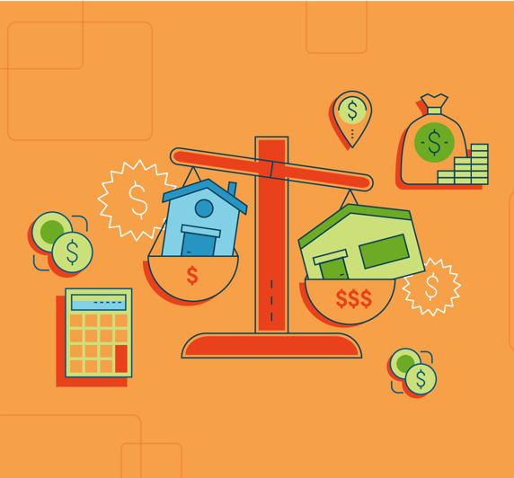
Size Up the Competition
In addition to recently sold homes, your agent will also look at properties that are currently for sale in your area. These listings will be your competition. But because listing photos don’t always tell the full story, a good agent will check out these homes in person to see what condition they’re in and to assess how your home sizes up.

You can do the same. For additional perspective, you can also get in touch with your local association of REALTORS®. Ask if they have information to offer about your neighborhood and the local market.

Understand the Market You’re In
The housing market where you live can greatly impact your pricing strategy.

If you’re in a seller’s market, where demand from buyers outpaces the number of homes for sale, you may be able to price your home slightly higher than market value.

But if you’re in a buyer’s market, where buyers have the advantage, you may have to price your home slightly below market value to get people interested.

You can see local market trends by checking the online resource realtor.com®. It offers charts that display important housing market data, such as a city’s average listing price, median sales price, and average days a home is on market. It’s a lot of information. At any point, you can ask your agent to help you make sense of how your local market will influence your home’s price.

Put Your Feelings Aside
As previously mentioned, many sellers think their home is worth more than it is. Why? Because memories. Because sentiment. Because pride.

But you have to stay objective when assessing your home’s value. Buyers, after all, won’t know your home’s personal history. What makes your home special to you may not be something that entices them. Read: They may want to convert that craft room you worked so hard to perfect into a man cave.

The lesson: As much as possible, set aside your emotional attachment to your home. It will make it easier to accept your agent’s realistic, clear-eyed calculation of its price.

Remember: It’s All Relative
As you and your agent are talking price, the local market may throw you a curveball or two. In some markets, for example, it could make sense to price your home slightly below its fair market value to spark a bidding war.

Of course, there’s no guarantee a pricing strategy such as this will pay off. Similarly, there’s no one-size-fits-all playbook. Your home should be priced for its own local, or even hyper-local, market. Period. Confer with your agent before you decide to try any market-specific pricing tactics.

Be Savvy With the Dollar Amount
Pricing your home requires careful attention. In some cases, fair market value may not be precisely what you should list it for — and the reasons can be subtle.

For example, if comps show that your home is worth $410,000, setting that as your asking price can backfire
- the reason is that buyers who are looking online for properties under $400,000 won’t see your home in search results in that case. This explains why many agents use the “99” pricing strategy and, for example, list
$400,000 homes for $399,000. The idea is to maximize exposure.

Have a Heart-to-Heart With Your Partner
Not the sole decision maker in your household? Talk to your partner about your home’s price before it’s listed. You can use the worksheet on page 63 as a guide for that discussion.

The reason isn’t just to foster the kind of open communication that’s important to any relationship. It’s that if you’re not on the same page about price or the other things that are important to you about sale, each subsequent step of the selling process will be impacted by that tension.

Keep Your Head in the Game
You’ve considered your agent’s advice, and the two of you have agreed on the right price for your home. Hey, champ! Your house is on the market.

Even after the listing date, price should be an ongoing discussion between you and your agent. Markets are fluid, so it’s possible that you’ll have to make tweaks.

In any case, it’s important to stay in continuous dialogue with your agent, the MVP of Team Sell Your House. Together, keep your eyes on the price.

STAGING YOUR HOME:
How to Make Buyers Fall in Love
With these tips and tricks, your house will be swoon-worthy in no time.

All the world’s a stage, said the Bard.
That includes your house. Which is for sale. And thus needs to look bee-yoo-tee-ful.

Staging entails hiring experts with a flair for interior design. They reimagine your living space and give your house a makeover (with temporary decor and furnishings) so that it gets “oohs” and “aahs” from the buying masses.

Great staging isn’t an insurance policy — there’s no guarantee it will bring in more money when you sell your home — but it’s an important marketing tool. It presents your house in a flattering light and helps you compete at a favorable price. (In that sense, staging is like dressing your house for the price you want, and not the price you have.)

Staging also leads to eye-catching listing photos, which are especially valuable given that most home buyers begin their search by scrolling through listings online.

So, are you thinking about hiring stagers for your home? Here’s what to consider.

Staging Really Does Help. Like, a Lot.
But you don’t have to take our word for it. A recent survey from the NATIONAL ASSOCIATION OF REALTORS® revealed that:

- 77% of buyers’ agents said staging makes it easier for their buyer to visualize the property as their future home. It’s like helping the buyer dream it so they can achieve it — and so you and your agent can make the sale.
- 39% of sellers’ agents said staging a home greatly decreases the amount of time a house is on the market. For you, time saved could mean moving into your new house even sooner.
- 21% of sellers’ agents said staging a home increases its dollar value between 6% and 10%. Simply put, that may lead to more money in your pocket.

Before You Stage, Budget Accordingly
Many listings agents offer staging services to clients as part of their services. If you want to use someone you find yourself, you typically will have to pay out of pocket.

Staging costs vary depending on where you live and how many rooms you’re staging. On average, home sellers pay between $302 and
$1,358 for staging, according to HomeAdvisor.com. If your house is empty because you’ve already moved, you might also have additional expenses for renting furniture and other homey decorations to make it look lived-in.

Many stagers offer consultations for as low as $150, Fixr.com reports. Using the advice you learn during the consultation to try DIY staging may be your best option if you’re on a tight budget. Listen for tips on how to use the furniture and decor you already have to show off your home’s best assets.

For the Best Results, Declutter
Spoiler alert: No buyer wants to walk into a messy house.

So, take time to clean and declutter your home. Organize everyday household items into crates and keep them out of sight. Stow away seasonal decorations (that means no Christmas in July). Make time for — or invest in
- a whole-house cleaning, including carpet shampooing. Change lightbulbs, finally make those minor repairs, and add a fresh coat of paint to any room that needs it. Clean out closet spaces — because buyers will want to check out the closets.

Also worth considering? Removing personal items from view, such as copious family photos, artwork, or religious keepsakes. The concern is not that home buyers will be offended by you or your lifestyle. The goal is to neutralize the space and help home buyers imagine themselves living there. (But don’t go overboard. You don’t want rooms to feel sterile, either.)

Yes, we did just tell you to clean out your closets. So where are you supposed to put all this stuff? If you don’t have a discrete place to tuck things away, consider renting a storage unit.

To Find the Right Stager for Your Home, Ask Questions
If your agent doesn’t offer staging services, he or she can likely recommend local stagers for you to work with. Before you hire a stager, it’s best to interview at least three candidates in person. You’ll want to get a sense of how much they charge — and whether they have good taste.

To do your due diligence, here are 10 questions to ask prospective stagers:

- On average, how many days were your staged homes on the market last year? Experience is important, but it’s not the only factor to consider when vetting stagers. You want someone who stages homes that sell — ideally within 30 days, because that’s when agents often recommend making a price reduction if your house is still on the market.

- What price range do you typically work in? Staging luxury homes is a totally different ball game than staging starter homes. Find someone who specializes in homes near your listing price.

- What styles of homes do you usually stage? Staging different types of homes also requires different skill sets (think of a penthouse versus a bungalow, for instance). Look for someone with experience working in homes similar to yours.

- What formal training have you received? A number of staging organizations, such as the Real Estate Staging Association (RESA) and the International Association of Home Staging Professionals (IAHSP), offer certification or accreditation. Training from these associations can distinguish professional stagers from beginners.

- Do you have insurance? Your home could get damaged when the stager moves furniture in and out. Find someone with business insurance so that you’re protected.

- Can I see your portfolio? One of the best ways to judge a stager’s skills is to look at their work. Ask to see photos from the person’s three most recently staged homes.

- Do you select the accessories, furniture, and paint for the homes you stage, or do you collaborate with other experts? Some stagers work independently, while others collaborate with other vendors. Make sure you know everyone who will be involved in staging your home, so you don’t have surprise guests rearranging your living room.

- What are your rates? Some stagers charge a fee for decorating services, plus a monthly fee for renting furniture, while others charge a flat fee per room for the duration of the listing. Ask about how a stager determines costs before you commit to working with him or her.

- What’s your availability? If you’re on a tight timetable, make sure the stager can get your house ready by the date you want to put your house on the market.

- Can you provide contacts for past clients? Get in touch with two or three people who have worked with the stager before. Ask how the stager’s services helped with the sale of their homes, and what they might have done differently.

Focus On the Rooms That Count the Most
You don’t have to stage your whole house to make buyers swoon. Staging the rooms where people tend to spend the most time usually makes the biggest impression on buyers. Start with the living room, followed by the master bedroom and the kitchen.

Keep in mind that you’re not going for an HGTV-worthy overhaul: Even small touches, like putting fluffy towels in the bathroom or replacing shabby throw pillows in the family room, can make your home that much more attractive.

Oh, and BTW: Stage Your Yard, Too
Your house has to look its best — inside and outside. After all, buyers form their first impression when they pull up in front of your home. It’s no surprise, then, that curb appeal — how your home looks from the exterior — can increase your home’s sales value up to 17%, a Texas Tech University study found.

If you’ve never had your yard professionally landscaped, now may be the time to do it. Landscaped homes have a sales price advantage ranging from 5.5% to 12.7%, according to research by Alex Niemiera, a horticulturist at Virginia Tech. That would mean an extra $16,500 to $38,100 in value on a $300,000 home.

Professional landscaping, however, can cost a lot. You’re aiming for polish, not a new garden of Versailles. If budget is a concern, start with these DIY improvements:
- Plant blooming flowers and fresh greenery. Even if it’s winter, you can add colorful winter blooms and
seasonal touches such as garland or lights.
- Mow the grass.
- Reseed bare patches of lawn and add fresh sod, as needed.

Then move on to these easy upgrades to your home’s exterior:
- Wash the front windows.
- Power wash siding and walkways.
- Repaint or stain porches and stairs, as needed.
- Make sure house numbers are easy to see, visible, and pretty.
- Make sure important outdoor features such as the front door, porch, and sidewalks and paths are well lit. (If not, install new fixtures or lighting.)

Even basic upgrades — like laying fresh mulch, changing porch lights, or installing a new mailbox — can help a buyer fall in love at first sight.

Just wait ’til they come inside and see what else you’ve done with the place.

10 TRICKS FOR
Hosting an Open House
That Make Buyers Say “OMG, Wow!”
Here’s what you can do to get your home ready for its big reveal.

Few words get home buyers more excited than these two: open house.
An open house is their opportunity to give your house a whirl. To wiggle the light switches. To admire the crown molding. To, y’know, awkwardly ask to use the bathroom. (Which, by the way, savvy buyers will totally do — because they’ll want to test how the water pressure holds up when they give the toilet a flush.)

For you, seller, an open house is a chance to throw open the doors. To dazzle buyers with the big reveal. To make someone fall head over heels for your charming abode. These tricks can help you make your open house a massive hit.

#1 — Time It Right
Your agent will typically hold an open house for two to three hours between 11 a.m. and 5 p.m. on Saturdays and Sundays, when buyers have time and flexibility away from their jobs. To maximize your foot traffic, avoid having your open house during holidays, big community events (marathon days, for example), or unofficial “holidays” like Super Bowl Sunday.

#2 — Let Your Agent Take the Lead
In your own personal Open House Show, your real estate agent has two roles. To you, they are the director, giving you instructions on how to prepare for open house day, and what to do during the event. To buyers, your agent is the host. They will welcome viewers, introduce your home’s impressive features, and take questions from the audience.

Your job is to make your house look like a million bucks — or more like $300,000, depending on your price range. (Tips on cleaning and spiffing up your home in a moment.)

The job of your agent, an expert on your local real estate market and what makes buyers tick, is to take care of the rest. That will include:
- Staging your home, or recommending a reputable stager that you can hire
- Hosting the open house
- Communicating with home buyers and buyers’ agents
- Receiving feedback during the open house and communicating that feedback to you

Your agent will also recommend that, actually, you should probably leave while they show off your house to strangers, who will look under your sinks and peek into your closets. Why should you heed that advice? Because it makes good business sense for you.

- A homeowner’s presence can make it awkward for the buyer. Buyers want to make assessments on their own, without worrying about how the seller might react or try to influence them.
- Buyers may have trouble picturing themselves living in the house when the owner is right there, say, serving lemonade in the kitchen.
- Sometimes sellers say too much. You might point out something that you think is a nice feature or amenity of your home, when it’s something that might turn off a buyer. (That busy arcade bar down the block may have been your favorite place to meet friends and play Pac-Man during weekends, but it could be a deal breaker for a buyer looking for a peaceful block.) You might blurt out something that could tip your negotiating hand, like how motivated you are to sell (soon!), or that you always wanted to update the
retro kitchen — but just never got around to it.

The last things you want buyers to think after the open house is, “This place needs work,” or “This seller is desperate — I have the upper hand.” So, let your agent take the lead. This won’t be their first rodeo. They know the nuanced ways to show your home in its best light so that buyers will oooh and ahhh. They also know how to strategically answer questions from buyers to help set you up for success later, during negotiation.

Your agent can also stage a broker’s open house on your behalf. Unlike standard open houses — where buyers can stop by — at broker’s open houses, only real estate agents and other industry professionals are invited
to attend. Generally, a broker’s open is held within the first few days of a house being put on the market. Complimentary lunch is often served as an incentive to get more people to show up.

There are two main benefits of having a broker’s open house:
- It gives your listing more exposure.
- It allows you to get feedback from real estate agents on your home.

If your house “shows well,” as they say in the industry, the agents who toured your home may recommend it to one (or more) of their buyer clients. If your home doesn’t get rave reviews, your agent will relay that feedback to you, and may suggest improvements before the next open house, such as staging certain rooms.

#3 — Try Some Simple Staging
You want your home to look its best while it’s on the market — especially during the open house. Many agents say the best way to primp your home for its big day is to stage it.

Depending on what your agent recommends, staging may involve renting new furniture or decor for certain rooms in your home. There are also some easy staging tricks you can try on the day of your open house. Consider displaying a bouquet of fresh flowers in the entryway, setting your dining room table to make it look inviting, or turning on your outdoor sprinklers shortly before visitors arrive to make your lawn sparkle.

#4 — Clean Like Crazy
When your home is on the market, you need to keep it in showing shape — not only for the open house, but also for any scheduled showings with buyers. Even though you’ve already (hopefully) cleaned and organized your home for its listing photos, there’s a good chance you’ve let clutter or dust pile up again, especially if you have children or pets.

Make sure appliances, windows, and mirrors are fingerprint-free. Clean and organize your closets, cabinets, and under the sinks (during the open house, buyers are allowed to be nosy). Clear every bit of clutter and get rid of it or put it in storage.

Don’t have the bandwidth to do a deep clean? Hire a house cleaning service to do the work for you. A professional cleaning service costs around $115 to $230 on average. If you’re not sure about which service to hire, ask your agent to recommend cleaners.

#5 — Do a Smell Check
If buyers get a whiff of something funky, they’re going to run — not walk — out of your open house. A week prior to the open house, ask your agent or a neighbor to do an honest, no-holds-barred smell check. Some possible smell solutions:

- If your house has the aroma of your beloved pet(s), deep clean the carpets, relocate the litter box, and take steps to eliminate all olfactory traces of Fluffy.
- If the basement is dank and musty, buy a dehumidifier to remove air moisture and run a fan to circulate the air.
- If the kitchen drain stinks, drop in a cup of baking soda, then two cups of white vinegar. Enjoy the bubbling, then let the mixture sit for 20 to 30 minutes. Finally run hot water for 15 to 30 seconds to flush the odor.

#6 — Put Your Pictures (and Valuables) Away
You want your home to feel cozy and inviting, but not like someone specific (you, for example) is living there. Personal belongings such as family photos, awards, and religious art can distract home buyers and make it harder for them to imagine themselves living in your home. You don’t have to go overboard — the idea isn’t to eliminate every trace of yourself — but consider temporarily hiding some pictures and personal effects out of sight during the open house.

There’s a safety element to stowing your personal belongings, too: Though your agent will be at the open house, you’re inviting strangers into your home.

- Securely store checkbooks, jewelry, prescription medications, family heirlooms, and other valuables.
- Alert your neighbors to your open house date — as a courtesy, but also to ask that they let you know if they notice any suspicious activity, in the unlikely event suspicious activity occurs.
- Make sure your agent signs visitors in and asks them to show
I.D., so that you have a record of who was in your house.
(Bonus: With the sign-in sheet, your agent can follow up with
buyers to find out if anyone is interested in making an offer.)
- Lock windows and doors after the open house.

We’re not suggesting that visitors have any intention other than potentially buying your home. It’s just a good idea, generally speaking, to keep your home secure.

#7 — Let the Light In
Light doesn’t only (literally) brighten up your space. It also makes rooms look and feel larger. On open house day, open all curtains and blinds to let natural light in. (And in the week before the open house, make sure curtains and blinds are squeaky clean.)

Replace every single burnt-out light bulb in and outside the home — buyers should see a working light every time they flip a switch.

#8 — Give Your House Some Extra Curb Appeal
Buyers will judge your house on its outsides. So make last-minute improvements to turn up your home’s curb appeal. Cut the grass, prune the trees, and trim the shrubs. Touch up porch fixtures and furniture with a little paint. Heck, paint the whole porch, if your budget allows. Plant new shrubs or set out potted flowers.

Small, relatively low-budget outdoor enhancements will make your home look all the more enticing to buyers
- and can add some last-minute value to its price.

#9 — Draw Attention to Your Home’s Best Features
After your agent signs in and welcomes buyers to your home, they typically will have some time to wander around on their own. Even though you won’t be there, you can still draw visitors’ attention to features in your home that you’d like to highlight.

Prior to the open house, post (friendly, aesthetically pleasing) signs around the house with calls to action such as, “look down, new hardwood floors,” or “gas fireplace, push this button.” Buyers will likely appreciate the help, and that they’re working with a conscientious seller.

#10 — Serve Refreshments
Serving warm cookies or freshly baked brownies at an open house is one of the oldest tricks in the book. That’s because it works: Buyers love being greeted with a sweet treat and a cold or warm beverage depending on the time of year. Refreshments also give people a reason to stay longer: No one will rush off because they’re hungry or thirsty.

Your agent may even have relationships with a local cafe or bakery, which might offer snacks for free advertising at the open house.

What to Do During and After the Open House
Once you’ve done everything you can to make your house look and feel amazing to buyers — and your agent is on site to assume their hosting duties — the time during your open house is yours to enjoy. Go to the park, get a three-course lunch, do whatever you like as long as you’re free to take calls.

Your agent may need to get in touch with questions, so make sure you’re available and have good cell phone
reception. (A movie, for example, is not a great activity for you during the open house for that reason.)

After the open house ends, your agent will share with you what questions buyers asked and any comments they overheard by visitors. Buyers’ remarks will likely run the gamut, including some that could be negative. (“Why is the closet such a mess,” for example.)

The important thing is to stay open to buyers’ feedback, and to follow your agent’s advice about how to respond. Based on buyers’ reactions, your agent may recommend that you make certain repairs, do some painting, or invest in additional staging before your next open house.

Whatever they advise, it’s not personal — it’s just the business of selling your home.

WHAT YOU NEED TO KNOW
Before Accepting — or Rejecting — an Offer
It’s not always about the money (except when it is).

The day will come — and it will be a wonderful, joyous, do-a-happy-dance day — when you receive an offer, or multiple offers, for your home.
And on that day, you’re going to face a question you may not have previously considered: How do you know if an offer is the best one for you?

Your listing agent will be a big help here. They will understand and help you suss out the merits and faults of an offer because — believe it or not — it’s not always about price.

One buyer’s beautifully high offer might not look so good anymore, for example, if you discover that it’s contingent upon you moving out a month earlier than planned. Or, conversely, you may prefer speed over price, particularly if you’re moving to a new city.

Your listing agent will have a sense of what you want financially and personally — and can help you determine
whether the offer at hand satisfies those goals.

Before the first offer rolls in, here’s what you need to know about the offer evaluation process, including the main factors that should go into making a decision — accept or reject? — with your agent.

5 Important Things — Other Than Price — to Consider When Evaluating
an Offer
Want to fetch top dollar for your home and walk away with as much money in your pocket as possible? Of course you do. You’ve gone through the time-consuming process of setting your asking price, staging your home, promoting your listing, and preparing for open houses — and should be rewarded for your efforts.

Your first instinct may be to just pick the highest bid on the table. But the offer price isn’t the only thing worth considering.

When vetting offers, evaluate these five areas in addition to price:

The Earnest Money Deposit
One important consideration when weighing an offer is the size of the earnest money deposit. The EMD is the sum of cash the buyer is offering to fork over when the sales agreement is signed to show the person is
serious (i.e., “earnest”) about buying your home. This money, which is typically held by a title company, will go toward the buyer’s down payment at closing.

A standard EMD is 1% to 3% of the cost of the home (so, that would be $2,000 to $6,000 on a $200,000 house). If a buyer tries to back out of an offer for no good reason, the seller typically keeps the EMD. Therefore, the higher the earnest money, the stronger the offer.

The Contingencies
Most offers have contingencies — provisions that must be met for the transaction to go through, or the buyer is entitled to walk away from the deal with their earnest money. Contracts with fewer contingencies are more likely to reach closing, and in a timely fashion.

Here are five of the most common contingencies:

- Home inspection contingency. This gives the buyer the right to have the home professionally inspected and request repairs by a certain date — typically within five to seven days of the purchase agreement being signed. Depending on where you live, you may be required to make home repairs for structural defects, building code violations, or safety issues. Most repair requests are negotiable, though, so you have the option to haggle over which fixes you’re willing to make.

- Appraisal contingency. For a mortgage lender to approve a home buyer’s loan, the home must pass appraisal — a process during which the property’s value is assessed by a neutral third party. The appraisal verifies that the home is worth at least enough money to cover the price of the mortgage. (In the event the buyer can’t make their mortgage payments, the lender can foreclose on the home and sell the property to recoup all — or at least some — of its costs.) Generally, the home buyer is responsible for paying for the appraisal, which typically takes place within 14 days of the sales contract being signed.

- Financing contingency. Also called a loan contingency or mortgage contingency, a financing contingency protects the buyer in the event their lender doesn’t approve their mortgage. Although the timeframe for financing contingencies can vary, mortgage lenders report that buyers generally have about 21 days to obtain mortgage approval.

- Sale of current home contingency. Depending on the buyer’s financial situation, their offer may be contingent on the sale
of their home. Usually, buyers have a window of 30 to 90 days to sell their house before the sales agreement is voided. This contingency puts you, the seller, at a disadvantage because you can’t control whether the buyer sells their house in time.

- Title contingency. Before approving a mortgage, a lender will require the borrower to “clear title” — a process in which the buyer’s title company reviews any potential easements or agreements that are on public record. This ensures the buyer is becoming the rightful owner of the property and the lender is protected from ownership claims over liens, fraudulent claims from previous owners, clerical problems in courthouse documents, or forged signatures.

The Down Payment
Depending on the type of mortgage, the buyer must make a down payment on the house — and the size of that down payment can affect the strength of the offer. In most cases, a buyer’s down payment amount is related to the home loan they’re taking out. Your chief concern as a seller, of course, is for the transaction to close — and for that to happen, the buyer’s mortgage has be approved.

Generally, a larger down payment signals the buyer’s financial wherewithal to complete the sale. The average down payment, according to the NATIONAL ASSOCIATION OF REALTORS®, is 10%. Some mortgage products, such as FHA and VA loans, allow for even lower down payments.

If, by chance, the appraisal comes in higher than your contract’s sale price, the buyer with a higher down payment would more likely be able to cover the difference with the large amount of cash they have available.

The All-Cash Offer
The more cash the buyer plunks down, the more likely the lender is to approve their loan. That’s why an all- cash offer is ideal for both parties. The buyer doesn’t have to fulfill an appraisal contingency — whereby their lender has the home appraised to make sure the property value is large enough to cover the mortgage — or a financing contingency, which requires buyers to obtain mortgage approval within a certain number of days. As always, having a sales contract with fewer contingencies means there are fewer ways for the deal to fall through.

The Closing Date
Settlement, or “closing,” is the day when both parties sign the final paperwork and make the sale official. Typically, the whole process — from accepting an offer to closing — takes between 30 and 60 days; however, the average closing time is 42 days, according to a report from mortgage software company Ellie Mae.

Three days before closing, the buyer receives a closing disclosure from the lender, which he compares with the loan estimate he received when he applied for the loan. If there are material differences between the buyer’s loan estimate and closing disclosure, the closing can’t happen until those amounts are reviewed and approved. But this is rare.

Some transactions can take more time, depending on the buyer’s financing. For example, the average closing time for a Federal Housing Administration (FHA) loan is 43 days, according to Ellie Mae.

Whether you want a slow or quick settlement will depend on your circumstances. If you’ve already purchased your next home, for instance, you probably want to close as soon as possible. On the other hand, you may want a longer closing period — say, 60 days — if you need the proceeds from the sale to purchase your new home.

When Should You Make a Counteroffer?
Depending on the circumstances, you may be in the position to make a counteroffer. But every transaction is different, based on the particular market conditions and your home. In some circumstances, you can be gutsy with your counteroffer. In others, it might serve your goals better to give in to the buyer’s demands. Your agent can provide helpful insight about when and why a counteroffer will be the right thing for you.

For instance: If you’re in a seller’s market — meaning that homes are selling quickly and for more than the asking prices — and you received multiple offers, your agent may recommend you counteroffer with an amount higher than you would have in a buyer’s market.

If you choose to write a counteroffer, your agent will negotiate on your behalf to make sure you get the best deal for you.

A caveat: In many states sellers can’t legally make a counteroffer to more than one buyer at the same time, since they’re obligated to sign a purchase agreement if a buyer accepts the new offer.

When Does an Offer Become a Contract?
In a nutshell, a deal is under contract when the buyer’s offer (or seller’s counteroffer) is agreed upon and signed by both parties.

At that point, the clock starts ticking for the home buyer’s contingencies — and for the sweet moment when the cash — and home — is yours.

YOUR GUIDE TO
Negotiating an Offer
What you need to know to get the best deal for you.

When it comes to evaluating offers, what’s good for the goose may not necessarily be good for the gander. One seller may be overjoyed with their offer, while another may be disappointed.
That means, in order to figure out whether an offer you receive is “good” —and whether you should negotiate
- you’ll need to do two things:

- Think back to your original goals, and ask yourself whether this offer helps you meet them.
- Get advice from your agent, who can help get the best deal for your specific situation, wants, and needs.

So what do you, the seller, need to know before negotiate with a home buyer? We’ve got answers to some commonly asked questions.

What Should a Seller Prioritize?
Before you start negotiating, you’ll want to know what you’re hoping get from the buyer. Obviously, money is important. But it’s not everything. There are other factors to consider when crafting a counteroffer, particularly timing.

So, sit down with your agent and have an open discussion about your goals. Do you want more money? A faster closing period? Fewer contingencies? When you review these types of questions with your agent before you respond to an offer, and have a crystal-clear sense of your priorities, the negotiation process will go a lot more smoothly.

Who Has More Leverage?
Ready to play hardball? Hold up, slugger. First, you have to consider your position on the field. How much negotiating power do you really have? The answer depends on several factors.

A lot depends on your local market conditions. If you’re in a buyer’s market — meaning the supply of homes exceeds demand from buyers — you may have to make some concessions to secure an offer. If you’re in a sellers’ market — and homes are flying off the proverbial shelves, selling at or above list prices — you may be able to persuade a buyer to offer more money for the house, for instance, or to let go of some contingencies (aka provisions that must be met for the transaction to go through).

Your timetable will also impact whether you have the upper hand. If you’re not in a rush to sell, you may be free to negotiate more aggressively. If you’re in a time crunch because, say, you already
bought your next home and don’t want to pay two mortgages at one time, your hands may be tied.

In any case: Confer with your agent. They can help you objectively assess your position and determine the right negotiating strategy.

How Long Can This Go On?
Don’t worry. It may only feel like forever.

When you make a counteroffer, the buyer can either accept the new offer, reject it, or make a new counteroffer.
(Sound familiar?)

This volley can go back and forth, and potentially end in a stalemate — unless you or the buyer put an expiration date on your counteroffer. This can be a smart strategy for you as a seller because it puts pressure on the buyer to make a decision. It also gives you the ability to move on to the next bidder if the buyer tries to stall (chances are, they’ll do this so they can look at more homes without giving yours up).

It’s not unusual for the first offer to be best one — depending on market conditions, of course. And often, sellers see the most interest from buyers in the first month of the home being on the market.

If you get a good offer right off the bat, start negotiating. You may get a better offer. On the other hand, you may not.

Which Negotiation Tactics Are Most Useful?
The actual negotiation is the job of your agent, who will be experienced in real estate deal-making. That being said, you should still strategize with your agent before they make that counteroffer for you. Here are five ways you can nab a better deal:

- Avoid making an emotional decision. It’s easy to get caught up by the emotional bond you’ve formed with your home. The backyard just might be where you got married. And that cozy office could be where your small business was born. But the important thing to remember is this: You have to detach yourself from your home. This is business — nothing more.

- Know your bottom-line. Before moving forward, figure out what you need to get from the deal, at a minimum. That will give your agent a baseline when opening negotiations.

- Negotiate a “clean” offer. You want an offer with as few contingencies as possible, since contingencies give the buyer the opportunity to back out of the deal. But some contingencies — such as an appraisal, an inspection, or a financing contingency — can’t be waived by home buyers who are obtaining mortgages because they’re typically required by a mortgage lender in order to approve the loan. Still, if you have multiple offers to choose from, you may be able to persuade a buyer to waive certain contingencies, such as a radon contingency or termite inspection contingency.

- Offer a home warranty. In a buyers’ market, a low-cost way to make a deal more appealing to a buyer is to offer a home warranty — a plan that covers the cost of repairing home appliances and systems, like the
air-conditioner or hot water heater, if they break down within a certain period of time (typically a year after closing). Home buyers love this extra security blanket, and the standard one-year basic home warranty will only set you back about $300 to $500.

- Don’t overlook the closing date. Typically, the sale process — from accepting an offer to closing — takes about 30 to 45 days (sometimes a little longer). But in most cases, the faster you can close the better. Especially if you need cash to buy your next home. A quicker closing period has to be feasible for the buyer, however, and some types of home loans take longer to obtain than others.

Should I Start a Bidding War?
If you have more than one offer on the table, you might be tempted to pit buyers against each other and watch them duke it out for your home. (Anyone who’s seen The Bachelor knows that kind of drama can be fun, after all.) But think twice before you do: This strategy can backfire. Buyers may walk away in frustration.

Rather than starting a bidding war, ask all buyers to come back with their “best and final” offer by a certain deadline (say, within the next 24 hours), and then choose the one that’s right for you.

Remember: It’s Good to Give and Receive
At the end of the day, receiving an offer is a good thing! It means you’re getting closer to a sale. But remember, you may have to give a little in the negotiations, too.

Keep your head on your shoulders — don’t make an emotional decision — and you’ll be all the more likely to get what you want.

A SELLER’S GUIDE TO
Navigating the Home Inspection
Passing the inspection advances you to the next level: closing the deal on your house.

Getting beyond the home inspection is sort of like advancing to the next level in a video game.
When you get past this step, you get to advance to a fresh, exciting place — your new home, to be exact.

In Every Inspection, There Are Stakes for Buyers and Sellers
Once the buyer has made, and you’ve accepted, the offer, your home will get the once-over from the buyer’s home inspector. The inspection is usually a contingency of the offer, meaning the buyer can back out based on serious problems discovered. The lender also expects an inspection to make sure it’s making a good investment. Makes sense, right?

During the home inspection, an inspector will examine the property for flaws. Based on the inspector’s report the buyer will then give you a list of repair requests.

Your agent will work with you to negotiate those requests. Don’t want to be responsible for a repair? (Maybe it’s best if the buyer has the fix made by their own contractor anyway.) Your agent may be able to negotiate a price credit with the buyer instead.

By the way, inspections aren’t necessarily a big, scary deal. Your agent will help advise you about repairs you need to make before the inspection. In fact, she may have made those recommendations to you even before you put the home on the market. And if you’ve been maintaining your home all along (and you have, right?), your punch list may be minimal.

In addition, back when you put the home on the market, you were required to disclose to buyers the home’s “material defects” — anything you know about the home that can either have a significant impact on the market value of the property or impair the safety of the house for occupants. Material defects tend to be big underlying problems, like foundation cracks, roof leaks, basement flooding, or termite infestation.

What a Home Inspection Covers Depends on the Home
Every home is different, so which items are checked during your property’s inspection may vary. But home inspectors typically look at the following areas during a basic inspection:
- Plumbing systems
- Electrical systems
- Kitchen appliances
- Heating, ventilating, and air conditioning (HVAC) equipment
- Doors and windows
- Attic insulation
- Foundation and basement
- Exterior (e.g., siding, paint, outdoor light fixtures)
- Grounds

Depending on the sales contract, the purchase may also be contingent on a roof inspection, radon inspection, or termite inspection.

What a home inspection won’t cover is the unseen. Your inspector isn’t going to rip open walls or mountaineer on the roof. (Though that would be kind of exciting to watch.)

So What Do You Need to Fix?
A home inspection report is by no means a to-do list of things that you must address. Many home repairs, including cosmetic issues and normal wear and tear, are negotiable.

There are, however, three occasionally overlapping types of repairs that sellers are typically required to deal with after a home inspection:

- Structural defects. This is any physical damage to the load-bearing elements of a home; these issues include a crack in the foundation, roof framing damage, and decaying floor boards.
- Safety issues. Homes for sale have to meet certain safety standards. Depending on where you live, safety issues that you, the seller, may have to address could include mold problems, wildlife infestation, or exposed electrical wiring.
- Building code violations. Building code violations — such as the absence of smoke detectors, use of non- flame retardant roofing material, and use of lead paint after 1978 — must be addressed by the seller.

Again, addressing these might take the form of a credit on the pirce, which in the case of structural issues could be sizeable.

Use This Checklist to Prepare for a
Home Inspection
So, are you ready for the inspection?
If you take these steps (with your agent’s assistance) you will be:

Assemble your paperwork
Transparency is key. Ideally, you’ll have summaries or invoices of renovations, maintenance, and repairs you’ve done on your home that you can provide to the home buyer. Create a file that collects this documentation and share it with the buyer.

Make sure your home is squeaky clean
Your home should be pristine when the inspector arrives — a good first impression will set a positive tone. Take time to declutter and
deep clean the whole house. A deep clean (stuff like cleaning the range hood and upholstery and sanitizing garbage cans), averages between $200 and $400, according to Angie’s List, depending on the size and condition of your home.

Remove any obstacles that may block the inspector's access
Take measures to ensure the inspector has complete access to all facets of the property, including electrical panels, attic space, and fireplaces. This may require temporarily moving clothing and other items that impede access.

Leave the utilities on
For the home inspector to test items such as the stove, dishwasher, furnace, and air conditioning system, the utilities must be connected regardless of whether the house is vacant; otherwise, the inspector may need to reschedule, which can potentially push back closing.

Fix minor problems ahead of time
Many cosmetic issues — say, a broken light fixture or a scratch on the wall — are minor and easy to fix, but they can make buyers more concerned about how well you’ve maintained other areas of the home. It’s best to take care of small problems yourself before the buyer’s inspection.

It’s a Good Idea to Do Your Own Inspection Before the Inspection
Some sellers choose to hire their own home inspector to check the property before their house is even listed. This is called a “pre-listing inspection,” and it has several advantages:

It can give you time to fix deal breakers.
Granted, a pre-inspection costs money — a basic inspection is about $315, with condos and homes under 1,000 sq ft. costing as little as $200 and homes over 2,000 sq ft. running $400 or more, according to HomeAdvisor.com. That said, it can enable you to address major issues that could cause a buyer to pull out of their offer. Big problems may include mold, water damage, or foundation cracks.

It can mean fewer surprises — and help you market your home.
Knowing what needs to be fixed in your home in advance will enable you to be upfront with buyers about any big pre-existing issues, which can give buyers peace of mind. You can also make it known to prospective buyers that consideration for those items has already been factored into the sales price.

It can speed up the negotiation process.
Having a pre-listing inspection can help reduce, or even eliminate the time-consuming process of having back- and-forth negotiations.

If you discover any material defects to the property in a pre-listing inspection, you are legally required to disclose them to buyers — even if you fix them. Also there’s no guarantee that the buyer’s own inspection won’t reveal things yours didn’t find. The choice to do a pre-listing inspection is yours, but it never hurts to get a head start on repairs.

Be Aware of These Tried-and-True Tactics for Negotiating Repairs
When it comes to repairs, your agent will haggle with the buyer’s agent for you — though it’s ultimately your decision as to how you want to respond to the buyer’s home repair requests.

Here are four time-tested negotiating techniques that your agent may deploy to protect your best interests — without reducing the sales price:

- Agree to make reasonable repairs. Unless your house is flawless — and the reality is that no one’s is — be prepared to receive repair requests from the buyer. You don’t have to offer to fix everything that buyer asks of you, but you should take responsibility for major issues.

- Offer a closing cost credit. Don’t want to deal with the hassle of making or ordering home repairs yourself? Ask your agent to offer the buyer a credit at closing for the estimated costs. This can also help you avoid complaints from the buyer over the quality of the workmanship, since you won’t be the one overseeing the repairs.

- Barter. One way to smooth things over with a buyer and keep the deal moving forward is to offer something of value that’s unrelated to the requested repairs. For example, if you know the buyer loves the new couch or bedroom set you bought, you could offer to leave it behind in exchange for making fewer repairs.

- Leverage the market. You may have more negotiating power depending on where you live. In a hot seller’s market, for instance, you might be in the position to offer the buyer fewer repairs, especially if you have another buyer eager to make an offer.

Home inspection may sound like a burdensome process, especially when you’re so close to your goal.

But when you cross it off your list, you’re readier than ever to jump to the next level — and into your life’s newest phase.

WHAT EVERY SELLER
Needs to Know About Closing
Walk-throughs, closing costs, and other items to check off your list before the big finish!

Closing time. The end of the road. The last hurrah — and hurrahs are in order.
If you’re here, then you’ve found a buyer, negotiated home repairs, and are ready to move out — and on. But before you can make this sale official (and get paid!), you still have a few items to cross off your list.

Here, we’ve laid out everything you need to know to have a successful settlement.

Closing Is the Final Step
Closing, or “settlement,” is when both parties sign the final ownership and insurance paperwork, and the buyer becomes the legal owner of the home.

Typically, closing day takes place about four to six weeks after you signed a purchase and sale agreement. During this window, the buyer’s purchasing funds are held in escrow until all contingencies, like the home inspection contingency and appraisal contingency, are met.

Your agent will be able to answer questions and offer support through closing. Here’s what to expect from the
process, start to finish.

Before You Close, You’ll Have a Final Walk-Through
Most sales contracts give the buyer one last chance to do a walk-through of the home within 24 hours of settlement. This is their chance to check that the property is in good condition, and to make sure the agreed- upon repairs were completed.

In most cases, no problems arise at this stage of the transaction. (If something is amiss, your agent can walk you through it.) The final walk-through mostly gives buyers peace of mind knowing that you, the seller, have adhered to the conditions of the sales contract and home inspection-related repairs.

Follow These Steps to Prepare for the Final Walk-Through
To help ensure that the walk-through goes smoothly, take these six steps ahead of time to prepare:

Step #1 — Clean house
Your home should be spotless for the final walk-through. Assuming the buyer is taking ownership on closing day, you should be fully moved out at this point. But moving can be messy. After purging, packing, and moving, you may want to do one more deep cleaning.

Step #2 — Leave owner’s manuals and warranties.
Make the buyer’s life easier by providing all manuals and warranties you have for home appliances. Print physical copies and put these documents in one place for the new owner. If you have receipts from contractors for repairs, leave them with the manuals.

Step #3 — Provide a vendor list
Give the buyer contact information for home contractors or maintenance companies that you’ve used in the past. These vendors are familiar with your home, and the new owner will appreciate having a list of servicers they can trust will take good care of their new home.

Step #4 — Check for forgotten items
Do one more check throughout the home to make sure you’re not leaving anything behind. One exception: You may want to leave unused or leftover paint cans in the colors currently in use within the home — but confirm with the buyer first.

Step #5 — Turn off water shut-off valves
The last thing you want before closing is a flood. With the buyer’s permission, turn off your house’s main shutoff valve 24 hours before closing.

Step #6 — Lock up
Until settlement is complete, you’re legally responsible for the home — meaning you’d be liable if there’s a break-in before closing. So, the day before settlement make sure to close window coverings and lock the entry doors. If a house looks un-lived in, it’s a welcome sign to burglars. It’s a good idea to leave a porch light on, or to set an interior light to turn on and off with a timer.

If the final walk-through reveals an issue with the house, don’t panic. The standard protocol is for the buyer’s agent to immediately alert the listing agent that there’s a problem. Then, both parties work together to solve it. Typically, either the closing gets delayed or there’s additional negotiation, such as monetary deduction of the sales price. In other words: There are options, and your agent can help you through this.

Up Next: The “Closing Disclosure”
Let’s assume the final walk-through is smooth sailing. (Woo-hoo!) What happens next? You’ll get info about your closing costs from the title company.
Meanwhile, the buyer’s mortgage lender must provide the buyer with a Closing Disclosure, or CD, three business days before settlement. This is a formal statement of the buyer’s final loan terms and closing costs. As the loan borrower, the buyer is entitled to a three-day review period to see if there are any significant discrepancies between their CD and Loan Estimate (LE) — a document buyers receive when they apply for a loan. The LE outlines the approximate fees the buyer would need to pay.

In most cases, there are no major differences between the CD and LE. However, if certain closing costs differ by 10% or more between the estimate and the disclosure, the buyer’s loan has to go back to the mortgage lender so that cost differences can be reviewed. If that happens, closing is usually delayed until the issue is resolved.

Expect to See These People at the Closing
The closing typically takes place at the title company, attorney’s office, or the buyer’s or seller’s agent’s real estate office. (Unless you live in a state that allows for electronic closings — eClosings — with remote notaries. In that case, the involved parties can opt to sign documents digitally.)

The list of legally mandated attendees will depend on your state, but usually you’ll be joined by:
- Your agent
- The buyer
- The buyer’s agent
- A title company representative
- The loan officer
- Any real estate attorneys involved with the transaction

Remember to Budget for Closing Costs
Closing costs can vary widely by location, but you’ll generally pay closing costs of 5% to 10% of the home’s sales price. So, on a $300,000 home, you can expect to pay anywhere from $15,000 to $30,000 in closing costs. In most cases, these costs are deducted from your proceeds at closing.

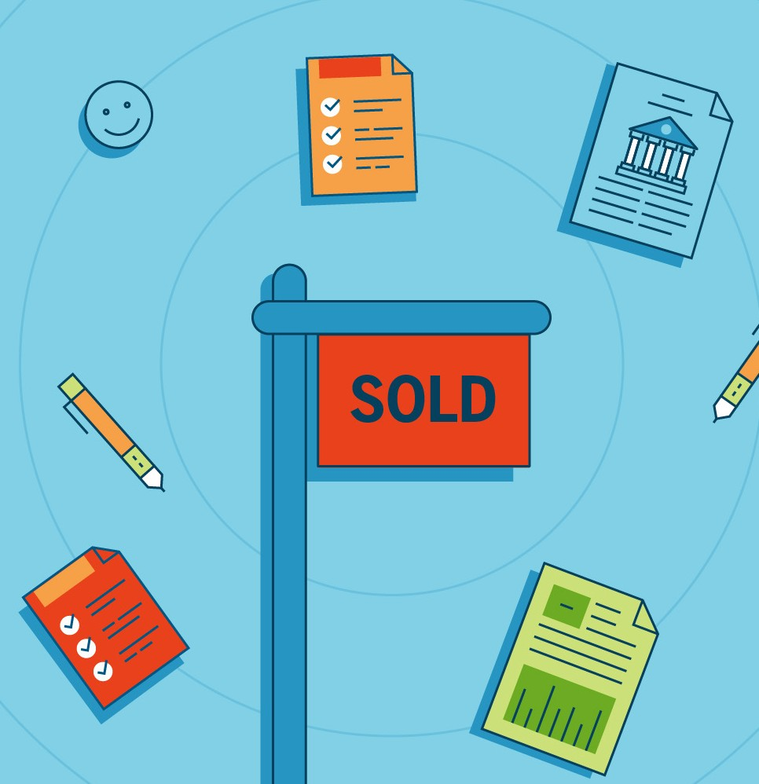
Closing costs for sellers typically include:
- The commission for the listing agent and buyer’s agent
- Transfer taxes or recording fees
- Loan payoff costs
- Unpaid homeowner association dues
- Homeowner association dues included up to the settlement date
- Prorated property taxes
- Escrow, title, or attorney fees

Be Sure to Bring These Things to Closing
At the closing you should have:
- A government-issued photo ID
- A copy of the ratified sales contract
- House keys, garage remotes, mailbox keys, gate keys, and any pool keys
- A cashier’s check, or proof of wire transfer, if your closing costs are not being deducted from the sales price. (Yes, it’s OK to use a cashier’s check — especially if you don’t want to deal with the hassle of a wire transfer, which can take time to clear. With a cashier’s check, you’re guaranteed the money you need for settlement will be there at closing.)

Don’t Forget to Dot These I’s and Cross These T’s
Before you rush off to pick out paint samples for your new place, remember to do these two steps that are often overlooked by sellers:

Transfer utilities. Don’t want to pay for the new owner’s utility bills? Coordinate with the buyer so that utilities
- including not only gas and electric but also water and cable — are transferred to the buyer on closing day.

Change your address. You obviously want your mail to be sent to your new home. Setting up a forwarding address will also ensure that you can be reached if there are any post-closing matters. You can file a change of address with the U.S. Postal Service.

Finally: Celebrate!
At last, your home is officially sold. Congratulations!

Give yourself a pat on the back — and then start settling into your new phase of life.

